

Experimental Aircraft Association

Chapter 891

The Sussex EAAgles

EAA Chapter 891 Newsletter for February 2020 Volume 2-20

Minutes from the January meeting

Date: January 9, 2020
Location: Sussex Elk’s Lodge
In Attendance: President: John Massari
Members: Dick Smith, Dick Deming, Joe Glennon, Bobby Hewitt, Henery Scherman, & Curt Pitzer.
Call to Order: The meeting was called to order at 7:30 PM
Secretary’s Report: The Monthly minutes were not available as the secretary was not present due to illness.
Treasurer’s Report: The Treasurer report was not presented as the treasure was not present due to illness.
Old Business: An update was given on the ongoing airport compliance issues by President John Massari.
A discussion about the closure of Trinca Airport was held all were in agreement it was a loss to the aviation community and would be missed.
(See updates later in this issue)
As it seams interest in a trip to the US Air Force Museum has increased John Lipari again been asked to review planning for a possible trip?
New Business: Planning is underway on starting a VMC club, topics for discussion and classes were requested. A meeting place is being reviewed.
A discussion insured about airport improvement grants now that the ongoing compliance issues look to be coming to an end.
Also discussed was the possibility of acquiring a new chapter trailer if the airport owner will permit it’s placement on the airport.
Projects: Bob Hewitt’s Champ in progressing nicely and hopes are for a spring debut. Dick Aaron’s Swift is having some exhaust gas temperature sensors replaced. Curt Pitzer’s Bee-Lite project is progressing.
The 50/50 Winner: No drawing was held.
Meeting adjournment: The meeting adjourned at 8:15 PM

This Month’s Topics:

Town will shut down 81-year-old airport it bought for $2.3M
By Rob Jennings | NJ Advance Media for NJ.com

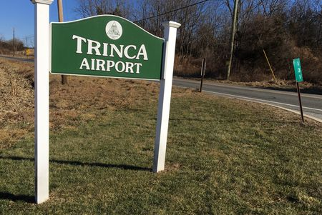
A sign at the entrance to Trinca Airport in Green Township, Jan. 17, 2020

An 81-year-old airport in Green Township where planes take off and land on a turf runway is shutting down on Sept. 1.
The township’s governing committee has voted to close Trinca Airport, which the Sussex County municipality bought for $2.28 million 18 years ago, and continues to review possible future uses for the 121-acre site, officials said Friday.
Pilots who sought to save the airport are expressing dismay at the impending shutdown.
“It’s a little piece of history that’s going to disappear,” said Damian DelGaizo, owner of the nearby Andover Flight Academy.
The Green Township Committee began holding public discussions on the airport’s future in 2018, about a year after the pilot of an amateur-built aircraft was killed in a crash at the end of the runway. It voted 5-0 to close it, effective Sept. 1, at a meeting four months ago.
Green Mayor Margaret Phillips, who serves on the committee, said financial and safety considerations drove the decision.
“We understand the history and nostalgia that goes along with that property. That doesn’t help our tax base,” Phillips told NJ Advance Media.
Phillips said Green Township receives zero revenues from Trinca Airport, which is one of 42 public-use airports in New Jersey and does not charge for flying in or out.
Annual expenses are $15,000, including approximately $6,000 for a part-time airport manager and maintenance, such as cutting grass on the turf runway.
While tie-downs are available for any pilot wishing to store their plane - there used to be a hangar, but it was removed in 2009 - the airport does not offer fuel and it has been at least several years since anyone rented an anchor, Phillips said.
A bigger financial concern is the “unknown future cost to taxpayers,” Phillips said, such as the Federal Aviation Administration (FAA) or Department of Homeland Security ordering improvements.
“ The expense to make-over the airport would be huge. There’s no water or septic. There’s nothing there,” Phillips said, adding that the lone building services mostly as a storage shed.
However, the airport property is potentially lucrative to Green Township, though Phillips said municipal officials are not considering selling any of the three lots making up the 121 acres.
Asked about options, Phillips said one company has expressed interest in leasing land and installing solar panels, while others have proposed a medicinal marijuana facility.
“There is nothing definitive about that property. The only thing that is definitive is, the town committee wanted to close the airport,” Phillips said.
DelGaizo said the airport is used by flight schools, since learning how to land on a soft field is among the requirements in getting a pilot’s license. It is also popular among pilots of antique planes, such as World War II-era Piper Cubs, that “fare better on grass,” he added.

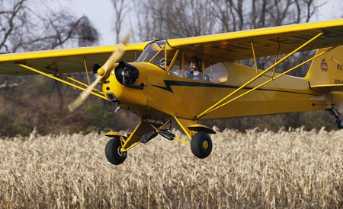
A Piper Cub airplane is seen taking off in Nov. 2011 from Trinca Airport
In Green Township Jerry McCrea / The Star-Ledger

He said that, even before the airport opened in 1939; it was used unofficially by air mail pilots.

“It really is a shame,” DelGaizo said of losing the airport.
Trinca Airport long has been a source of debate and discussion in Green Township, a rural municipality that is home to 3,400.
It was under private ownership in the 1990s when residents opposed a proposal to pave and expand the runway in order to attract corporate jets and even commercial aircraft. After the N.J. Department of Transportation blocked the proposal, the owner sought to close the airport and build 225 houses, including 21 that would have been set aside for low-income families. Green Township headed off that possibility by buying the airport in 2002, for $2.28 million.
The New Jersey Aviation Association, which supported the failed expansion in the 1990s and testified last year in opposition to closing the airport, expressed regret at the outcome Friday. “Green Township as the owner of this public-use airport has the right to close the airport. It is unfortunate though for general aviation that this basic and historic transport facility in New Jersey will close,” said the association’s executive director, Suzanne Solberg Nagle.
Nagle said that public-use airports in New Jersey declined from 82 in 1950, to 42 last year and that the remaining airports deserve additional funding from the state’s Transportation Trust Fund.
A public use airport is an airport available for use by the general public without a requirement for prior approval of the airport owner or operator, she explained.
Nagle said that the state DOT has authority over public-use airports and that the commissioner “should exercise this authority when necessary to preserve airports and meet the needs of 21st century aviation.”

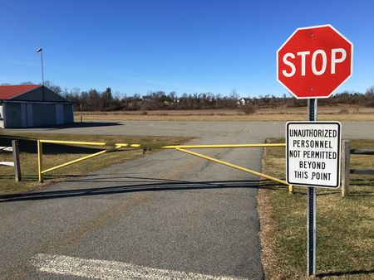
A gate blocks the entrance to Trinca Airport in Green Township
Jan. 17, 2020.Rob Jennings / NJ Advance Media for NJ.com
The runway at Trinca Airport is open from sunrise to sunset, seven days per week. It is among at least seven public-use airports in New Jersey with turf runways that remain in use, Nagle said.
When it is snowing, as was the case on Saturday, pilots typically use skis with their landing gear, the mayor said.
The airport’s entrance was gated around 1 p.m. Friday and no planes were in sight. The part-time airport manager was not in.
Asked about the decision to delay the airport’s closure until Sept. 1, Phillips said that was the earliest it could be shut down without requiring the township to repay a portion of the state grant it received in 2010 to study airport improvements. “That’s why we have delayed the closing,” she said.
DelGaizo said he is looking forward to a final summer at the airport.
“I’ll use it right up until the day it closes,” he said.

Trinca Closure Tied To Marijuana and Money
Article submitted by Don Provost

The article as it was originally published in the New Jersey Herald by Jennifer Jean Miller is reprinted below and might lead some to believe that marijuana and money have everything to do with the Green Township’s decision to close Trinca.
They paid $2.5 million for it not too long ago. See last paragraph for why they picked September 1st for the closing… Dodging a $63k penalty if they close it before the DOT grant expires on July 27th.

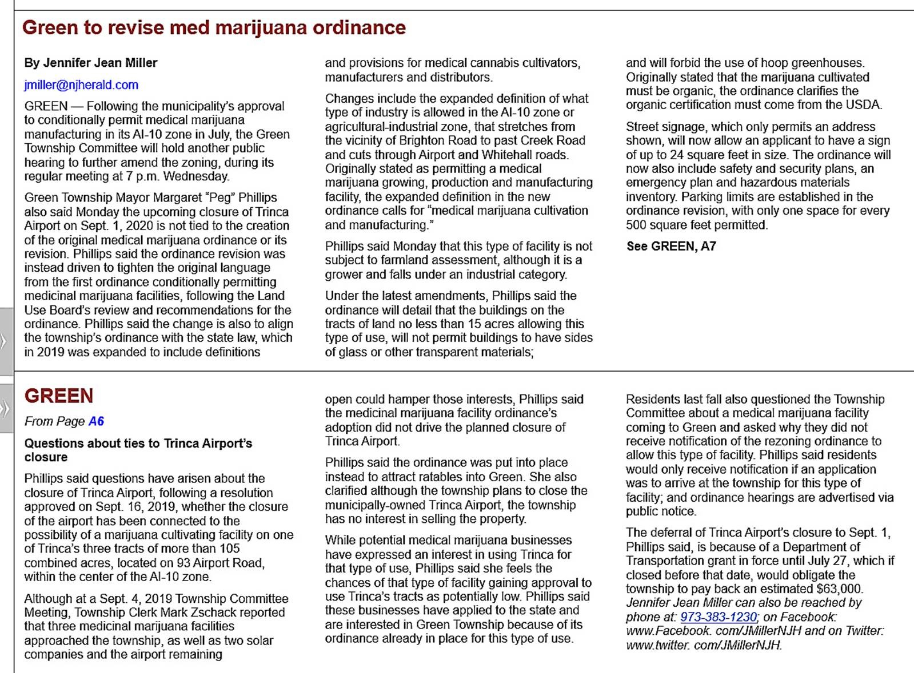
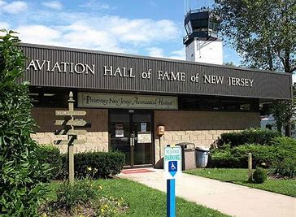

CDW Wings and Wheels fundraiser Weekend

The word is out that New Jersey Aviation Hall of Fame and Museum has set their CDW Wings and Wheels fundraiser weekend as July 11 and 12. Details are pending as it is not on the museum calendar yet. http://www.njahof.org/
The announcement came from:
NJAHOF’s Mark Beeby markbeeby8@gmail.com
We got the word from Chapter 501 because they need our volunteer help and that of other EAA chapters. They are trying to avoid the cost of expensive warbirds hired for display. The theme will be Family Fun Day that will include kiddie rides plus display planes and cars and military vehicles.
Chapter pilots with “unique” aircraft have for a number of years volunteered their time and showed off their parked aircraft for a half-day, whole day or both days. Nick Kapotes with his Army vehicles has often been there with a contingent of Army event reenactors.
Here is the NJAHOF pitch to EAA members…Looking for an eclectic collection of wings, and owners who will engage with the visitors....obviously this is where EAA fits perfectly.
Chapter 501suggest this could be a 2 day Young Eagles event to help the show and asks if several chapters would be willing to work together? We’ll have to find out what NJAHOF wants.
At W&W 2017 we had an EAA info desk there giving away free literature.
More details will follow when they are made available.

EAA, FAA, FCC, NTSB, & AOPA News:

Proposed Remote ID Rule Contains Concerning Requirements

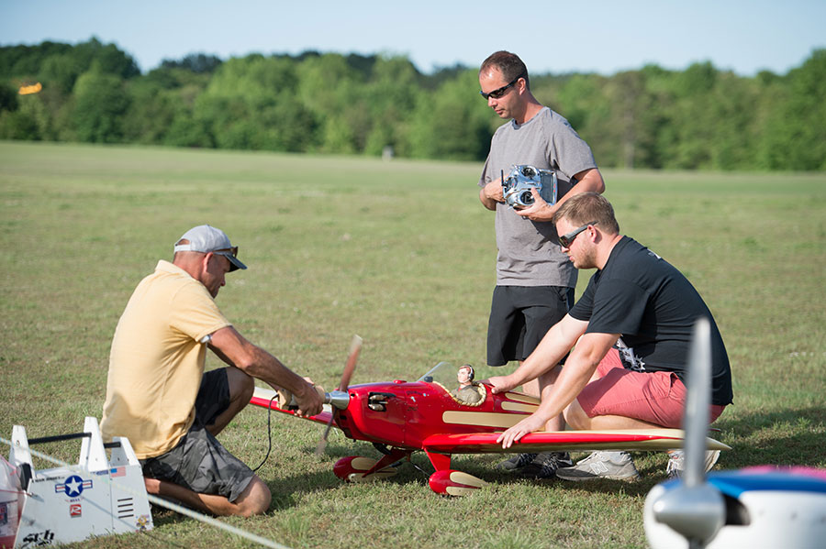

January 16, 2020 - EAA is very concerned that the FAA’s proposed rule on Remote Identification (RID) of Unmanned Aircraft Systems (UAS) could have a severe detrimental impact on traditional model aviation, and is preparing a full package of comments on the Notice of Proposed Rulemaking (NPRM).
The rule would require most UAS, no matter whether they are “drones” or traditional model aircraft, to carry equipment that identifies the device and broadcasts its location. Additionally, many would be required to be equipped with “geofencing” systems that autonomously contain the craft within a defined altitude and lateral boundary.
While EAA is primarily an organization that fosters and supports passion for manned flight, we recognize the modeling community as an important pathway into aviation. In fact, last year we launched the Young Eagles Build and Fly Program, a chapter activity to guide youth in building their own electric RC model, which they can then fly with a local Academy of Model Aeronautics (AMA) club. There are many legitimate safety concerns surrounding drones, primarily those that are airborne camera platforms capable of flying beyond visual line-of-sight with little or no training by the operator, but traditional modeling has been operating trouble-free for nearly the entire history of manned flight. Despite this NPRM not directly impacting the manned flying community, we are concerned that regulatory overreach in the modeling world could easily set a precedent for future action against general aviation, such as an equipment mandate for the benefit of commercial UAS integration into the airspace.
EAA’s first action on this rule was to request a comment period extension from 60 to 120 days to allow time for the public to adequately evaluate this complex and sweeping proposal. Since then we have been carefully reading through the NPRM and working with industry partners in the modeling community. So far, these are our top concerns:
This rule is based on an imagined security and safety threat that simply is not proven in relation to traditional modeling.
There is absolutely a risk posed by drones operated in proximity to aircraft by poorly informed, careless, and/or deliberately malicious operators, but the same cannot be said for models.
The rule would require every modeler to uniquely register every aircraft they own. Models come and go from modelers’ collections on a regular basis, which would necessitate frequent changes to the registry. A prolific modeler could easily own more than 100 models – a truly unwieldy number to maintain valid registrations, especially if there is a per-aircraft fee involved.
The FAA has based some of this rule on an assumption that the average UAS has a lifespan of approximately three years. This is wholly inappropriate in relation to model aircraft, which may last for 20 or more years or may crash on the first flight.
The NPRM has a narrow exemption to the RID requirement, but only for aircraft that are more than 50 percent amateur-built and flying at a recognized model field. The “51 percent rule” works well for full-size amateur-built aircraft, but cannot simply be adapted to modeling without a large amount of unnecessary bureaucracy. Adopting the rule as written could easily cause major consequences for builders of almost-ready-to-fly kits, which account for a majority of new model aircraft. These kits still involve extensive assembly and customization, but would likely fall short of the proposed 50 percent standard.
Under the NPRM, model fields (termed “FAA recognized identification area,” or “FRIA”) would be approved in a one-time, 12-month window. This is clearly meant to “grandfather” existing facilities, with no mechanism for approving new ones. From time to time, modeling clubs can and do relocate their operations for a variety of reasons, and new clubs are established. Additionally, EAA believes that anyone operating under the guidelines of a community-based organization should be able to establish a FRIA, such as individuals in rural areas who wish to fly from their own property.
Under “limited remote ID,” in circumstances where a model is not flown at an approved FRIA or is not compliant with the amateur-built carve-out and lacks onboard reporting equipment, a geofencing system is required. These are difficult to engineer and would severely hamper operations away from FRIAs or the use of prebuilt commercial models.
The rule mandates technology that is not available in large numbers and is not yet fully mature. In the case of the ADS-B mandate, for example, extensive testing took place prior to the 2008 NPRM that mandated its use (and the mandate was not in effect until a decade after the publication of the rule).
There is ambiguity about whether this rule applies to control line and free-flight modeling, and it could even cause complications for indoor modeling.
There are many more elements of the rule that EAA is scrutinizing. Ideally, EAA is pushing for a solution that cleanly carves out traditional modeling as exempt from the RID requirement, which is only useful in identifying negligent drone users.
EAA will provide guidance to members who wish to comment in the coming weeks. When you do comment, please be respectful and use rational, fact-driven arguments in your own words. Form letters and emotional comments have much less impact on the regulatory process. More updates will be provided as they become available.

EAA Web-site Upgrades
As EAA National is changing the chapters web-site provider and updating our web-site as a result. In working with the previous site it was very difficult to post information to the site with excessive re-editing to gain a professional appearance. National in listening to the many complaints form numerous chapters believe it necessary to change the web-site host provider.

New Newsletter Format

As you can clearly see our newsletter has undergone an updating with a new look which is hoped better reflects our chapter image. It was my feeling that the old newsletter was looking dated and could use a new look. After speaking with some of you for your ideas and input this is what I came up with. I hope the new look will meet with everyone’s approval. As EAA National is changing the chapter web-site provider and updating our web-site I am hoping the new look will work with the web-site as well. As always I seek your suggestions and comments for content, ideas, and improvements.

EAA Webinars Schedule

February 18, 2020 @ 8PM EST EAA Flying Start: A Great Way to Grow Your Chapter w/ Serena Kamps
February 19, 2020 @ 8PM EST Vans RV Maintenance Common Questions
w/ Vic Syracuse Qualifies for FAA WINGS and AMT credit.
February 25, 2020 @ 8PM EST Chapter Chat: Tax Exempt Basics
w/ Patti Arthur
February 26, 2020 @ 8PM EST Bang for the Buck: Affordable Aircraft Building
w/ Tim Hoversten
February 27, 2020 @ 8PM EST Become a Better Chapter Leader – Secretary/Treasurer w/ John Egan
March 4, 2020 @ 8PM EST Bolted Joints in Shear
w/ Mike Busch Qualifies for FAA WINGS and AMT credit.
March 11, 2020 @ 8PM EST Stabilized Approaches and Go-Arounds
w/ Prof. H. Paul Shuch Qualifies for FAA WINGS credit.
March 11, 2020 @ 8PM EST How to Read and Call an Aerobatic Sequence
w/ Jim Bourke Qualifies for FAA WINGS credit.
March 18, 2020 @ 8PM EST ATC and You: Communicating With Confidence and Clarity w/ Richard Kennington and Bob Obma Qualifies for FAA WINGS credit.
March 18, 2020 @ 8PM EST Chapter Chat: Donations and Contributions to Chapters w/ Patti Arthur
April 8, 2020 @ 8PM EST You Just Got Your Pilot Certificate — Now What?
w/ Jim Bourke and Marianne Fox Qualifies for FAA WINGS credit.
April 22, 2020 @ 8PM EST Flying Clubs - Growing Participation in Aviation
w/ David Leiting, Chapter Field Representative II
April 29, 2020 @ 8PM EST Float Flying: Freedom to Explore
w/ Amy Gesch Qualifies for FAA WINGS credit.

Grab Bag:

Best Of The Web: How Merlins Were Built
AV Web Editorial Staff February 9, 2020

Anyone who has visited Oshkosh has heard the unique exhaust song of the Rolls-Royce Merlin. Nearly 150,000 of these iconic 12-cylinder engines were manufactured, some in the U.S. as the Packard V-1650. In this fascinating documentary, the assembly of the engine’s 11,000-plus parts is described in rich detail. (Credit King Rose Archives.)
Copy and past this link to view the video: https://youtu.be/-fo7SmNuUU4

Next Business Meeting:
7:30 PM Thursday February 13, 2020 @ the Elk’s Club south end of the airport. The lodge is accessible from the entrance off route 565.

Calendar of events:
March 7, 2020 EAA Chapter 166 Host The Chapter Leadership Boot Camp
8AM-5PM Hartford-Brainard Airport Hartford, CT
July 11 and 12, 2020 New Jersey Aviation Hall of Fame and Museum
CDW Wings and Wheels fundraiser Caldwell Airport Fairfield, NJ
September 11 and 12, 2020 AOPA Fly-In
Greater Rochester International Airport Rochester, NY
Possible fly-out destinations
Eagles Mere Aviation Museum
Owls Head Transportation Museum
US Air Force Museum

2020 Chapter Officers
President: John Massari: jmassari@embarqmail.com
Vice President: Dick Aaron: raaron4u@yahoo.com
Treasurer: John Lipari: slick1@ptd.net
Secretary: John Lipari: slick1@ptd.net
And Appointments
Newsletter Editor: John Lipari: slick1@ptd.net
Web-page Editor: Bob Hewitt: street@warwick.net
Membership Chairman: Dick Deming: rfdeming@optimum.net
Young Eagles Coordinator: Dick Aaron: raaron4u@yahoo.com

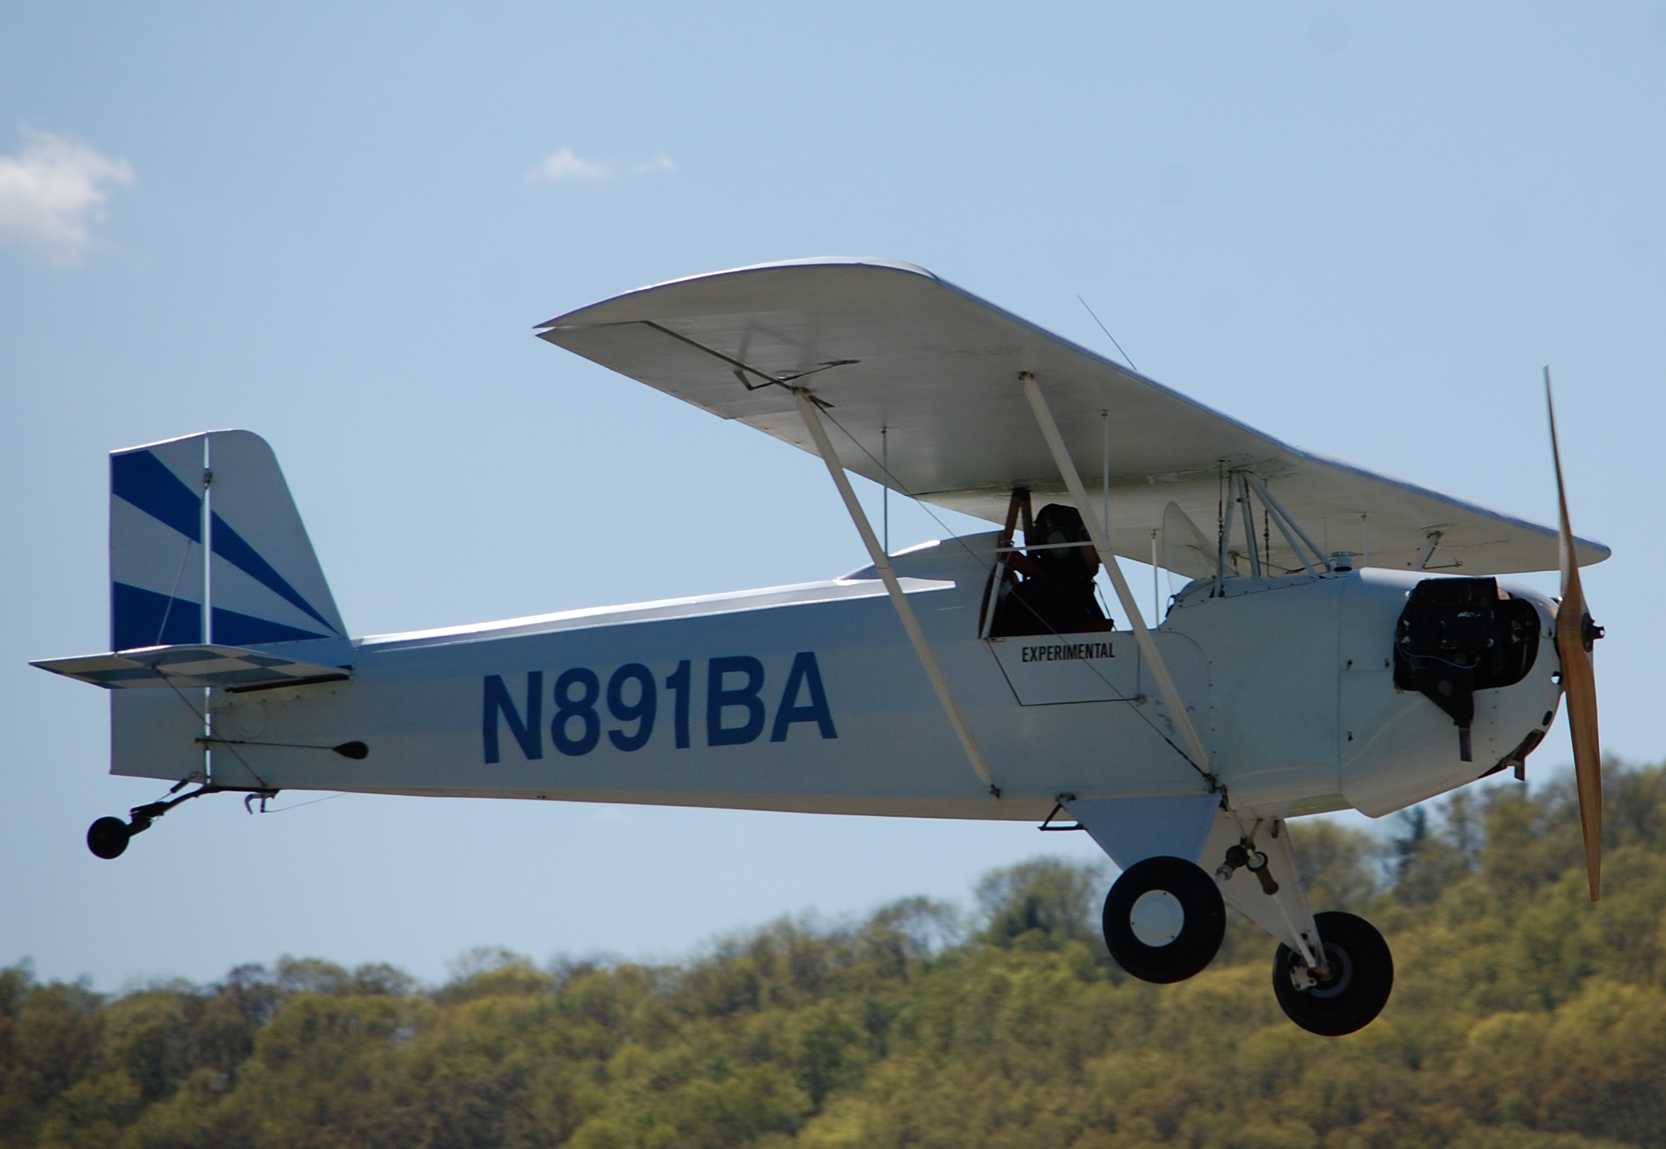
EAA Chapter 891
Sussex Airport
P.O. Box 311
Sussex, NJ 07461-
Visit us at: http//www.eaa891.org

