**Next Meeting**

***Administration Building***

**When**

***Thursday, 14 March at 1900***

**Calendar of Events**

**March**

14 EAA Chapter 864 Meeting at 1900

**April**

11 EAA Chapter 864 Meeting at 1900

**May**

09 EAA Chapter 864 Meeting at 1900

**EAA events**

[www.eaa.org/eaa/events](https://www.eaa.org/eaa/events)

**Fun Places to Fly**

[www.funplacestofly.com](http://www.funplacestofly.com/)

**ALN Hangar Page on Facebook**

<https://bit.ly/aln-tenants>

**President:**

**John Harding 618-466-8733**

[hard1pt17@yahoo.com](mailto:hard1pt17@yahoo.com)

**Vice President:**

**Rick Farrow 618-593-4009**

[rnvfar@gmail.com](mailto:rnvfar@gmail.com)

**Treasurer:**

**Rick Huebner 618-377-2352**

[rv656@aol.com](mailto:rv656@aol.com)

**Secretary:**

**Lou Dieu**

[acflyer2@gmail.com](mailto:acflyer2@gmail.com)

**Young Eagles Coordinators:**

**Bill Orrill**

[b.orrill@yahoo.com](mailto:b.orrill@yahoo.com)

**Jan McKee**

[jcmcke701@gmail.com](mailto:jcmcke701@gmail.com)

**Newsletter:**

**Mark Heckler**

[mark@thehecklers.org](mailto:mark@thehecklers.org)

**Please keep Mark and Kathy Heckler in your thoughts during their difficult time. Please bear with me on this month’s newsletter. – Nicholas Hobbs**

**Next Chapter Meeting**

Our next meeting is Thursday, 11 April. Our guest speaker, Max Langham, will give a presentation on directional control takeoff and landing scenarios. Max is also a CFI and does tailwheel and spin endorsements in a fully restored 90 hp Champ!

**EAA Chapter 864 Meeting Minutes – 14 March, 2024**

28 members and guests in attendance. President John Harding called the meeting to order at 1900.

A motion was made by Jan McKee, seconded by Rick Farrow to approve the secretary’s report as written in the March Newsletter. The motion was approved.

**Treasurer’s Report**

* Checking account balance is $16,616.22 with a total of 53 paid memberships.

**Old Business**

* Randy and Jan McKee discussed the Ray Scholarship. The chapter has been approved to award a scholarship for $11,000. The nomination committee will be: Mr. John Harding, Mr. Lou Dieu, Mr. Art Segieda, and Mr. Stan Clark. Two applicants were present at the meeting.
* A total of 5 campsites have been reserved for the chapter in Camp Schollar for EAA AirVenture. The cost is $324 each.

**New Business**

* For those interested in observing the upcoming eclipse, Clarkson Eyewear has viewing glasses for $2.00 + tax per pair.
* Piston Aviation has offered to host Young Eagle registrations at their facility. We can use their Wi-Fi!

**News**

* The chapter’s May cookout will be hosted at Piston Aviation on 9 May.
* John Harding discussed obtaining a plaque for the Cisco brothers from Jerseyville who were Tuskegee Airman.
* St Louis FSDO is planning a first responder seminar on the ALN ramp 20 April, 2024. They are asking for static display aircraft to familiarize the participants.
* The Chapter has $1,635 of Young Eagle credit that needs to be spent by 31 December, 2024
* Piston Aviation open house is 30 March. They are requesting static aircraft displays on the ramp in front of their FBO.

**Program:**

* No program this month as the floor was open for discussion.
* A motion was made by Rick Farrow, seconded by Stan Clark to adjourn the meeting at 7:50pm

*Submitted by Don Miller for Louis Dieu, Secretary*

**Important Notes**

Click on this link to access our chapter’s online resources: <https://bit.ly/eaachapter864>

**New to this month’s Chapter newsletter:**

**News from the Tower - Joe Case:**

* The fire equipment has been updated in the control tower!
* Mowing season has started. Be on the lookout for mowers in and around all taxiway and runways.
* The Goodyear Blimp will be staying overnight at ALN 28 April.
* Tower numbers for the month of March: 2453 operations compared to 1912 for March 2023 and 2987 for February 2024

**Announcements:**

We are excited to announce that we have taken training for our EAA chapter to host VMC/IMC events!

**What is a VMC/IMC Club?**

**VMC** - non-instrument rated pilots who want to improve their proficiency have an excellent resource through EAA’s Visual Meteorological Conditions (VMC) Clubs. The purpose of EAA VMC Clubs is to build proficiency when flying under visual flight rule conditions.

EAA VMC Clubs are extensions to local EAA chapters and offer monthly meetings in which pilots can network and share knowledge and experience. The meetings use real-world scenarios to engage members, and allow a free exchange of information that improves awareness and skills. The intent is to create a community of pilots willing to share information, provide recognition, foster communications, promote safety, and build proficiency. Through the EAA VMC club programs, visual flight rule pilots have improved their proficiency and they love it.

**IMC** - The purpose of EAA Instrument Meteorological Conditions (IMC) Clubs is to promote instrument flying, proficiency, and safety. The intent is to create a community of pilots willing to share information, provide recognition, foster communications, promote safety, and build proficiency in instrument flying. EAA provides monthly program resources in the form of actual IMC related scenarios designed to encourage open discussion, and for all participants to answer the question “What would you do if this happened to you?” Providing the opportunity for each IMC member participant to hypothetically place themselves into an actual IMC situation, and be involved in open discussion is the key to build proficiency and increase safety as a pilot. This is educational “hangar flying” at its’ best. Additional program offerings such as the “IMC Question of the Month” is a monthly thought-provoking question designed to be a challenging and engaging educational question related to IFR operations.

Our chapter should be set up and ready to roll starting in May! Watch the monthly newsletter for an VMC/ IMC “question of the month” to get everyone thinking… “what if?” The VMC/IMC will not be an additional meeting. It will be held in conjunction with our monthly meetings.

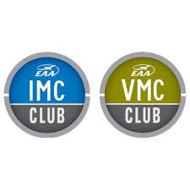

There are a couple of great things coming to Sparta Community Airport - Hunter Field (SAR).

On Saturday, 20 April, 9:00 A.M, start the day off with the AOPA Rusty Pilot seminar! This event is free for AOPA members. The cost for non-members to attend this event is $89, however, an AOPA membership is $89 also, so you can join AOPA and attend for “free!”

Please use the link to register:

[AOPA Rusty Pilots Seminar at Sparta Community-Hunter Field (SAR) - Campaign](https://webforms.aopa.org/event/aopa-rusty-pilots-seminar-at-sparta-community-hunter-field-sar/e561472)

After the Rusty Pilot seminar, Sparta Aero Services are hosting an Aviation Swap meet until 4pm at the main FBO hangar:

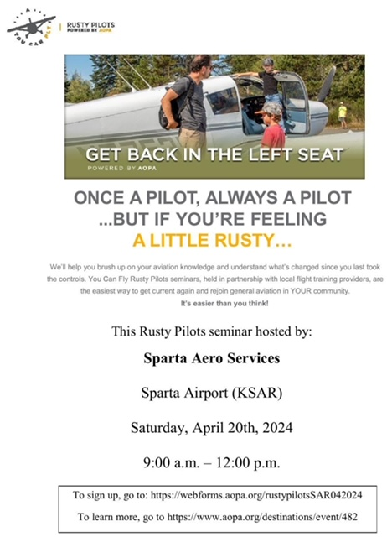 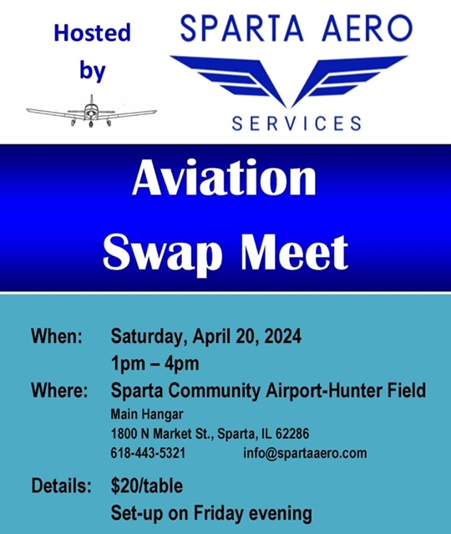

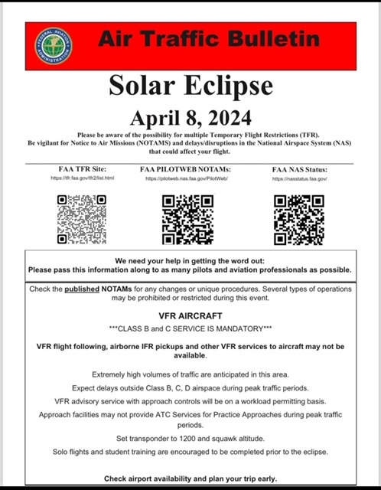

**Looking to buy a cool airplane?! Check this out:** [1947 Bellanca Cruisair - NC14396 - Aircraft For Sale - Indy Air Sales](https://indyairsales.com/current-inventory/aircraft/1947-bellanca-cruisair-king-sigtronics/)

**1947 Bellanca Cruisair! Only $37,500!!**

