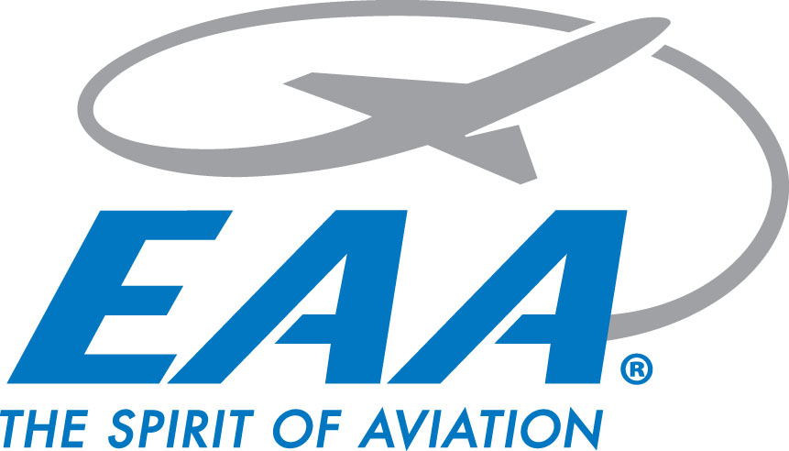

**EAA Chapter 770 March Chapter Gathering Minutes**

**Thursday March 20, 2025**

**Location: IDOT Aeronautics**

**Meeting start:** 1826 hrs - 29 members present

**fliChapter video presented**

**February Minutes presented**

Motion to accept made by Jim Bildilli, 2nd from Greg Benshoff

**Minutes accepted after unanimous vote**

**Treasurer’s report:**

* Total $11,398.62
  + Scholarship fund $7,326.44 + $3,752.48 EAA account
  + Collected $25.70 in interest

Motion to accept made by Val Nester, 2nd from Liz Bron

**Treasurer's report accepted after unanimous vote**

**Announcements:**

* Morrisonville School Public Safety field trip - 03/28 from 11-Noon
* STL Soaring Seminar - 03/29
* STEM Fair - Rochester HS - 04/09 1730-2030
* STEAM Career Fair 04/29 & 04/30 - Orr Building 0900-1300
* YE Rallies 04/12, 05/10, 06/14, 08/14, & 09/13
  + Rain Dates following week
* Build & Fly
  + Per Oliver, plans in place to start next month
* ABEC
  + Cliff to start when he returns from Sun N’ Fun
* Ford Tri-Motor 05/30-06/01
  + No details yet when plane arriving
  + Volunteers needed
* Air Academy
  + Ages 16-18 - Discovery Camp - 07/07-07/12
  + Ages 14-16 Explorer Camp - 06/28-07/03
  + Kiefer Croxton & Jimmy Osborn attending
* **Wings & Wheels updates:**
  + Per Scott, contact made with military for static displays, development plans still ongoing

**Adjournment:**

* Adjourned @ 1850 hrs for Skip Talbet’s storm chasing presentation