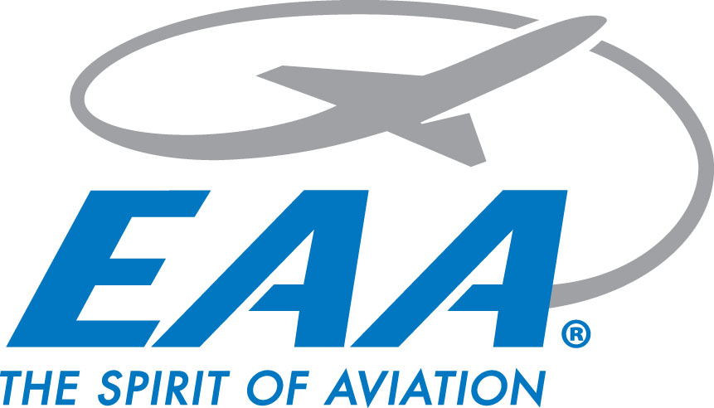

**EAA Chapter 770 Chapter Gathering Minutes**

**Thursday April 18, 2025**

**Location: IDOT Aeronautics**

**Meeting start:** 1826 hrs - 27 members present

* Chapter guests Kieth & Mason Milliman introduced

**Chapter video presented**

**March Minutes presented**

Motion to accept made by Bill Benard, 2nd from Rick Nelson

**Minutes accepted after unanimous vote**

**Treasurer’s report:**

* Total $9,670.38
  + Scholarship fund $5,174.12 + $4,496.26 EAA account
  + Collected $28.42 in interest

Motion to accept made by Greg Benshoff, 2nd from Bill Benard

**Treasurer's report accepted after unanimous vote**

**Announcements:**

* Air Academy nominee Jimmy Osborn introduced
* Ford Tri-Motor 05/30-06/01
  + Tour positions discussed
  + Volunteers needed
* STEAM Career Fair 04/29 & 04/30 - Orr Building 0900-1300
* YE Rallies 04/12, 05/10, 06/14, 08/14, & 09/13
  + Rain Dates following week
* Build & Fly
  + Per Oliver, in touch with RC club. Hoping to start program 05/09, will send note confirming start date
* VMC/IMC Club
  + New coordinator Carol completed training
  + Meeting preferred to be on Tuesdays
* TRACON Education Seminar April 22nd - KALN
* ABEC Update
  + Cliff to start when he returns from Sun N’ Fun
* **Wings & Wheels updates:**
  + Per Scott, submitted military paperwork to the FAA after obtaining signature from Beth at Stellar. Hoping for B-2/F-35 Flyover.
  + Logo design voted on by committee, was hoping for HS student response to help with logo design. Also looking at idea for chapter patch.

**Adjournment:**

* Adjourned @ 1915 hrs