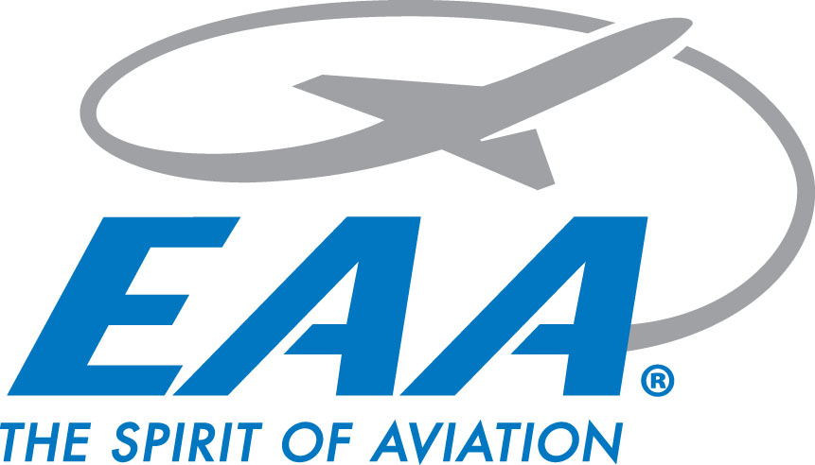

**EAA Chapter 770 January Chapter Gathering Minutes**

**Thursday February 20, 2025**

**Location: IDOT Aeronautics**

**Meeting start:** 1830 hrs

**Chapter video presented**

**New member Kevin Smith introduced, Welcome Kevin!!!**

**January Minutes presented**

Motion to accept made by Scott Winningham, 2nd from Jim Bildilli

**Minutes accepted after unanimous vote**

**Treasurer’s report:**

* Total $11,078.92
  + Scholarship fund $7,326.44 + $3,752.48 EAA account
* Chapter dues collected - remains $20/family or individual member

Motion to accept made by Jim Bildilli, 2nd from Terry Blome

**Treasurer's report accepted after unanimous vote**

**Announcements:**

* LLCC Aviation information session 03/04 @ 5PM - LRS Aviation Center
* Chapter leadership Bootcamp - KSUS 03/08
* Morrisonville School Public Safety field trip - 03/28 from 11-Noon
* STL Soaring Seminar - 03/29
* STEM Fair - Rochester HS - 04/09 1730-2030
* STEAM Career Fair 04/29 & 04/30 - Orr Building 0900-1300
* YE Rallies 04/12, 05/10, 06/14, 08/14, & 09/13
  + Rain Dates following week
* Build & Fly
  + Per Oliver, hoping to start in April due to weather
* ABEC
  + John mentioned spoke with Cliff to get program going again, waiting to hear back from Cliff
* Ford Tri-Motor 05/30-06/01
  + No details yet when plane arriving
* Air Academy
  + Ages 16-18 - Discovery Camp - 07/07-07/12
  + Ages 14-16 Explorer Camp - 06/28-07/03
  + Committee being formed to pick attendees

**New Business:**

* John mentioned chapter membership is growing, possibly wanting to have executive meeting with goal of establishing board
* No Ray scholarship due to missing application deadline
* [EAA770newsletter@gmail.com](mailto:EAA770newsletter@gmail.com) for newsletter submissions
* **Wings & Wheels updates:**
  + No major updates, development plans still ongoing

**Adjournment:**

* Motion made to Adjourn by Jim Bildilli, 2nd from Chris Bildilli
* Adjourned @ 1930 hrs