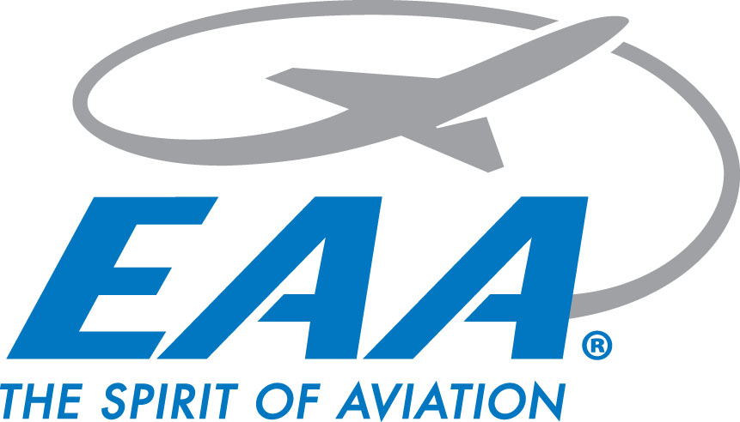

**EAA Chapter 770 Chapter Gathering Minutes**

**Thursday May 15, 2025**

**Location: Chapter Hangar**

**Meeting start:** 1826 hrs

* Chapter guests Abby, Alex, & Steve introduced (did not get last names)

**Chapter video presented**

**April Minutes presented**

Motion to accept made by Jim Bildilli, 2nd from Liz Bron

**Minutes accepted after unanimous vote**

**Treasurer’s report:**

* Total $9,692.37
  + Scholarship fund $5,174.12 + $4,518.25 EAA account
  + Motion made by Marty to reimburse John $50 for Tri-Motor Ad
  + Motion to accept made by Liz Bron, 2nd from Val Nester - Motion passed unanimously (Motion also passed for Treasurer's report.

**YE Rally Update:**

* 53 registered, 41 flown
* June 14th next YE Rally

**Announcements:**

* **Ford Tri-Motor 05/30-06/01**
  + Tour positions discussed
  + Volunteers needed
  + Potluck Friday Night 05/30 of tour for crew - 6PM
    - Sides requested
* **VMC/IMC Club**
  + Next meeting 06/03 - VMC topic
* **Wings & Wheels updates:**
  + Per Scott, submitted military paperwork being processed, still hoping for B-2/F-35 Flyover.
  + Logo design voted on by committee presented to chapter
  + Need 2-3 golf carts
* **Ray Scholar Update**
  + Dominic has stopped training, planning on enlisting in Navy
* **Air Academy Update**
  + Air Academy nominee Kieffer Croxton introduced

**Adjournment:**

* Adjourned @ 1941 hrs