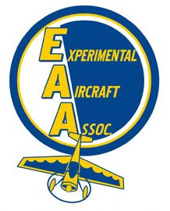
10/28/19
Chapter 544
Hastings, NE

EAA Chapter 544 met at 7pm at the Hastings Air FBO in Hastings NE
Meeting called to order at 7:00 p.m.

In attendance:
• Mike Oswald, Steve Wilson, Aaron Schardt, Glen Bredhauer, Troy Johnson, Russ Specht, Bryon Jorgensen

Minutes from the previous meeting were unavailable

Treasurer Report:
• Around $3400
• Note to members that dues are to be renewed in January

Club Project
Various potential club projects were discussed. Steve Wilson offered his Long EZ project up for completion by the chapter, it was discussed that it may take several thousand hours of work to complete and would initially require a heated hanger for the fiberglass work. Also discussed was rebuilding of an engine or cosmetically refurbishing a 152 or 172. Discussion was tabled until next meeting.

Troy reported that he’s redoing some wiring on this DA-2 project. He reports the engine not running smoothly as it currently is wired.

Glen Discussed AD’s during annual and showed the group a plug of some sort for an engine the crankshaft sits against.

Mike played two VMC Club videos and they were both discussed.

Meeting Adjourned at 8:30 p.m.

