**PASO ROBLES EXPERIMENTAL AIRCRAFT ASSOCIATION (EAA) CHAPTER 465 NEWSLETTER – JULY 2020**

**The regular Wednesday July 8 will be held at the Airport Terminal at 7 PM.**

**You can attend in person (we will social-distance and/or use masks) or you can join remotely via Zoom. To access Zoom: (i) download the free Zoom Software to your computer, (ii) open your Zoom account on your computer about 6:55, (iii) click on “join meeting” and enter the meeting number** 364 075 1694 **and password EAA465 then you will have audio and video access**

**HIGHLIGHTS OF THE MONTH:**

* We have a full program planned for this fall including start of our new VMC club, a Fast Start program for new adult pilots, fly-in and fly-outs, a Young Eagles flying day, possibly an engine building activity, etc. As such your participation in the July 8 meeting is important so we get your input and assistance in planning the above events.
* Strategic Chapter Planning: we have a draft plan (*see Annex I of this newsletter*) that that reflects many of our current programs, but we need more member input to be sure we serve both existing and potential new members interests.
* EAA Ray-scholarship Program*.*Our Chapter Young Eagle Scholar, Aiden Bajema is close to his SOLO and will be at our meeting July 8, and we may soon have enough funds to sponsor the second ranked applicant to his solo flight.

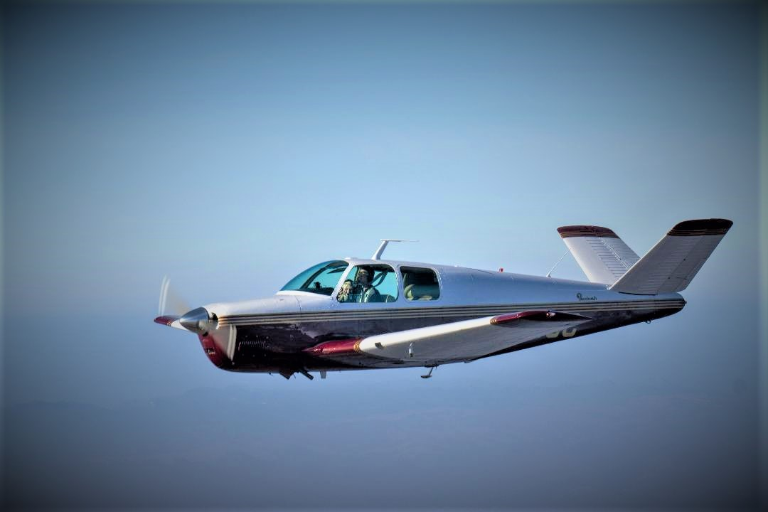

A Member’s Bonanza at play. If you have a favorite photo of your plane or an aviation activity send it to [eaa465@sbcglobal.net](mailto:eaa465@sbcglobal.net) , we may put it in a newsletter and in our Display at the Airport terminal

**WHAT IS THE HISTORY AND LINEAGE OF YOUR AIRCRAFT?**

**STEVE ELLS –CHAPTER CONTRIBUTING EDITOR**

The Ercoupe, also known as the “UrpCup” when it was used as a trainer, or the “Cardboard Connie” due to having each of two rudders attached to the outer end of each horizontal stabilizer was sold as an unstallable airplane. Up elevator travel and rudder travel was limited to prevent a cross control stall. It was revolutionary for other reasons such as being the first small airplane with a tricycle landing gear and a full cantilever wing.

In this little story let’s assume Jane Pilot owns a 1946 ERCO 415 C. She wants to know more. Her mechanic gives her the URL for the FAA listing of Airworthiness Directives (ADs).

All the airworthiness directives (ADs) for all aviation products including airframes, engines, props, accessories, etc. are listed on a FAA website at: <https://rgl.faa.gov/Regulatory_and_Guidance_Library/rgAD.nsf/MainFrame?OpenFrameset>.

Jane loved her Ercoupe and, being a computer savvy and proactive pilot decided to create an AD list to help her track these important notices. Jane’s was amazed when she found the following quote from Andrea Tracey, director of the College Park Aviation Museum, ““You could order it (an Ercoupe) from Macy’s and J.C. Penney, just like you could have ordered a house through Sears Roebuck.”

She checks the data plate on her airplane—it reads “ERCO Ercoupe 415 C.” Imagine Jane’s surprise when there was no “Erco” heading under the “E” listings. She tried again: “ERCO” worked. There were 10 airframe ADs. The listing included ADs on the 415 C and 415 D models.

Just for fun, Jane entered “415 C” and hit the jackpot. That worked too. The site also revealed that four companies had owned the Type Certificate for what was originally called the Ercoupe 415 C and 415 D.

ERCO built over 5,000 Ercoupes before it sold the rights to the Sanders Corporation, which ended production in 1950. Thus, was the long trail of different owners of the Type Certificate. Aeronca had a license to build a derivative, Univair Air Products bought the TC in 1950 and still owns it and produces parts. Other companies that have adopted the design include Forney/Fornaire, Air Products Company, Alon Aircraft, and Mooney aircraft, which replaced the twin tails with a more conventional single tail. Early 415 Cs, since the maximum takeoff weight is 1260 pounds, making it eligible for use as a Light Sport airplane.

PS from Dave Fretwell: *My first plane was* *a 415C. I lived in the DC area, often flew into the historical College Park Airport (cited as the longest continually operating airport in the US), visited the Museum, and toured the former factory which is now the repository for the US Government mapping agency). I also met Fred Weick, the designer of the Ercoupe who moved on to be the designer at Piper Aircraft.*

**VMC CLUB AND FLYING START PROGRAMS**

**VMC Program leader Marc Dart , Flying Start Program leader Kendall Pearson**

Start-up of these related programs is delayed due to Virus; we intend to get them started this fall or earlier

The Visual Meteorological Conditions (VMC) club is anticipated to start at **6 PM before our regular 7 PM meeting in September.** It is targeted at existing pilots who would like to improve their proficiency, learn new skills, tap into the experiences of other pilots and just do some hangar flying. It’s also a way to recruit new members to our EAA chapter. The club is an EAA sponsored and supported activity, with many resources to support its missionMore information can be found   <https://chapters.eaa.org/EAA465/VMC-Club>

The Flying Start program is anticipated to start at a selected **Saturday AM in November**. The program is targeted to adults who may have been thinking about taking pilot training but may need help in making a decision to do so.. This program promotes and involves interested adults in free half-day aviation/flying introductory seminar**.** This isfollowed by a free Eagle flight with similar benefits as the Young Eagle program, but done on a one by one basis as opposed to the day event we do for young eagles. Of course, once an adult starts PPL training, he/she may want to join the above mentioned VMC Club. Full information on the flying start program can be found at. <https://www.eaa.org/eaa/eaa-chapters/eaa-chapter-resources/chapter-programs-and-activities/flying-start>

**FLY-IN AND FLY-OUT OUT ACTIVITIES:**

**Fly-Outs:**

We are planning these for every other month, they can be linked with our new VMC club. We have two possible targets, depending on the status of the virus, including: (i) the Mojave “plane crazy” second Saturday of the month fly-in, and (ii) the Shafer Wings and Wheels day November 14. We need a fly-out leader for each to find out for sure the events are happening, provide information to our members, and informally lead the fly-outs

**Fly-In**

**Southern and Central California EAA Chapter fly-in** This event is going forward as planned on Sunday Oct. 11, it will have a focus on the Estrella Warbird Museum. See following for details and we need chapter volunteers to help with plane parking and registration.

**SOUTHERN AND CENTRAL CALIFORNIA EAA CHAPTERS FLY-IN**

**SUNDAY OCT 11, 2020 - HOSTED BY PASO ROBLES EAA CHAPTER 465**

Join us in Paso Robles for a one-day event centered at the Estrella Warbirds & Race Car Museum [www.ewarbirds.org](http://www.ewarbirds.org/) , which has the highest tourism visit rate on the central coast after Hearst Castle!!!

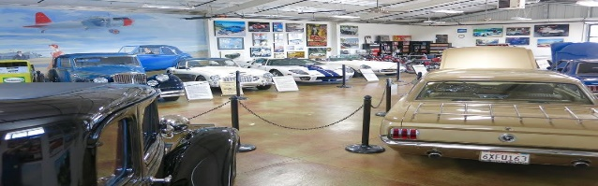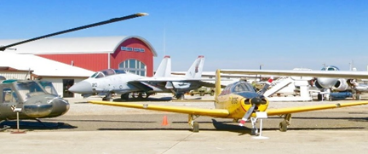

**SOUTHERN AND CENTRAL CALIFORNIA EAA CHAPTERS FLY-IN (continued)**

**The one-day event will include:**

* Full day access to the Estrella Museum which opens at 10:00 AM
* A catered lunch
* Presentation and “Fast Credit” by the FAA Fast Safety team, and/or a retired NTSB official
* Fuel Discount anticipated

Pre-registered cost per person for the day is $32 up to Oct. 4, later or on-arrival registration $42.

**To register please send EAA 465:**

* An Electronic Mail message to [EAA465@sbcgloabl.net](mailto:EAA465@sbcgloabl.net), including the: (i) your name(s), (ii) type of plane, (iii) N number, and (iii) your EM and Phone number
* A check for the number of people in your plane times $32 to: Treasurer EAA465, 7460 Pinal Ave, Atascadero, CA 93422, or send payment to our EAA 465 Pay Pal Account at [EAA465@sbcglobal.net](mailto:EAA465@sbcglobal.net)

Hope to see you there. To find out more about EAA465 go to <https://chapters.eaa.org/eaa465> which has a link to send us any questions you may have.

**Aviation Building and Repair Projects**

**Legal Eagle Ultra Lite .** This is at the airport and is now running well thanks to Jonnie Via, we need to get together to put on the wings, do some taxing around, find a place to store it, and decide what to do with it in the long run.

**Glasair and Engine Donation from Ron Steinberger:** this is potentially sold and the funds will go into the Young Eagles program support fund. Thanks to Kendall for facilitating the sale.

**Engine Build Project:** Several members have suggested we get an engine and have interested adult and young eagle members dismantle, rebuild, and run an engine. This could be done repeated times as a learning device, without spending a lot of funds. We have one engine already donated and another possibility. **We need a team leader (s) who could organize and supervise a build day every few weeks, someone handy with a welder to build a test platform, and hanger space where we can house the engine build project.**

**EAA Chapter Hanger Project:** After review and discussion with members the committee recommended we not try to take-on building a new hanger at this time but rather look at existing options (i.e. donation and use of existing space). We are actively publicizing this option via Facebook, our Website , on bulletin boards, and at businesses at the airport. Tony

Gaspar is leading this activity (see Annex 2 for Flyer )

**Cloud Clippers:**

Ron Steinberger is a member of our Chapter and also a member of the Academy of Model Aeronautics (AMA) & active in the Local “Cloud Clippers” [www.**cloudclippers**.**org**](http://www.cloudclippers.org). They usually meet & fly their RCs on Sunday at their field west of runway 13/21 at the Airport. They will be scheduling an “open house” for interested EAA Chapter adult and young eagle members of our chapter on a Sunday morning in September. The plan is to then implement a local version of the EAA “build and fly” program with interested Chapter members. This has proven to be very successful in many EAA Chapters, and the Cloud Clippers already have a kit ready for building. <https://www.eaa.org/eaa/eaa-chapters/eaa-chapter-resources/chapter-programs-and-activities/EAA-Young-Eagles-Build-and-Fly-Program>

**YOUNG EAGLES PROGRAM**

**Additional funding Needed for Young Eagle Scholarships and Related Activities**

Chapter 465 is soliciting funds to support its overall aviation programs, in particular introducing and promoting aviation as a career and/or avocation for Chapter young eagle members. Examples for use of these funds include: (i) funds to help the second ranked Ray Scholarship Applicant to start training for a private pilot’s license (i.e. **if each adult chapter member donated an average of $100 we could finance about 50% of training required for a PPL**, (ii) providing YE introductory flights for youth in N. county youth, (iii) sending selected YEs to a summer Air Academy at EAA national headquarters in Wisconsin, and (iv) materials to introduce YEs to building, operating, and maintaining aircraft.

We have already raised over $1000 from local businesses and Chapter funds from the sale of the Glasair kit and engine parts. All donations provide the donor with a tax credit because Paso Robles Chapter 465 is a 501 © 3 non-profit organization (EIN 84-2139203). Funds can be forwarded to Chapter 465 via PayPal to [eaa465@sbcglobal.net](mailto:eaa465@sbcglobal.net), or via check to Treasurer, EAA Chapter 465, 7460 Pinal Ave, Atascadero, Ca, 93442.

**ADMINISTRATIVE STUFF**

* **Check out our new web site at** <https://chapters.eaa.org/eaa465>
* **Check out and post things on our Facebook Page,** Sean Thomas one of our Young Eagles is helping post content on a regular basis**.** <https://www.facebook.com/EAAchapter465/?pageid=1372309742934835&ftentidentifier=1411397102359432&padding=0>
* **If you want to join our Chapter we would welcome you (only $20 per year), see following list of basic events, our member application form can be found at** <https://chapters.eaa.org/EAA465/Archives>
* **Check out and post things on the KPRB Paso Robles Pilots Facebook Page,**

|  |  |  |
| --- | --- | --- |
| 2020 EAA Chapter 465 Activity Schedule 07/04  *Check Newsletter, Facebook, Web Site for updates and more details* | | |
| TBD | **Activity/Event** | **Contact/Liaison** |
| 07/08  07/08 | Regular Chapter Meeting. 7 PM, Airport Terminal  VMC Meeting, 6:00 PM, Airport Terminal | Dave Fretwell 703 606 0865 Marc Dart 805 239 4184 |
| 08 | No events scheduled – Summer Break |  |
| 09/09  08/09 | Regular Chapter Meeting, 7 PM, Airport Terminal  VMC Club Meeting, 6:00 PM, Airport Terminal | Dave Fretwell 703 606 0865  Marc Dart 805 2384184 |
| 10/03  10/11 | Young Eagles flight and Pancake Breakfast  South and Central CA EAA Chapter Fly-in | Darrell Radford 805 464 9863  Dave Fretwell 703 606 0865 |
| 11/11  11  11/14 | Regular Chapter Meeting, 7 PM, Airport Terminal  Fast Start/Eagles program (tentative schedule)  Shafter Wings and Wheels flyout | Dave Fretwell 703 606 0865  Kendall Pearson 805 586 0550  Need leader |
| 12/06 | Xmas Party, 12:30 PM, Airport Terminal | Dale Ramey 805 466 3684 |

**ANNEX I**

|  |  |  |  |
| --- | --- | --- | --- |
| **PASO ROBLES EXPERIMENTAL AIRCRAFT (EAA)**  **- DRAFT CHAPTER 465 ANNUAL AND LONG-RANGE PLAN 06/02/2020** | | | |
| **Mission:** To grow participation in aviation in our community, and promote the airport, by involving adults & youth in aviation activities with homebuilt/experimental, antique, classic, warbird, aerobatic, ultralight, general aviation, and unmanned aircraft | | | |
| **Objective** | **Activity : activities for one objective often support multiple objectives.** | **Target**  **2020 by 2023** | **Team**  **Leaders** |
| 1. Increase adult membership of our EAA Chapter by 15% per year (5 per year) | * Develop outreach program for the over 200 EAA national members within 60 miles who are not members of our chapter (i.e. EAA Blast). * Develop and distribute Chapter promotional material in the Community by direct contact with community organizations and other aviation groups. * Run at least one Chapter event per year targeted at general public (i.e. pancake breakfast during Young Eagles flight day) * Initiate Fast Start program and related individual adult Eagle program flights * Each existing member invites one non-member pilot or adult to a chapter event | 40 members 55  Display material  developed  1 3  5 15  30 90 |  |
| 2. Increase Youth membership in our EAA Chapter by 100 per year, currently over 500 youth have participated | * Hold at least one Young Eagles (YE) flight event per year * Complete first Ray Scholarship program and apply for second * Co-sponsor at least one YE to EAA summer academy each year * Follow-up program for YEs (i.e. pancake breakfast, engine/plane build etc.) * Obtain donations to support young eagle programs | 600 total 800  1 2  1 3  1 3  $4000 |  |
| 3. Promote safe aircraft operation and general aviation flying at KPRB, in CA and beyond, | * Hold a Chapter flight advisor safety briefing every 6 months * Sponsor or be directly involved in one FAA FAST program each year * Initiate semi-monthly VMC club meetings for members and non-members * Hold a Chapter technical advisor briefing every 6 months * Initiate at three Chapter flyouts per year (linked with VMC, Eagle, Fast start) | 2 6  1 3  2 6  2 6  3 9 |  |
| 4. Increase local and regional awareness of our Airport as a gateway to our community | * Sponsor and/or host one type club fly-in per year * Invite aviation and community organizations to speak at Chapter * Chapter members speak at aviation and community organizations * Attend at least two regional fly-in events at other chapters – promote EAA465 * Float in Pioneer Parade and other town events (Atascadero, Templeton) * Business cards for Chapter Board Members & advisors, name tags for members * EAA Trimotor, B17, B25 events | 1 3  1 3  1 3  2 6  1 1  8 8  1 1 |  |
| 5. Improve Chapter services and facilities for members | * Initiate study to find permanent Hanger/space for Chapter * Invite local and regional guest speakers * Chapter Member(s) provide snacks/greeting for visitors at meetings * Strengthen communications (i.e. Facebook, Web Site, Newsletter, EMs) * Involve all members, when possible, in leading/implementing Chapter activities | Complete 2020  See objective 4  1 1  Need leaders  More Volunteers |  |
| 6. Improve income and financial status of Chapter | * Increase annual chapter dues from $20 to $30 * Add tip jar, sell EAA hats and T-shirts at Chapter events, pancake breakfasts * Hold silent auction at Xmas Party - $15 average item value * Income from EAA for Young Eagle flights ($15 each – average 100 per event) * Donations for Young Eagle scholarships (average $100 per member) * Donations from businesses for young eagle programs (average $300) * Hold Plane wash day once a year ($25 donation requested) * Sell donated aircraft materials locally, eBay, Craigs list, Chapter Newsletter * Income from Trimotor, B17, B25 Visits – one per year * Donations for Hanger project is/when implemented (members and businesses) | +$350 +$550  $300 $500  $300 $600  $150 $200  $3000 $5500  $1500 $2500  $250 $350  $300 $500  $800 $800 |  |

**Annex II**

**Paso Robles EAA Chapter 465**

**HANGAR NEEDED**

**Paso Robles EAA Chapter 465** is growing and in need of its own hangar. We are actively seeking a hangar of our own where we can continue to grow our membership, build airplanes, conduct Young Eagles activities and promote general aviation. We are a 501C(3) charitable organization.

Do you have a hangar to donate for a tax-deductible donation?

Would you like to donate funds or perhaps an airplane that we can sell to help us acquire a hangar?

**Please help Paso Robles EAA Chapter 465** and our local aviation community.

Please contact Tony Gaspar at 805-423-1816 or at [tony@connecthomeloans.net](mailto:tony@connecthomeloans.net) to discuss how you can help. Thank you!!

If you’d like to learn more about EAA Chapter 465 please go to: <https://chapters.eaa.org/eaa465>