**EAA Chapter 1705 July 9th, 2024, Meeting Minutes**

**Announcements by EAA 1705 Chapter Members**

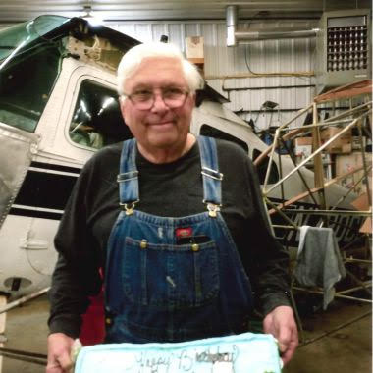

**In Memoriam.** Our condolences to the family of Bradley Alan Niemann, 72, of Baldwin, WI died suddenly in an automobile accident July 1st, 2024.

**New Richmond Regional Airport Announcements**

August 2nd, New Richmond Regional Airport turns 60years young. Starting at 6 pm, a party will be held to commemorate this event. Food and Music will be provided by East Metro Jet Center.

The good, the bad, and the ugly about the New Richmond Regional **Airport Gates**…

Gate 1 closes at 10 pm and reopens at 4:30 am during the week and 6 am on the weekends. The keypad works.

Gate 2 will always remain open, since it is inoperable.

Gate 3 closes at 10 pm, reopens at 4:30 am during the week and 6 am on the weekends. Unfortunately, the keypad does not work. After 10 pm, you can only exit through this gate. If you need to re-enter, please do so through Gate 2. Be mindful of ramp traffic!

To bring all Gates up to code, requires a $250,000 investment by the State of Wisconsin. We hope this will be part of the finding by Governor Eves for the airport. New Gates by Spring 2025???

**Events Calendar & EAA 1705 Chapter Website Development**

See attached tentative Events Calendar. If you know of any events that need to be posted on the calendar let us know. [EAA 1705 Chapter - Events Calendar.docx](https://docs.google.com/document/d/1RsPH6y2vfETP3u4F19wQ00gb8kqweNIk/edit?usp=sharing&ouid=107564852285671374399&rtpof=true&sd=true)

Our next Chapter meeting is tentatively scheduled for the **13th of August at 6PM**.

The focus of our next meeting is on our Young Eagles. Lucian Banitz and Mike Demulling have offered to set up flight simulators and have RC planes to fly. We hope to set up **Young Eagles RC event** at Rick’s Hobby Farm on the south end of New Richmond later on this Fall.

**Poker Run** Event

What is it…

Our Poker Run will include 5 local airports, starting either at the Chapter Hangar or some other location (i.e. New Richmond, Osceola, Amery, Menomonie, and Boyceville).

The Poker Run is an event with three parts — and if you participate in all three, it makes for a wonderful day.

**The Breakfast**: In the morning folks gather to meet and greet and have breakfast. Planes come and go as folks are fed and decide to head out. You don’t have to fly in conjunction with another plane, but often planes leave in groups.

**The Flight**: You also don’t have to fly to the 5 airports in a specific order, but most do since the suggested order is the most efficient and helps get you to a lunch destination at about the right time.

Note: This is not an activity with a prize going to the plane that is fastest around the circuit, so we encourage everyone to take their time and enjoy the scenery. Be safe. Make sure you understand the airports we have chosen. (We have plenty of pilots who can give you pointers.)

The Proposed Rules

* After registering at the first designated airport, fly to the other four in no particular order.
* The dealer will either deal you a card, or you may choose a card, and then both you and the dealer initial your card with the pen that has been provided to that dealer. Each airport has a different color.
* NO CHEATING!
* Return to final destination airport by specified time.
* If you cannot make it to all of the airports, additional decks of cards will be at the final destination airport so that you can still get a full hand.
* Best hand of poker wins!

**The Awards & Dinner**: Again, you do not have to attend the dinner, since awards for the best hand are given out separately from the dinner, and some have other obligations, but most find the food and fun to be too tempting. Prizes are given (including white elephant gifts, which are especially entertaining), good food is served, and hangar stories abound.

We need volunteers to form a **committee** and set up this event…

Multiple folks to work with the five airports to set this event up

Sponsors of low dollar prizes – maybe from local businesses?

Setting and Running the Breakfast

Organizing and breakdown of the Potluck Dinner

We need suggestions on a date to hold our Poker Run…

We are in the process of setting up and operating our **EAA Chapter’s website** <https://chapters.eaa.org/eaa1705>

Please vote on our **Chapter logo!** Merchandise to follow soon…. Our options:

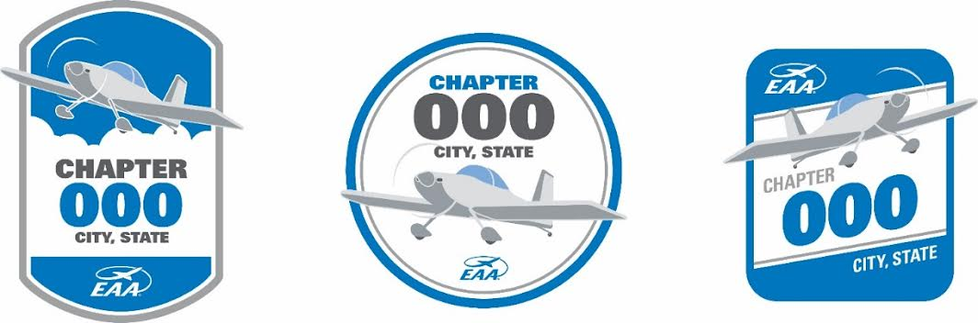

[EAA Chapter 1705 Logo Vote](https://docs.google.com/forms/d/e/1FAIpQLSfUwNdO9u86jjgn-HdbzxINzApXBRIpPJF0C8x1FodcmyIWug/viewform?usp=sf_link). Please **vote** by clicking the hyperlink with your choice by 01 August. (Extended, vote if form is on…)

**EAA 1705 Chapter Dues & Nametags**

We still need to collect dues from some of our members. Please contact Bill Lawson, our Treasurer. Without dues we can’t fund our meetings and events. Please provide your EAA numbers as well so we can make you a nametag for our meetings.

**EAA 1705 Chapter Members Contact List**

We purposefully protect the privacy of our members by not sharing your contact information. We would like to gauge interest in a voluntary public contact list for our chapter members. Please let us know your thoughts…

**EAA Airventure 2024** is next week, 22- 28 July at Oshkosh, WI. Enjoy the week of fun and adventure! We have two Chapter members camping at Camp Scholler this year; Bill Lawson and Jeffrey Turner. We are south of Lindberg Street, between 12th and 14th street. Stop by and say Hello.

We closed the meeting with the **Really, Really Cool Airplane of the Month** featuring Jeffrey Turner’s Van’s RV-14 that he and his family built in their basement over the course of 4 ½ years. So often we get to see these wonderful machines taxi by, but we never get to experience them up close and share the joy. We hope to feature our chapter members’ aircraft each month.

Please let us know about your aircraft projects and whatever chapter activities you have interest in.

Fly for fun!

Jeffrey Turner

EAA Chapter 1705 President

651-335-5735

jeffrey.turner@hotmail.com