Scholarship Followup Form

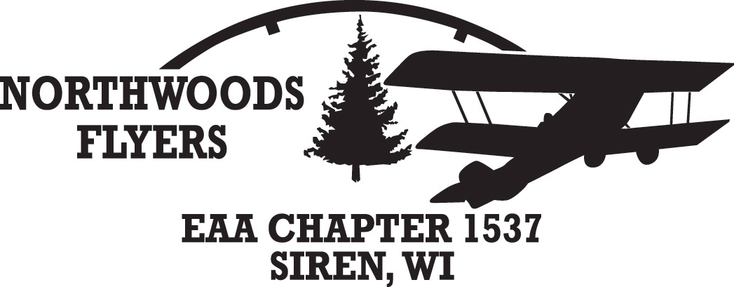
EAA Chapter 1537 requires a follow up interview with our scholarship recipients. This interview will be at a regular chapter meeting in front of the members present so they may get to know the recipient and the results of scholarship given. Please use the following questions to frame the discussion.

What did you achieve?

How did the scholarship help in your education?

PAGE 2

What have you learned about your interest in aviation?

Have your career goals changed and if so how?

