2024 09 SEPTEMBER
“LEARNERS AS WE GO!”
mr. bill

NO SEPTEMBER MEETING ON SATURDAY 09/07/2024
WHY?
Hello Neighbors and Friends of EAA 1387. Seeing that this is the last long weekend of the summer, most of our members are out and about for this long week and will be out of town for the first weekend.
Your “Balloon Crew Chief” EAA 1387 President will be on the grounds in Connor Prairie, Indiana with the “SUGAR MOMMA” balloon next weekend. What I did NOT know about these AERONAUTS, (The technical name for a hot air balloon pilot is AERONAUTS) is there is usually a balloon event every weekend somewhere.
9/06-08 Connor Prairie, IN
9/14 Eureka, MO Balloon Glow
9/20-21 Forest Park Balloon Glow and Race
10/04-13 Alburquerque Intl Balloon Festival
Well enough about this hot air stuff……..
Our condolences go out to the Baldwin Family with the loss of FLORENCE “FLO” BALDWIN. Her smile from her kind heart was always precious to see.
PILOT UPDATE
Don Glaser III

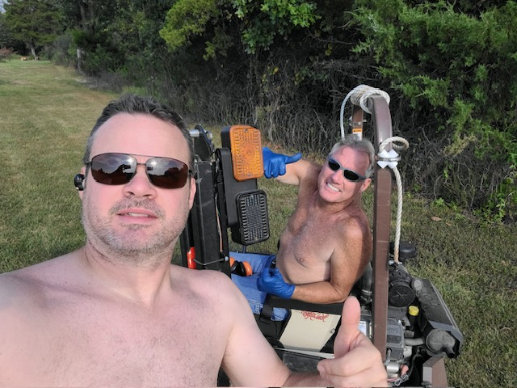
Captain Don fulfilled a long time dream of earning his Private Pilot Certificate on July 10 this year in that Classic Cessna C-172 you will view later.
Grace Applebaum

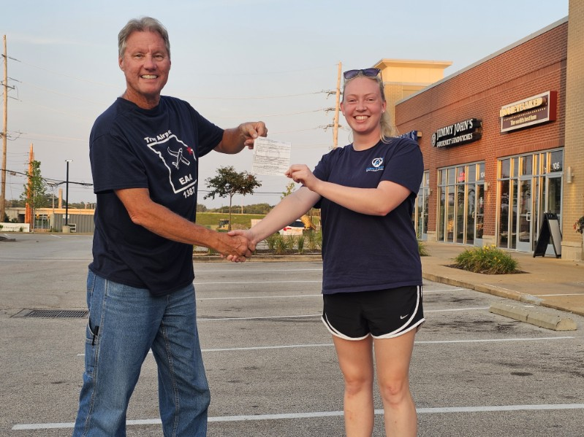
mr. bill and Lady Grace with her new Temporary Private Pilot Certificate

Brody Seth
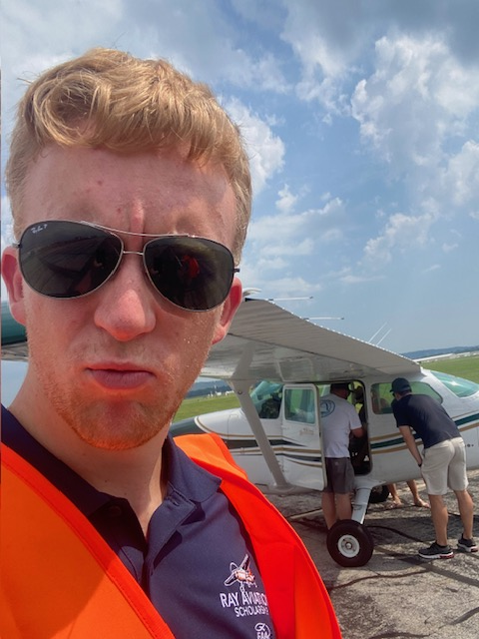
EAA 1387 RAY SCHOLAR Brody has soloed and is taking his Private Written soon

I know there is a lot of talk about today’s young people BUT, if you hang around the “Cool Kids” it makes you see that there are some really dedicated kids dealing with some difficult times.
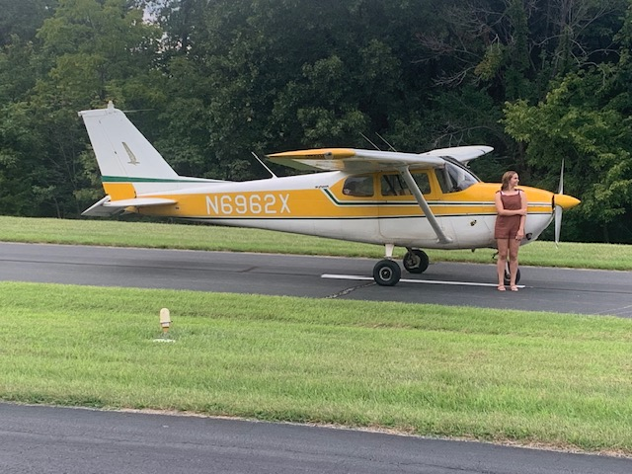
Ms. Anna taking here Senior pictures with Captain Catfishes’ Cessna C-172 airplane
Well gang, THANKS TO ALL OF YOU, FOR ALL THAT YOU DO, TO MAKE THIS CHAPTER AND AIRPARK A COOL PLACE TO LIVE AND HANG OUT AT!
So again, we will NOT have a September meeting for EAA 1387 due to the long holiday weekend.
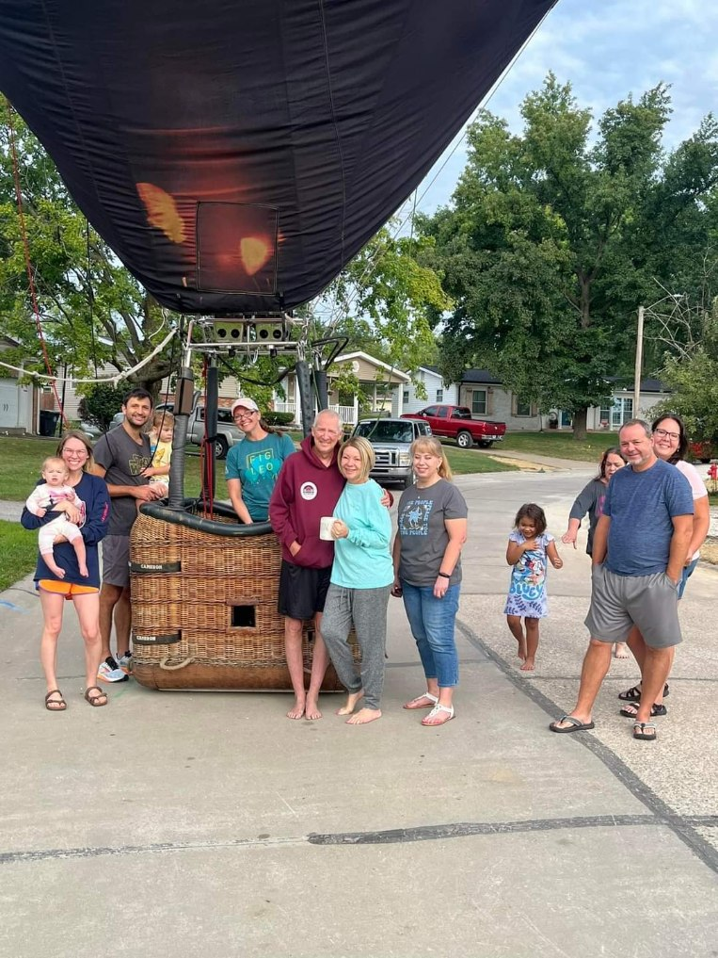
One last photo of “WHAT you do when you land a balloon in the neighbor cul-de-sac???”
Bring out the neighbors and take a photo!

So again, we will NOT have a September meeting for EAA 1387 due to this long holiday weekend. BUT….

I would like to have a “End of the Summer Bonfire” Social at the airpark. Maybe call it OCTOBERFEST???

BE SAFE OUT THERE! With this summer’s heat there have been MANY Density Altitude problems. Also, MANY, “I FLEW THE AIRPLANE INTO THE CLOUDS WITH MY AUTO-PLIOT BUT NOW THAT IT GOT INTO TURBULENCE, THE AUTO-PILOT KICKED OFF
AND I DO NOT HAVE THE SKILLS TO HAND FLY THIS MACHINE!”

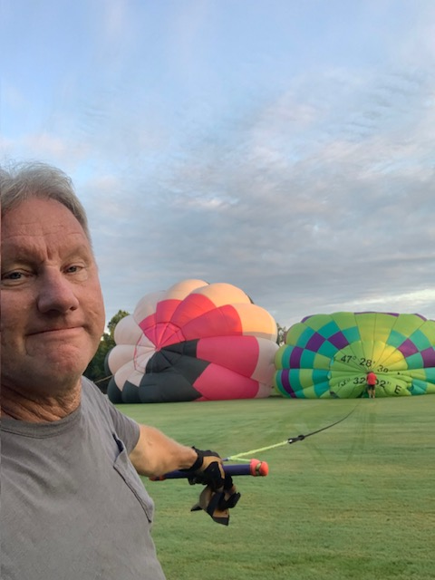
Working the balloon Crownline
One last photo of two balloons…well, I am not sure what these two balloons were doing. So I had to look away. Maybe making a little balloon?

