Purchase Your EAA AirVenture Oshkosh 2023 Tickets

July 24 - 30, 2023
Getting your EAA AirVenture Oshkosh 2023 tickets, parking, camping, and more is fast and easy! With a few simple steps, you'll be inside the gates in no time and ready to take in AirVenture. You'll simply select weekly or daily tickets, select optional add-ons like parking, camping, and flight experiences, and pay by credit card using our secure online system.

What's Included With Admission
- Access to all showplane parking areas, including homebuilts, vintage, aerobatic, warbirds, ultralights, lightplanes, rotorcraft, and seaplanes.
- AirVenture forums and workshops with no reservations required.
- A variety of evening programs, including nightly movies at the Fly-In Theater and programming at the Theater in the Woods.
- A variety of air show activities, including daily afternoon air shows and showcase flights, the Wednesday and Saturday night air shows, and Twilight Flight Fest.
- EAA membership information and merchandise areas.
- More than 1 million square feet of commercial exhibits, displays, and information from 800+ exhibitors.
- All AirVenture speaker venues, including Museum Speaker Showcase, Authors Corner, Warbirds in Review, and more.
- EAA Aviation Museum admission during the event.
- KidVenture located behind the museum at Pioneer Airport.

Methods of Payment
- Cash, personal checks, and traveler’s checks are accepted.
- Accepted credit cards: MasterCard, Visa, American Express, and Discover.
- ATMs are available on the grounds.
Please note: To access the Member Store, membership must be current through July 30, 2023, or your membership must be on auto-renew.
Please click the renew or join link and allow 2-3 minutes for processing before purchasing your tickets at member rates. For the best experience, log into your EAA.org account before clicking the "Member Store" button.

Reminder:
Welcome to Monday night popcorn at 7pm in our EAA Chapter 132 hanger 57 at the Elkhart airport.
Saturday morning breakfasts from 8-9am at the our EAA Chapter 132 Clubhouse.

------------------------------------------------------------------------------------------------------------------------------------------

Jan 26, 2023 Membership Meeting 7 - 8:30 pm

Phil gave us a briefing on the Jan 12, 2023 Board Meeting info made by secretary Marty.

Jerry was given several membership renewal funds for 2023.

Andy Jones and Scott Duck gave us great info on the Formation Flight School May 18 & 19, the USO party and the WWII re-enactment and airshows May 20 & 21. Phil let them know that we will take care of the breakfast and lunch for WWII re-enactment / airshow event.

Andy was also hoping EKM could have a Ride In, Fly In & Drive In on June 10, 2023. EAA will have to change the Young Eagle June 10 date due to this unless the RFD date is changed.

Tim F gave the Flight Sim presentation.

Jeremy Quick was re-elected as one of our chapter directors for 2023/2024. Tim Farrell was elected as another chapter director for 2023/2024 as well as continuing to also be the chapter communicator.

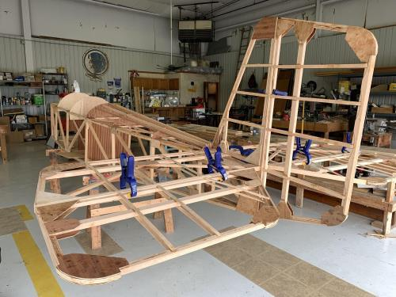

See Jim’s Experimental Aircraft Pietenpol project every Monday evening at 7pm at the EAA 57 hanger at the Elkhart Municipal Airport. He and Steve is adding elevator and rudder to their Pietenpol project. Have popcorn and meet with other
EAA Chapter 132 members too!

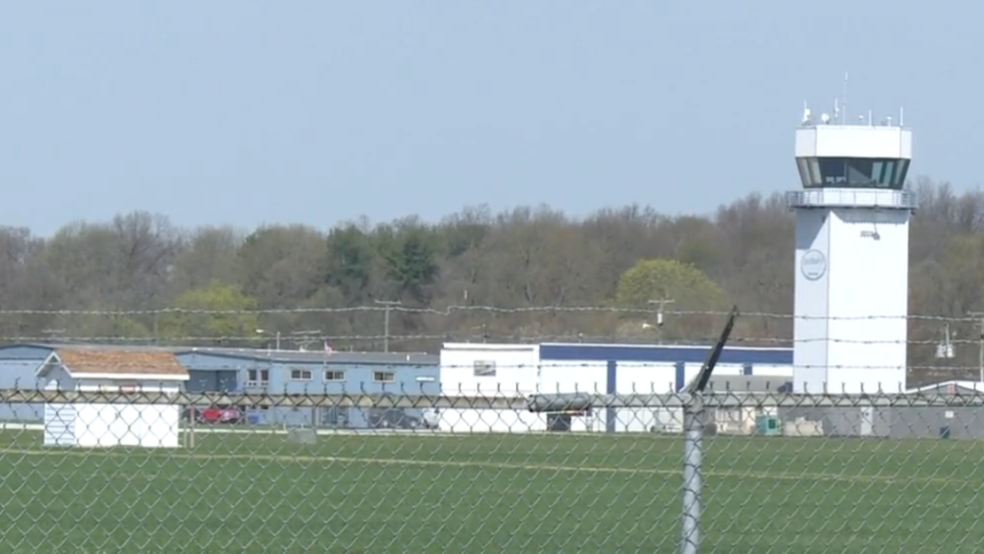

Jan. 12, 2023 Board Meeting 7:05-7:40pm

Secretary Marty was in charge of the Board Meeting.
Jerry gave us the financial rundown of 2022. All chapter paperwork including insurance has been paid.
We missed October of 2022 for board members Jeremy Quick and Dave O’Conner terms ended in 2022. Jeremy volunteered for re-election for 2023/2024. We need one other member as well.
There was a briefing on the Formation Flight School Thursday & Friday May 18 & 19 this year. Elkhart Municipal Airport hosting WWII re-enactment and full airshow May 20 & 21 this year as well. Andy Johns and Scott Duck will brief us at the membership meeting on these.
Our Young Eagle is Sat June 10th.
F4 presentation may not be available. Tim F may do Flight Sim presentation in place.
Membership renewal is requested as soon as possible early in 2023.

