

December 5 – Christmas Dinner 6:00 PM

@ admin hanger



**At 6:30 PM - Parmesan Crusted Chicken Breast or Baked Ham for your main entrée.**

**All will include a tossed salad, dinner roll, and roasted Italian blend vegetables.**

**Food will be individually packaged. The Chapter will provide drinks and a dessert.**

**50/50 Raffle**

**Silent Auction**

**Our Emcee for the evening will be the world-renowned Dave O’Connor**

FYI - It was decided to charge $25.00 per person and payment (and choice of chicken or ham) will be able to be made via either a web site or checks mailed directly to Tim Farrell 28630 Golden Pond Trail Elkhart, IN 46514. MONEY (and entrée choice) MUST be received no later than December 1, 2020. I’m hoping to have a page available this weekend on our EAA Chapter 132 website for payment.

Steve is in charge of the 50/50 drawing and silent auction. Due to space limitations this year, we are keeping the silent auction down to a few items. If you have something you would like to include, you will need to contact Steve (574-264-7320 or 574-596-4051) ahead of time.

Masks required.





**FLY-IN BREAKFAST @ MERK’S FAMILY DINING**

**Muncie Delaware County Regional Airport (KMIE)**

**Saturday Morning November 21, 2020**

**Try to arrive KMIE for breakfast at 9:00 AM**

92 NM from KEKM (Elkhart Municipal)

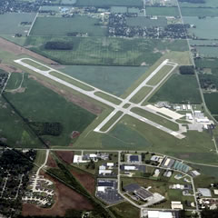



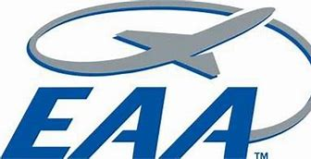

**JOIN EAA CHAPTER RECOGNITION PROGRAM**

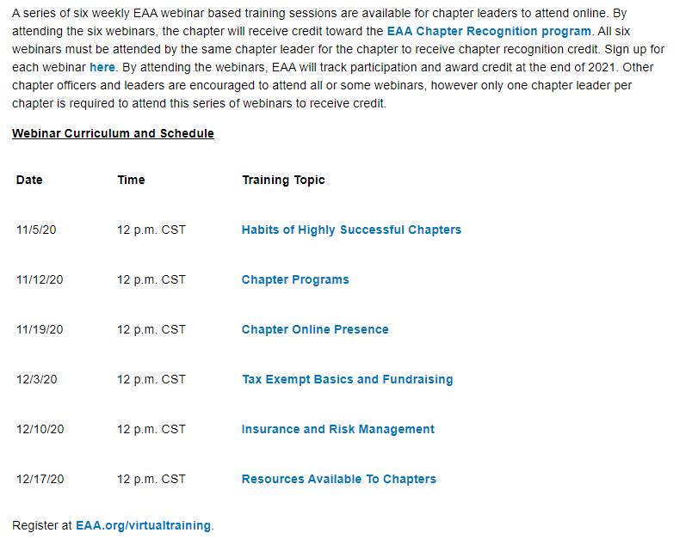

**Membership Meeting October 29, 2020 7:02 pm to 8:35 pm**

17 members and guests present / held in the Elkhart Airport Admin Hanger

Doug started the meeting by stating the donated Mini-Max has been sold for $5,000.00

Brian gave a prayer.

Arden announced he and his partner had purchased a Citabria, originally from Alaska.

Unfortunately, it ground looped on the trip to Elkhart in high winds and the landing gear was damaged. It is currently being repaired.

Doug announced that the Chapter Christmas party will be held December 5 in the Admin Hanger. The party will be held with social distancing, facemasks and individually portioned meals. No buffet this year. Cost will be $25.00 per person. 50/50 and silent auction will still take place and donated items for the auction are needed (See Steve).

A video was shown for the Lifeline Pilots volunteer organization.

Pilots volunteer their aircraft to get (mostly children) to and from medical facilities.

More information can be found at: LifelinePilots.org

“Who’s smarter than a rusty old pilot” was played by Jeremy, Brandon and Ryan.

All three did well but in the end Brandon won. The prize was a “job well done” and an elbow bump.

On November 7, 2020 the Prop Blast Café will be open and a group flight up is being planned.

Bill W gave a presentation on the history, use and science behind LORAN. A unit was donated to the Chapter by the widow of Keith Wishmeier and will be available to anyone to play with.

Two board members at large need to be filled for 2021-2022. Doug nominated Dave O’Conner and Jeremy Quick. There were no other nominations made and a quick hand vote was made (to the affirmative).

Jim and Doug both spoke about Keith Wishmeier, a pilot and EAA member who had recently passed away (from cancer).

Our program for the evening was made by Tim Skokol via the internet.

Tim is the FAASTeam Program Manager and is an A&P with 34+ years of experience.

Tim gave an in-depth presentation on Maintenance & Inspection Best Practices.

Very good information that every aircraft owner should know.

The 50/50 drawing was won by Doug.

# AirVenture 2021 Tickets Available Now

# Buy Your 2021 EAA AirVenture Oshkosh Tickets

Purchase your EAA AirVenture Oshkosh admissions, camping, parking, flight experiences, and merchandise in advance.

**It's fast and easy!** With a few simple steps, you'll be inside the gates in no time and ready to take in AirVenture. You'll simply select weekly or daily tickets, enter the number of tickets you'll need for each category, pay by credit card using our secure online system, print your bar-coded ticket(s), present your ticket at any entry point to receive your AirVenture wristband, and breeze through the lines. If you purchased tickets at the preferred EAA member rate, please be prepared to provide proof of membership when you have your e-ticket scanned at the gate.

AirVenture 2021 dates: Monday, July 26-Sunday, August 1. You may purchase a daily ticket for any of the seven days, or a weekly pass, which includes all seven days.

Note: If your EAA membership is not current, please [**click here to renew**](https://www.eaa.org/eaa/renew-eaa/renew-membership), and allow 48 hours for processing before purchasing your tickets at member rates.

## Early bird discounted pricing ends June 15, 2021.

**NEW THIS YEAR! Free youth admission ages 18 and under has been generously supported in part by:** Boeing

For more information on ticket purchasing, visit

<https://www.eaa.org/airventure/eaa-airventure-tickets>

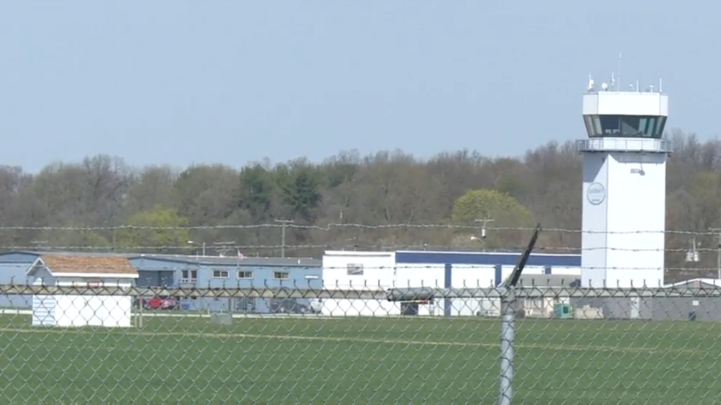

Board Meeting November 12, 2020 7:00 pm to 8:16 pm

Jerry, Doug, Steve, Jim, Tim F, Michelle / Bill, Dave O’ via zoom

2021 Calendars are available at the Chapterhouse for $8.00 each.

The Mini-Max donated from John Horvath’s estate has sold (money received) for $5,000.00.

This was an incredible gift from John and Marilyn and the funds will be used to keep Chapter 132 going for years to come.

Jim asked about the procedure used for determining the value and consequent sale.

Doug stated that at the July (2020) meeting he had informed the membership that 132 would be receiving the Mini-Max and asked for input on how it should be handled (keep/work on/sell) and the only feedback he received was to sell it. Based on this he had Dave Cooper (from Team Mini-Max) assess the project and give his opinion on the condition/value ($6,500). Doug then put the project up for sale. An offer of $5,000 was made. Doug then informed the Board and received an affirmative vote from several of the Board members. The project was sold to the President (John Fearnow) of the EAA Chapter located in Frankfort, IN. Although John personally purchased and owns the project his intent is to finish as a Chapter project. He plans on holding a fly-in at some point and would like our Chapter to attend to see it fly.

Our Chapter Christmas party is still a GO!

We have two meal quotes. One from Callahan’s and one from Mario’s Catering.

Although Callahan’s has provided a good meal in the past we decided to go with Mario’s as we know they also have excellent food and it is something a little different.

The party will be held in the Elkhart Administration Hanger (same as years past).

Masks will be required while not eating/drinking and physical distancing will be in place (i.e. fewer chairs at each table). Also, no buffet style meal. Food will be individually packaged.

The menu is as follows:

Your choice of either Parmesan Crusted Chicken Breast or Baked Ham for your main entrée.

All will include a tossed salad, dinner roll, and roasted Italian blend vegetables.

The Chapter will provide drinks and a dessert.

It was decided to charge $25.00 per person and payment (and choice of chicken or ham) will be able to be made via either a web site or checks mailed directly to Tim Farrell. Tim will communicate this information to the members. MONEY (and entrée choice) MUST be received no later than December 1, 2020 as Mario’s will need December 2.

Steve is in charge of the 50/50 drawing and silent auction. Due to space limitations this year, we are keeping the silent auction down to a few items. If you have something you would like to include, you will need to contact Steve (574-264-7320 or 574-596-4051) ahead of time.

Doug will take care of setting up and decorations (ok, really will be Doug’s family) but he of course can use any additional help.

Jim and Cindy will be your drink (aka bartenders) servers.

And our Emcee for the evening will be the world-renowned Dave O’Connor.

It was brought up that the Chapterhouse is in need of fixing/replacing the two entrance doors. We believe at least one, if not both are of a non-standard size. Under “go big or go home” we all were dreaming of simply building a new Chapterhouse which would of course take care of the door fix.

Steve brought up the fact that much of our kitchen equipment and utensils are old/worn/nasty/ plastic and should be disposed of. After presenting Doug with his very own old food encrusted, plastic spatula it was decided that it might be a good idea. After the COVID goes away and we are able to start holding the Saturday morning breakfasts once again, we will purchase all new.

Saturday morning flights:

On November 3rd 22 met at the Prop Blast restaurant at the Coldwater airport.

The next Saturday morning flight is scheduled for November 21. Meet (fly) to Merks at Muncie.

Questions may be directed to either Doug or Tim F.

Jim’s self-proclaimed poor performance relating to the upkeep of the Chapter 132 web site has prompted him to step away from the Web Lackey position. Jim will be sending both Doug and Tim F the necessary credentials so that they can take over. The web site is provided for free from National EAA and is very good/complete. However, is does require a certain amount of skill and dedication of which Jim professes to be lacking.

