Aug 31, 2023 EAA Chapter Membership Meeting No Meeting
Our August membership meeting was Sunday August 20th 1pm at Duck’s Fly In / Drive In Lunch and Airshow Event. Everything was awesome there. The food was great. The planes there were awesome. Four of the Oshkosh award planes were there. The three airshow planes did a great job. The only issue that day was the parachute lady hit the ground hard when landing with an injury. She was great in the air with the U.S. flag.

Email/Facebook Problem:
Tim F is having an issue with our EAA Chapter 132 gmail email account. His part of the account has been deleted two or three times in the last 6 months from his access. He was able to fix until this June thinking the gmail account has been hacked by someone or made more unstable by more securities gmail is using. Over 6 months ago, he was hacked on the EAA Chapter 132 facebook account as well and unable for him to use our facebook account. He can still do our EAA vortex and send it to our EAA Chapter 132 website. He just can’t send email to all anymore. If another member is good at the gmail account and can seed emails that would be great. Tim was unable to let our members know about the Duck’s Fly In / Drive In info a few days before the event.

Other EAA Chapter Events Info:

August 19th Private Young Eagles Event for Boy Scouts was cancelled.

September 9th Saturday at 8am will be our first EAA Chapter Saturday Breakfast since later in May.
Hope to see you there.

Our September 28th membership meeting will be at the IFC hanger with Matt Bransen as the presentation.

September 30th looks to be our other big EAA Chapter Young Eagles Event this year.

Dick will do a presentation on our Oct membership meeting.

No November membership meeting due to Thanksgiving.

Dec 2nd will probably be our day (night) for our EAA Chapter Christmas Party Event.

No Dec EAA Chapter membership meeting at the end of Dec due to Christmas.

Still will have our board meetings in Nov and Dec.

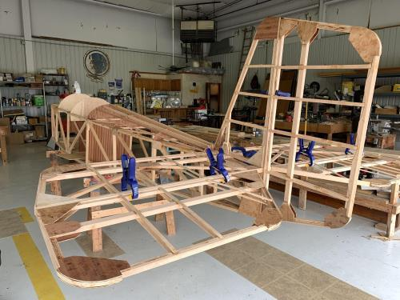

See Jim’s Experimental Aircraft Pietenpol project every Monday evening at 7pm at the EAA 57 hanger at the Elkhart Municipal Airport. He and Steve is adding elevator and rudder to their Pietenpol project. Have popcorn and meet with other
EAA Chapter 132 members too!

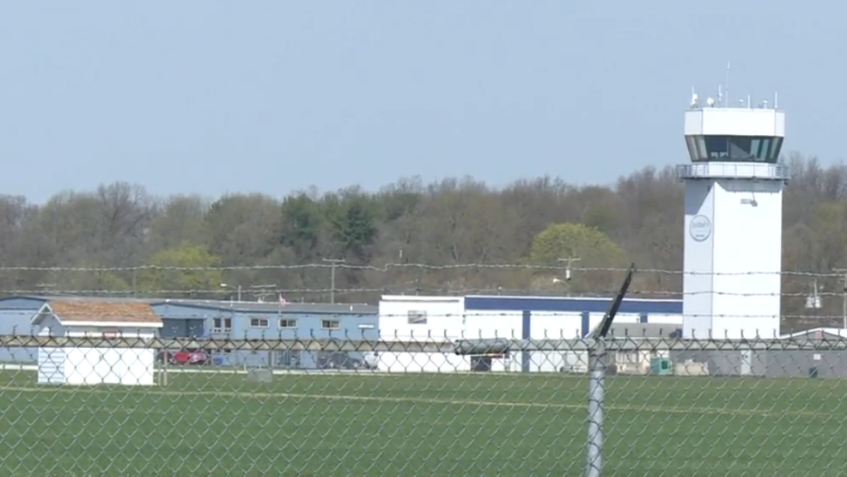

Aug 10, 2023 Board Meeting 7:00-7:45pm
Phil, Marty, Tim, Ted, Ryan, Dick & Don
Phil was in charge of the Board Meeting.
Saturday August 19th Private Young Eagles Event for Boy Scouts
Sunday August 20th Duck’s Fly In / Drive In Lunch at 1pm
Elkhart Airport is going to do an RC jets airshow in 2024. Will do another WWII Re-Enactment in 2025.
Dick will do a presentation on our Oct Membership Meeting
Dec 2nd might be the day of our EAA chapter Christmas Party.
We need a new popcorn and coffee machines because our current ones are not working good or at all.
We may be helping in a STEM in Aviation that should start around September at the Mishawaka Pilot Club airport.
Membership renewal is requested as soon as possible early in each year.

