Sept 28, 2023 EAA Chapter Membership Meeting 7:00-8:30 PM
Marty did a great presentation on the FAA VARMA and the AVGAS issue that will eventually get rid of 100LL at most airports including Elkhart Municipal.

There is a Sonex airplane project available for a cost of about $450 for our EAA chapter.

Our coffee machine was replaced is new and is working good. The popcorn machine still needs to be replaced.

Other EAA Chapter Events Info:

Our EAA Chapter Saturday Breakfast needs cookers signed up. We have only had 8 members or less since Sept 9th at the breakfast’s.

Our membership meeting will be at the IFC hanger with Matt Bransen as the presentation has been changes to possibly Nov 9th.

Monday Oct 16th and 23rd looks to be our other private EAA Chapter Young Eagles Event this year for the Boy Scouts at IFC..

Dick and Don will do a presentation on our Oct membership meeting.

No November membership meeting due to Thanksgiving.

Dec 2nd will starting 6pm for our EAA Chapter Christmas Party Event at the Green Jacket 4 Lakes.

No Dec EAA Chapter membership meeting at the end of Dec due to Christmas.

Still will have our board meetings in Nov and Dec.

Email/Facebook Problem:
Phil has taken over the email account. Tim F is still able to do our vortex.

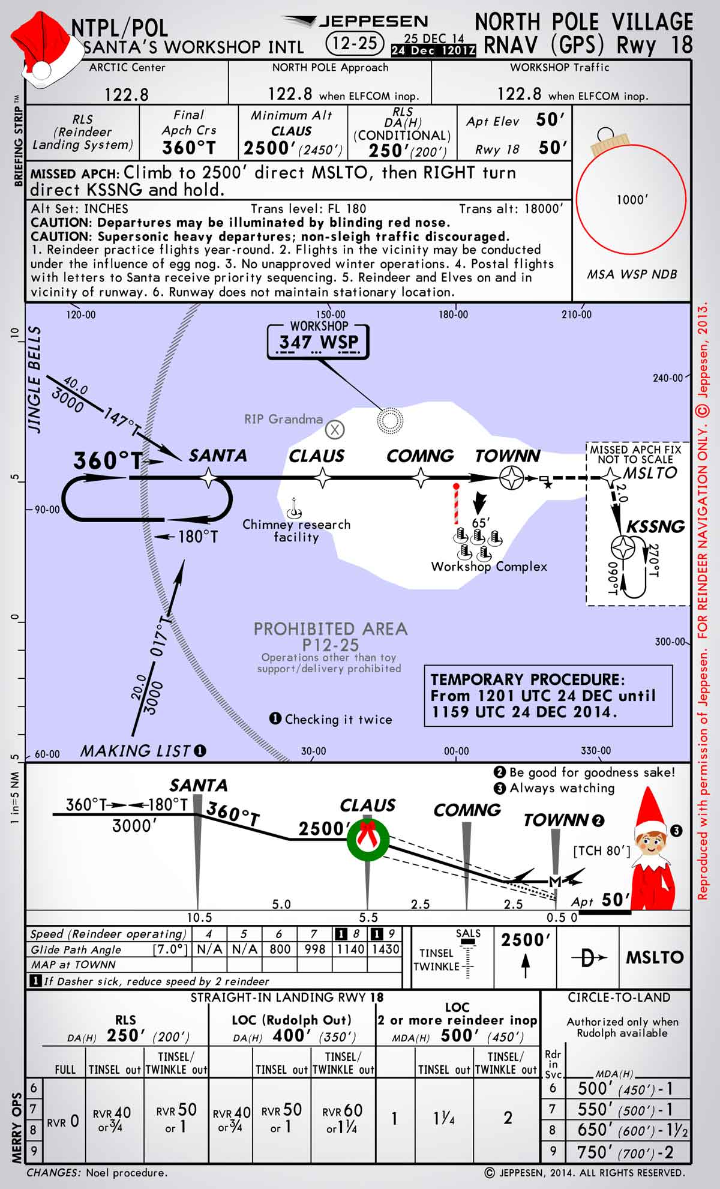
NIGHT BEFORE CHRISTMAS

Twas the night before Christmas, and out on the ramp,
Not an airplane was stirring, not even a Champ.
The aircraft were fastened to tiedowns with care,
In hopes that come morning, they all would be there.
The fuel trucks were nestled, all snug in their spots,
With gusts from two-forty at 39 knots.
I slumped at the fuel desk, now finally caught up,
And settled down comfortably, resting my butt.
When the radio lit up with noise and with chatter,
I turned up the scanner to see what was the matter.
A voice clearly heard over static and snow,
Called for clearance to land at the Elkhart airport below.
He barked his transmission so lively and quick,
I’d have sworn that the call sign he used was “St. Nick”.
I ran to the panel to turn up the lights,
The better to welcome this magical flight.
He called his RNAV runway 27 position, no room for denial,
“St. Nicholas One, turnin’ left onto runway 27 final.”
And what to my wondering eyes should appear,
But a EAA 132-built sleigh, with eight Rotax Reindeer!
With RNAV to final, down the glideslope he came,
As he passed all fixes, he called them by name:
“Now Goshen! Now Dinye! Now Fediv and Cogne!
On Comet! On Cupid!” What pills was he takin’?
While controllers were sittin’, and scratchin’ their head,
They phoned to my office, and I heard it with dread,
The message they left was both urgent and dour:
“When Santa pulls in, have him please call the tower.”
He landed like silk, with the sled runners sparking,
Then I heard “Right at Bravo 3,” and “Taxi to parking.”
He slowed to a taxi, turned off of two seven
And stopped on the ramp with a “Ho, ho-ho-ho…”
He stepped out of the sleigh, but before he could talk,
I ran out to meet him with my best set of chocks.
His red helmet and goggles were covered with frost
And his beard was all blackened from Reindeer exhaust.
His breath smelled like peppermint, gone slightly stale,
And he puffed on a pipe, but he didn’t inhale.
His cheeks were all rosy and jiggled like jelly,
His boots were as black as a cropduster’s belly.
He was chubby and plump, in his suit of bright red,
And he asked me to “fill it, with hundred low-lead.”
He came dashing in from the snow-covered pump,
I knew he was anxious for drainin’ the sump.
I spoke not a word, but went straight to my work,
And I filled up the sleigh, but I spilled like a jerk.
He came out of the restroom, and sighed in relief,
Then he picked up a phone for a Flight Service brief.
And I thought as he silently scribed in his log,
These reindeer could land in an eighth-mile fog.
He completed his pre-flight, from the front to the rear,
Then he put on his headset, and I heard him yell, “Clear!”
And laying a finger on his push-to-talk,
He called up the tower for clearance and squawk.
“Take taxiway Bravo, the northbound direction,
Turn right three-two-zero at pilot’s discretion”
He sped down the runway, the best of the best,
“Your traffic’s a Mooney, inbound from the west.”
Then I heard him proclaim, as he climbed through the night,
“Merry Christmas to all! I have traffic in sight.”
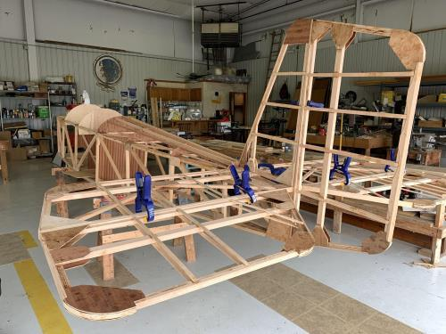

See Jim’s Experimental Aircraft Pietenpol project every Monday evening at 7pm at the EAA 57 hanger at the Elkhart Municipal Airport. He and Steve is adding elevator and rudder to their Pietenpol project. Have popcorn and meet with other
EAA Chapter 132 members too!

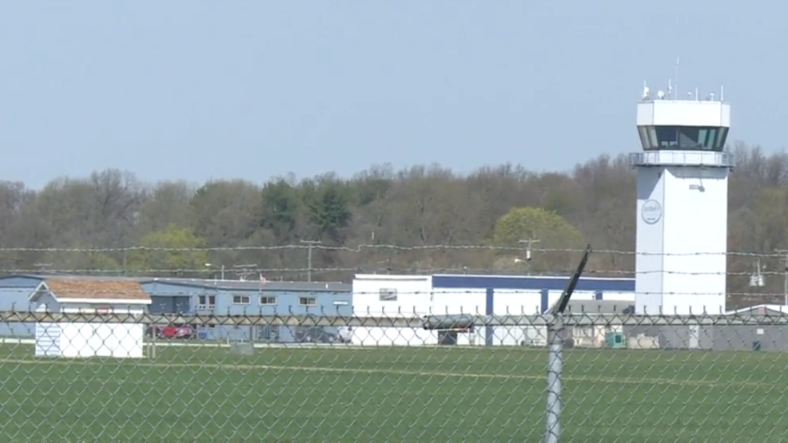

Sept 14, 2023 Board Meeting 7:00-7:45pm
Phil, Marty, Tim, Ryan, Dick, Jerry & Don
Phil was in charge of the Board Meeting.
Marty will have a presentation about AVGAS on our Sept 28, 2023 EAA Chapter 132 membership meeting.
Elkhart Airport is going to do an RC jets airshow in 2024. Will do another WWII Re-Enactment in 2025.
Dick and Don will do a presentation on our Oct Membership Meeting
Dec 2nd might be the day of our EAA chapter Christmas Party.
We need a new popcorn and coffee machines because our current ones are not working good or at all.
We may be helping in a STEM in Aviation that should start around September at the Mishawaka Pilot Club airport.
Membership renewal is requested as soon as possible early in each year.
Our chapter Director officers Steve and Don and other officers will be changed or renewed in our October membership meeting.

