Oct 26, 2023 EAA Chapter Membership Meeting 7:00-8:30 PM
Dick Wagner did a great presentation of the 2023 EAA Oshkosh that he attended. Videos of many great and different planes and the airshow. He also showed Don Duck was by his plane with three women singing songs next to him.

We also had a great attendance of our members at the meeting.

There is a Sonex airplane project available for a cost of about $450 for our EAA chapter.
There is also a STEM for school kids at a Mishawaka Pilots Club hanger that EAA Chapter 132 can help kids how to put planes together. Kids can then fly in these planes that are made if they helped put the plane together.

Our coffee machine was replaced is new and is working good. The popcorn machine is going to be replaced because it isn’t working.

Due to less coming to our Saturday 8am breakfast at the EAA Chapter 132 house, we have looked into just trying to do a second Saturday of each month to do a 9-11am breakfast not just for EAA Chapter members but also to attend any pilot flying/driving in from other airports like Goshen, Nappanee, Mishawaka Pilots Club and others.

Our EAA Chapter 132 Officers/Directors Ted, Jerry, and Steve and Don will be renewed by the following for 2024-2025:
Treasure: Mike Hurshburger
Vice President: Ryan Sherwood
Director: Wendy Knox
Director: Dick Wagner

Other EAA Chapter Events Info:

Our EAA Chapter 132 Saturday Breakfast needs cookers signed up. Our current 8am breakfast version may be changed to a second Saturday 9-11am only.

Our November board/membership meeting will be at the IFC hanger with Matt Bransen as the presentation has been changes to possibly Nov 9th.

No November 30th membership meeting due to Thanksgiving.

Dec 2nd will start at 6pm for our EAA Chapter Christmas Party Event at the Green Jacket 4 Lakes.
You can order/pay your own food you want.

No Dec EAA Chapter membership meeting at the end of Dec due to Christmas.

Still will have our board meetings in Dec.

Email/Facebook Problem:
Phil has taken over the email and Facebook account since Tim F has been hacked on both and can’t get on them again. Tim F is still able to do our vortex.

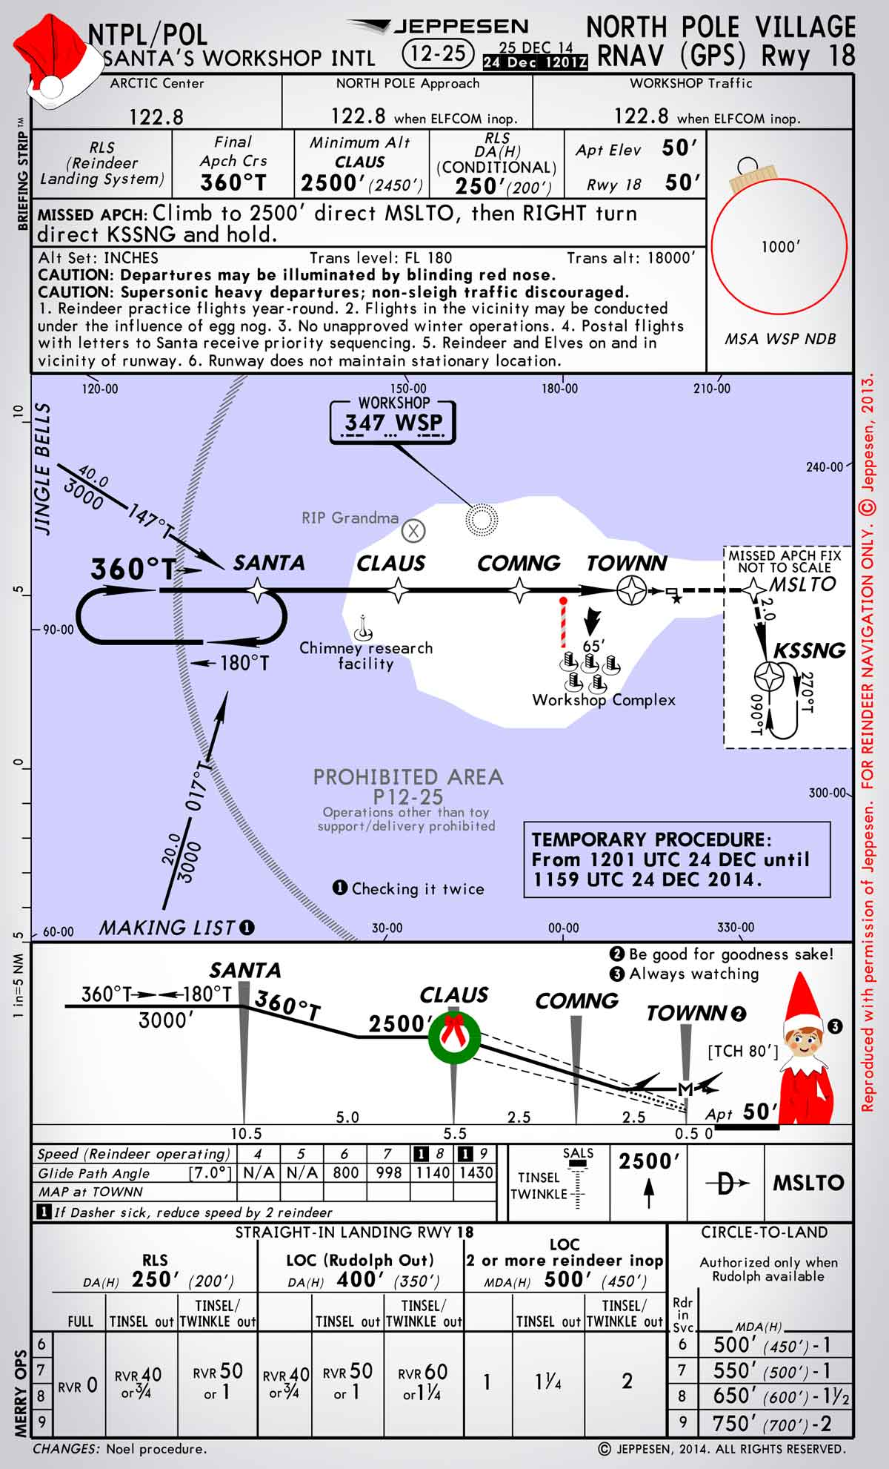
NIGHT BEFORE CHRISTMAS

Twas the night before Christmas, and out on the ramp,
Not an airplane was stirring, not even a Champ.
The aircraft were fastened to tiedowns with care,
In hopes that come morning, they all would be there.
The fuel trucks were nestled, all snug in their spots,
With gusts from two-forty at 39 knots.
I slumped at the fuel desk, now finally caught up,
And settled down comfortably, resting my butt.
When the radio lit up with noise and with chatter,
I turned up the scanner to see what was the matter.
A voice clearly heard over static and snow,
Called for clearance to land at the Elkhart airport below.
He barked his transmission so lively and quick,
I’d have sworn that the call sign he used was “St. Nick”.
I ran to the panel to turn up the lights,
The better to welcome this magical flight.
He called his RNAV runway 27 position, no room for denial,
“St. Nicholas One, turnin’ left onto runway 27 final.”
And what to my wondering eyes should appear,
But a EAA 132-built sleigh, with eight Rotax Reindeer!
With RNAV to final, down the glideslope he came,
As he passed all fixes, he called them by name:
“Now Goshen! Now Dinye! Now Fediv and Cogne!
On Comet! On Cupid!” What pills was he takin’?
While controllers were sittin’, and scratchin’ their head,
They phoned to my office, and I heard it with dread,
The message they left was both urgent and dour:
“When Santa pulls in, have him please call the tower.”
He landed like silk, with the sled runners sparking,
Then I heard “Right at Bravo 3,” and “Taxi to parking.”
He slowed to a taxi, turned off of two seven
And stopped on the ramp with a “Ho, ho-ho-ho…”
He stepped out of the sleigh, but before he could talk,
I ran out to meet him with my best set of chocks.
His red helmet and goggles were covered with frost
And his beard was all blackened from Reindeer exhaust.
His breath smelled like peppermint, gone slightly stale,
And he puffed on a pipe, but he didn’t inhale.
His cheeks were all rosy and jiggled like jelly,
His boots were as black as a cropduster’s belly.
He was chubby and plump, in his suit of bright red,
And he asked me to “fill it, with hundred low-lead.”
He came dashing in from the snow-covered pump,
I knew he was anxious for drainin’ the sump.
I spoke not a word, but went straight to my work,
And I filled up the sleigh, but I spilled like a jerk.
He came out of the restroom, and sighed in relief,
Then he picked up a phone for a Flight Service brief.
And I thought as he silently scribed in his log,
These reindeer could land in an eighth-mile fog.
He completed his pre-flight, from the front to the rear,
Then he put on his headset, and I heard him yell, “Clear!”
And laying a finger on his push-to-talk,
He called up the tower for clearance and squawk.
“Take taxiway Bravo, the northbound direction,
Turn right three-two-zero at pilot’s discretion”
He sped down the runway, the best of the best,
“Your traffic’s a Mooney, inbound from the west.”
Then I heard him proclaim, as he climbed through the night,
“Merry Christmas to all! I have traffic in sight.”
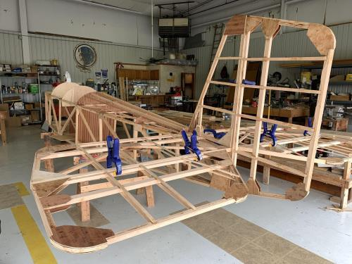

See Jim’s Experimental Aircraft Pietenpol project every Monday evening at 7pm at the EAA 57 hanger at the Elkhart Municipal Airport. He and Steve is adding elevator and rudder to their Pietenpol project. Have popcorn and meet with other
EAA Chapter 132 members too!

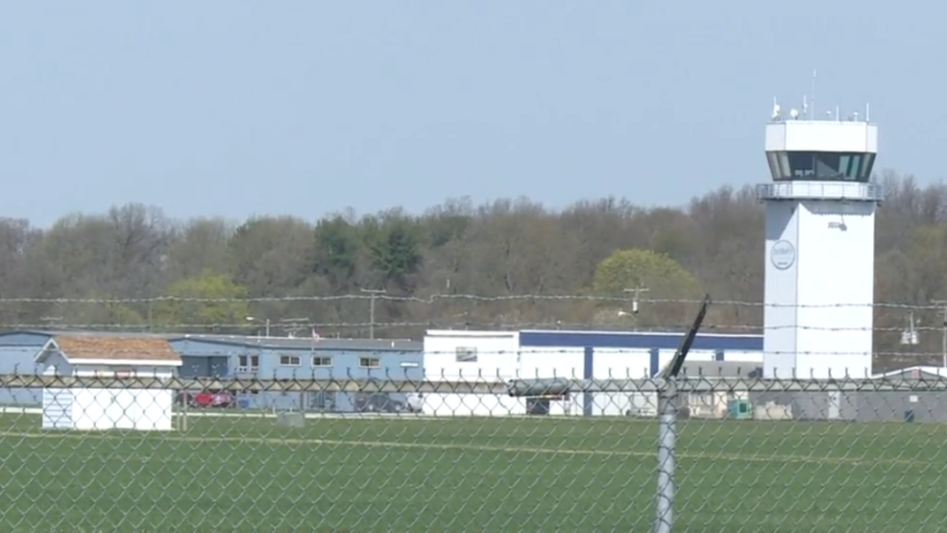

Oct 12, 2023 Board Meeting 7:00-7:45pm
Marty, Tim, Dick, Jerry & Don
Marty was in charge of the Board Meeting.
Elkhart Airport is going to do an RC jets airshow in 2024. Will do another WWII Re-Enactment in 2025.
Dick and Don will do a presentation on our Oct Membership Meeting
Dec 2nd might be the day of our EAA chapter Christmas Party.
We need a new popcorn machine because our current one are not working good or at all.
We may be helping in a STEM in Aviation that should start around September at the Mishawaka Pilot Club airport.
Membership renewal is requested as soon as possible early in each year.
Our chapter Director officers Steve and Don and other officers will be changed or renewed in our October membership meeting for 2024 -2025.

