Purchase Your EAA AirVenture Oshkosh 2023 Tickets

July 24 - 30, 2023
Getting your EAA AirVenture Oshkosh 2023 tickets, parking, camping, and more is fast and easy! With a few simple steps, you'll be inside the gates in no time and ready to take in AirVenture. You'll simply select weekly or daily tickets, select optional add-ons like parking, camping, and flight experiences, and pay by credit card using our secure online system.

What's Included With Admission
- Access to all showplane parking areas, including homebuilts, vintage, aerobatic, warbirds, ultralights, lightplanes, rotorcraft, and seaplanes.
- AirVenture forums and workshops with no reservations required.
- A variety of evening programs, including nightly movies at the Fly-In Theater and programming at the Theater in the Woods.
- A variety of air show activities, including daily afternoon air shows and showcase flights, the Wednesday and Saturday night air shows, and Twilight Flight Fest.
- EAA membership information and merchandise areas.
- More than 1 million square feet of commercial exhibits, displays, and information from 800+ exhibitors.
- All AirVenture speaker venues, including Museum Speaker Showcase, Authors Corner, Warbirds in Review, and more.
- EAA Aviation Museum admission during the event.
- KidVenture located behind the museum at Pioneer Airport.

Methods of Payment
- Cash, personal checks, and traveler’s checks are accepted.
- Accepted credit cards: MasterCard, Visa, American Express, and Discover.
- ATMs are available on the grounds.
Please note: To access the Member Store, membership must be current through July 30, 2023, or your membership must be on auto-renew.
Please click the renew or join link and allow 2-3 minutes for processing before purchasing your tickets at member rates. For the best experience, log into your EAA.org account before clicking the "Member Store" button.

Reminder:
Welcome to Monday night popcorn at 7pm in our EAA Chapter 132 hanger 57 at the Elkhart airport.
Saturday morning breakfasts from 8-9am at the our EAA Chapter 132 Clubhouse.

------------------------------------------------------------------------------------------------------------------------------------------

Feb 23, 2023 Membership Meeting 7 - 8:30 pm

Secretary Marty King gave us a briefing on the Feb 9, 2023 Board Meeting info.
We will need volunteers to serve breakfast/lunch on May 20th & 21st for the re-enactment members.
Jeremy was re-elected as a board director and Tim was elected as a board director and communicator. Andy was also hoping EKM could have a Ride In, Fly In & Drive In on June 10, 2023. Nothing has been heard of yet. Our EAA chapter will have to change the Young Eagle June 10 date due to this unless the RFD date is changed.

Unfortunately, Phil has let us know that Oshkosh doesn’t want work party group any more.

Steve was wanting one of our members to be in charge of getting food for our Saturday breakfast.
We also need cookers to assign for the Saturday breakfast until later in May.

Brandon Herzog told us about his journey from being a charter pilot to becoming a 1st officer pilot at American Airlines in the B737 Max 8 and B737 NG and maybe becoming a captain sometime soon.

Had a good crowd of EAA members and friends at the membership meeting.

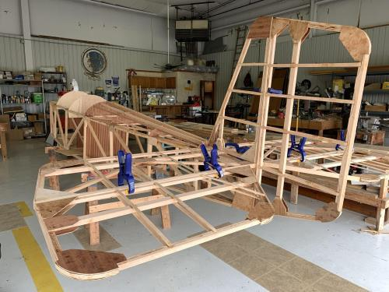

See Jim’s Experimental Aircraft Pietenpol project every Monday evening at 7pm at the EAA 57 hanger at the Elkhart Municipal Airport. He and Steve is adding elevator and rudder to their Pietenpol project. Have popcorn and meet with other
EAA Chapter 132 members too!

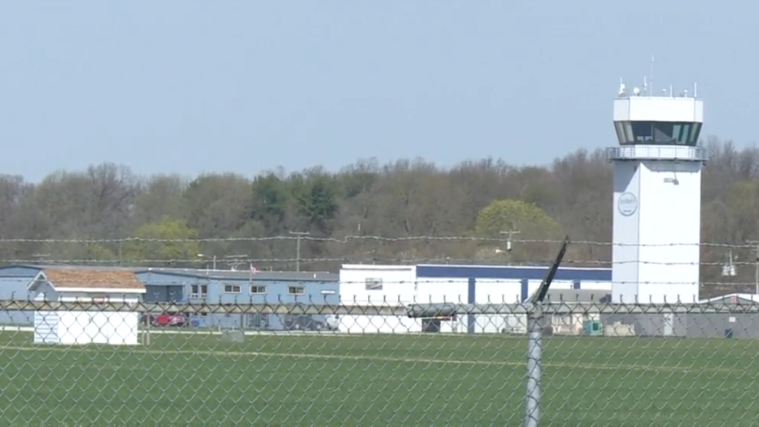

Feb. 9, 2023 Board Meeting 7:05-7:28pm
Phil, Dick, Don, Jeremy, Tim, Marty, Jerry & Steve
Secretary Marty was in charge of the Board Meeting.
Jeremy Quick and Tim Farrell became the directors for 2023/2024. Steve and Don are still directors for 2023 as well.
There was a briefing on the Formation Flight School Thursday & Friday May 18 & 19 this year. Elkhart Municipal Airport hosting WWII re-enactment and full airshow May 20 & 21 this year as well.
Our Young Eagle is Sat June 10th unless Andy wants EKM to have the RDF-IN on the same date.
Brandon Herzog will do a presentation on his journey as a charter pilot to becoming an American Airline 1st officer pilot.
Membership renewal is requested as soon as possible early in 2023.

