Reminder:
Welcome to Monday night popcorn at 7pm in our EAA Chapter hanger.
Saturday morning breakfast will start again the Saturday after Labor Day Weekend
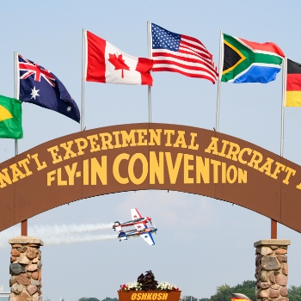
Get Your AirVenture 2022 Tickets
It's never too early to start planning for your favorite week of the year! Early bird pricing is in effect until June 15, 2022.
Read More

American Freedom Fest
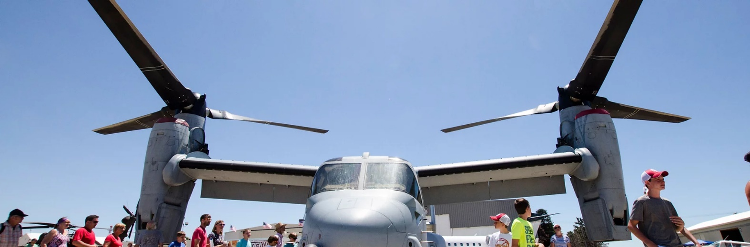
July 9, 2022 at Goshen Municipal Airport

ADMISSION

GATE (cash only)
Adult (13 and over): $20
Child (ages 6-12): $10
Children 5 and under: Free
Veterans with valid Military ID: Free

ADVANCE TICKETS
Adult (13 and over): $15
Child (ages 6-12): $8
PARKING
​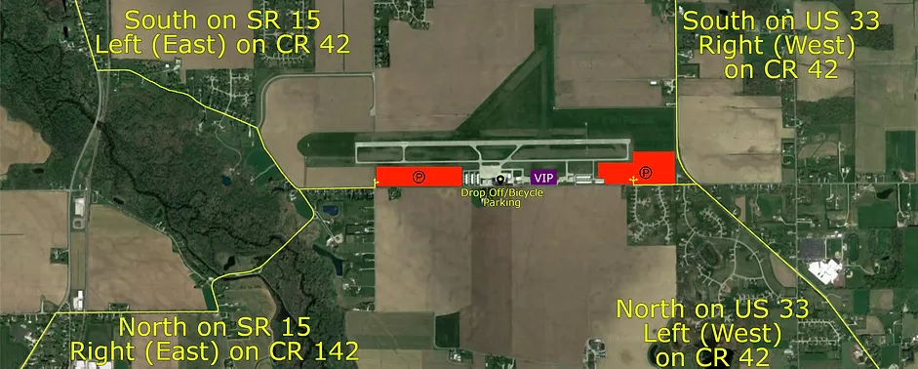

Friday Fly-In Lunches Start April 1st 11:30am to 1:00pm
Donations recommended

Goshen Airport (KGSH) will have every 1st Friday lunch from April to December
Smith Field Airport (KSMD) will have every 2nd Friday lunch from April to October
Elkhart Airport (KEKM) will have every 3rd Friday lunch from April to October at the Indiana Flight Center old passenger terminal.
La Porte Airport (KPPO) will have every 4th Friday lunch from April to October
Fulton Co Airport (KRCR) will have any 5th Friday lunch from April to October.

-------------------------------------------------------------------------------------------------------------------------

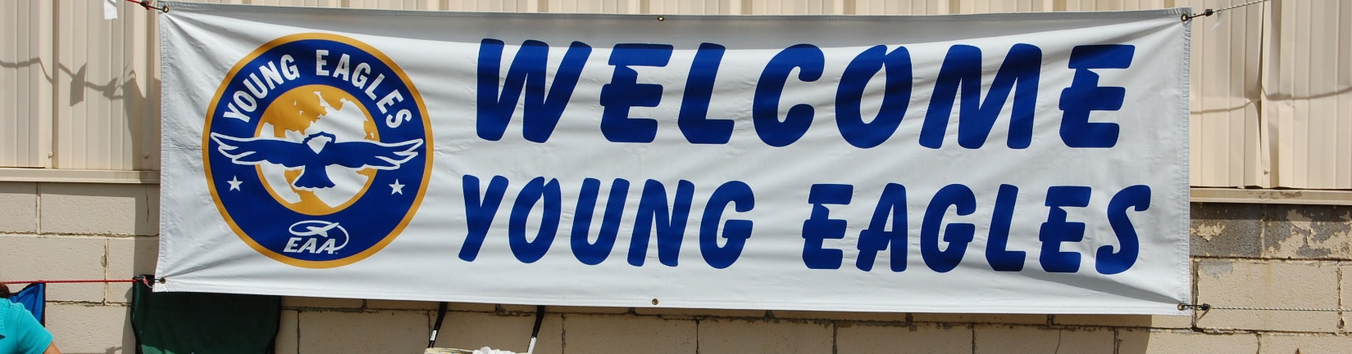
Elkhart, IN 2022 Spring Event
EAA Chapter 132 at Elkhart Municipal Airport
Saturday May 21, 2022 @ 9:00am – 12:00pm
Contact: Ryan Sherwood – (574) 370-2279

Reminder: Pilots and Young helpers will need to have there 3 year Child Protection renewed at https://youngeaglesday.org/

June 30, 2022 EAA Chapter 132 Membership Meeting at 7 – 7:49 pm

President Phil opened the meeting.
Board Meeting minutes were not read due to Marty not feeling well and unable to be at the meeting.

Phil let us know that the Freedom Fest application was not easy. He had to get with another person for this and things given to us for where we will be at the Goshen airport got changed.
Wendy has got some Red, White & Blue ice cream sticks for 21 cents each that we can sell for $2 as she suggested. She also got some small glider planes for kids we can also sell for $2 each. She is also going to see about other ice cream items as well. Shirts will be made for this with the sizes needed for members at the event that have been issued. It appears we will have a descent amout of members helping with the ice cream, water, Young Eagles and EAA membership applications.
July 9th Freedom Fest Airshow: Friday night setup is possible on the 8th.
Chapter Banner: Ryan will retrieve it from the Admin hanger.

Phil says they had a pretty good time on the Kite Flying. However, some wind got stronger making his Kite get damaged and almost lifting some of the kite flyers off the ground.

Other interest: Wendy arranged for Phil in a P-51 Gunfighter at the upcoming Fort Wayne flyin on the July 4th.

Note: Jerry H leaves for Oshkosh July 3rd so monies need to be transferred prior to the 9th.

Tim had issues with pictures for his TV to do program about Alaska Vacation & Aviation.
Maybe can due it next member meeting.

50/50 raffle $15 was won by Phil

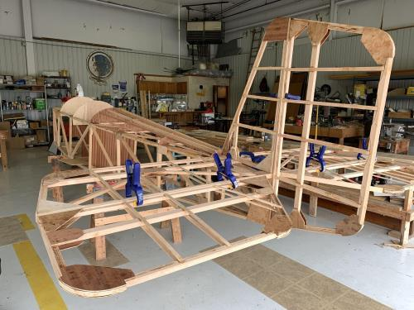

See Jim B & Steve L’s Experimental Aircraft Pietenpol project every Monday evening at 7pm at the EAA 57 hanger at the Elkhart Municipal Airport. They just added landing gear to their Pietenpol project. Have popcorn and meet with other
EAA Chapter 132 members too!

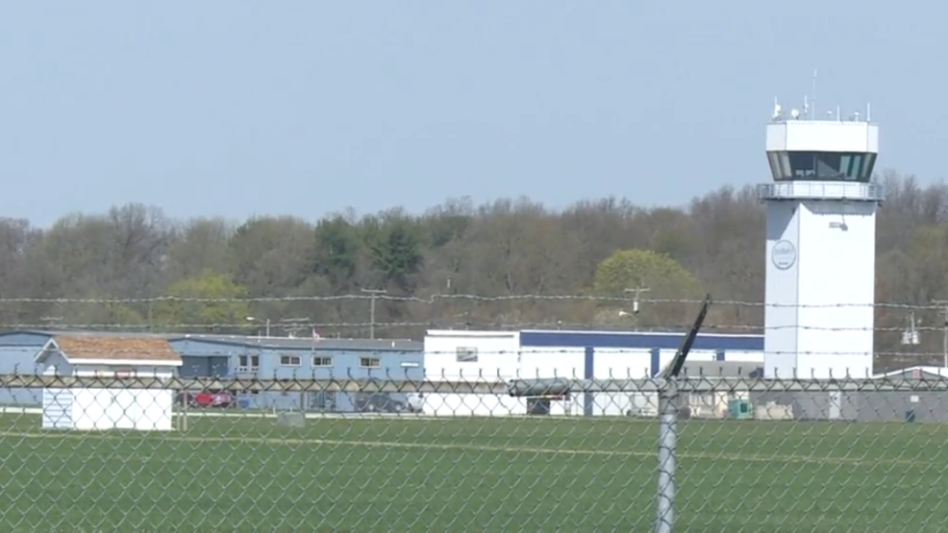

May 26, 2022 Board Meeting 7-7:50pm
15 present
President Phil opened the meeting.
Board meeting minutes were read.
Jerry reported we have 3K in checking. 13K in the Linton Saving account and $3965.00 in the chapter savings. Steve said there is about $400 in food services cash.
Phil is having the Kite fly at his house on June 11th at his farm. Hamburgers/Hotdogs will be available. Needs directions to get there to his place.
July 9th Freedom Fest Airshow: Friday night setup is possible on the 8th.
Wendy is checking prices at Gordon’s for Ice Cream sandwiches, etc.
S& H carbonic was suggested as a source for dry ice.
Shirt size need to get to Wendy. There will be an email to members.
Chapter Banner: Ryan will retrieve it from the Admin hanger.
Other interest: Wendy arranged for Phil in a P-51 Gunfighter at the upcoming Fort Wayne flyin on the July 4th.

Note: Jerry H leaves for Oshkosh July 3rd so monies need to be transferred prior to the 9th.

There will be a meeting setup with Randy Gingrich when Tim returns from vacation on the number of airshow topics.

EAA Chapter 132 needs to fix ceiling panels in the clubhouse.

