Purchase Your EAA AirVenture Oshkosh 2023 Tickets

July 24 - 30, 2023
Getting your EAA AirVenture Oshkosh 2023 tickets, parking, camping, and more is fast and easy! With a few simple steps, you'll be inside the gates in no time and ready to take in AirVenture. You'll simply select weekly or daily tickets, select optional add-ons like parking, camping, and flight experiences, and pay by credit card using our secure online system.

What's Included With Admission
- Access to all showplane parking areas, including homebuilts, vintage, aerobatic, warbirds, ultralights, lightplanes, rotorcraft, and seaplanes.
- AirVenture forums and workshops with no reservations required.
- A variety of evening programs, including nightly movies at the Fly-In Theater and programming at the Theater in the Woods.
- A variety of air show activities, including daily afternoon air shows and showcase flights, the Wednesday and Saturday night air shows, and Twilight Flight Fest.
- EAA membership information and merchandise areas.
- More than 1 million square feet of commercial exhibits, displays, and information from 800+ exhibitors.
- All AirVenture speaker venues, including Museum Speaker Showcase, Authors Corner, Warbirds in Review, and more.
- EAA Aviation Museum admission during the event.
- KidVenture located behind the museum at Pioneer Airport.

Methods of Payment
- Cash, personal checks, and traveler’s checks are accepted.
- Accepted credit cards: MasterCard, Visa, American Express, and Discover.
- ATMs are available on the grounds.
Please note: To access the Member Store, membership must be current through July 30, 2023, or your membership must be on auto-renew.
Please click the renew or join link and allow 2-3 minutes for processing before purchasing your tickets at member rates. For the best experience, log into your EAA.org account before clicking the "Member Store" button.

May 25, 2023 Pot Luck 7 pm

May 25th will be a Pot Luck dinner at the EAA Chapter Hanger with leftovers from the WWII Re-Enactment food we used for them..

We still need many of our members to renew their membership. So far, we only have 25 renewed. Before the covid pandemic, we had 50 renewed members.

Had a very good crowd of EAA members and friends at the membership meeting.

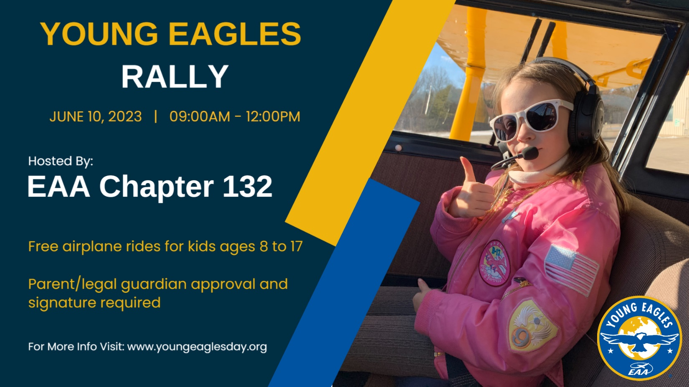
Young Eagles Day Elkhart Indiana
EAA Chapter 132 at Elkhart Municipal Airport
Saturday, June 10, 2023 @ 8:00 AM - 12:00 PM
Contact: Ryan Sherwood - (574) 370-2279 -
Please scroll down to register for this event.
Help us celebrate National Young Eagles Day with a free airplane ride for your kids! Space is limited and sign ups are only allowed in advance through this site.

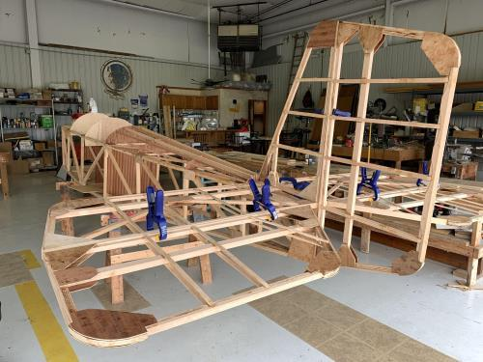

See Jim’s Experimental Aircraft Pietenpol project every Monday evening at 7pm at the EAA 57 hanger at the Elkhart Municipal Airport. He and Steve is adding elevator and rudder to their Pietenpol project. Have popcorn and meet with other
EAA Chapter 132 members too!

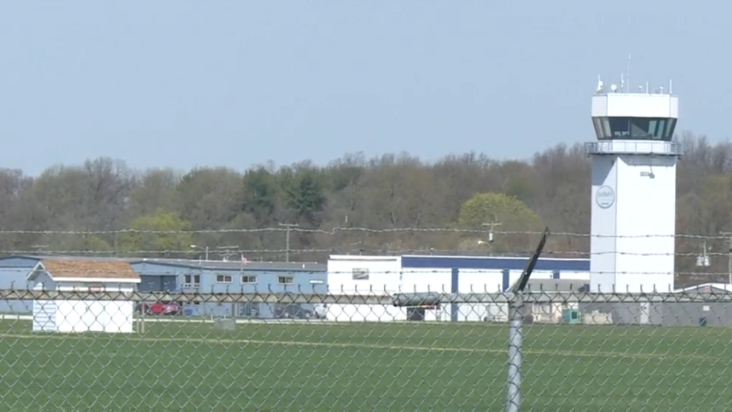

May 11, 2023 Board Meeting 7:00-7:28pm
Phil, Wendy, Matt, Dick, Tim, Jerry, Yeager, Don, Karen &Ted
Phil was in charge of the Board Meeting.
About 300 re-enactment people will be able to have breakfast and lunch by our EAA Chapter volunteers at the Coachman hanger. We have decided on what to have for the breakfast and lunch for the WWII re-enactment people. Breakfast 7-9 both days. Lunch 10-1 both days.
Elkhart Municipal Airport hosting WWII re-enactment and full airshow May 20 & 21 this year. Volunteers needed for re-enactment as well.
Lowell will have a birthday gathering at a hanger in Goshen airport May 13 at 2-6pm.
Our Young Eagle is Saturday June 10th
Our Thursday May 25th Membership meeting will be a Pot Luck event at our EAA Hanger at 7pm.
We may be helping in an STEM in Aviation that should start around September at the Mishawaka Pilot Club airport.
Membership renewal is requested as soon as possible early in 2023.

