Reminder:
Welcome to Monday night popcorn at 7pm in our EAA Chapter hanger.
Saturday morning breakfasts from 8-9am at the our EAA Chapter Clubhouse.

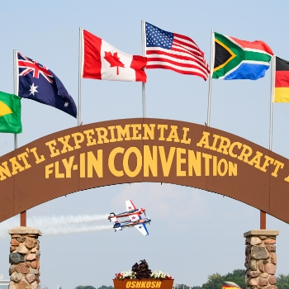

Get Your AirVenture 2022 Tickets
It's never too early to start planning for your favorite week of the year! Early bird pricing is in effect until June 15, 2022.
Read More

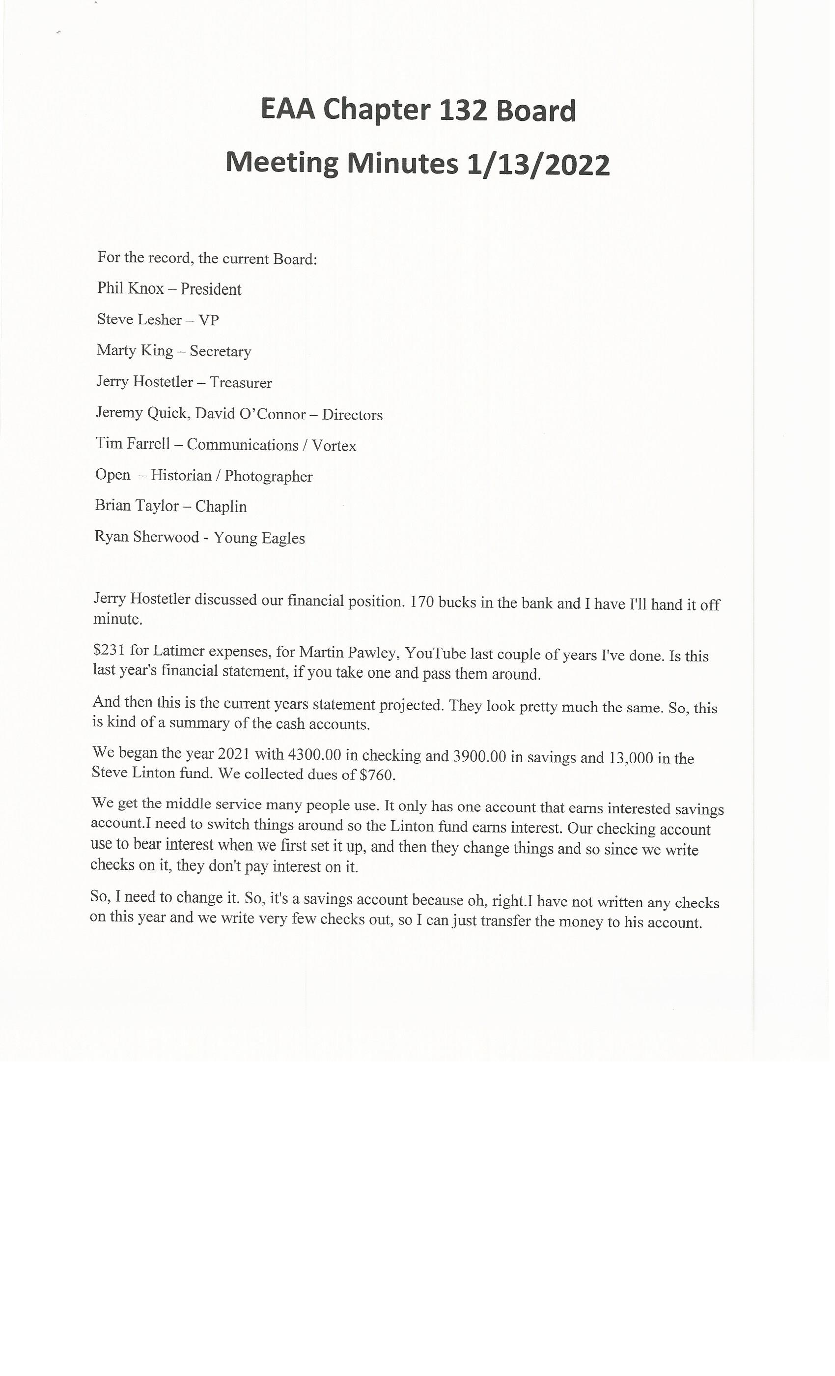
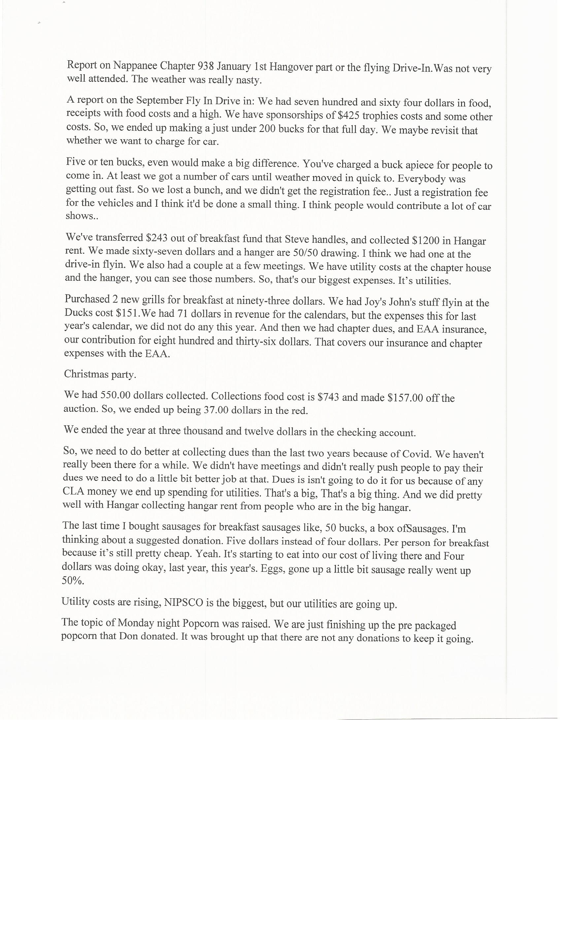
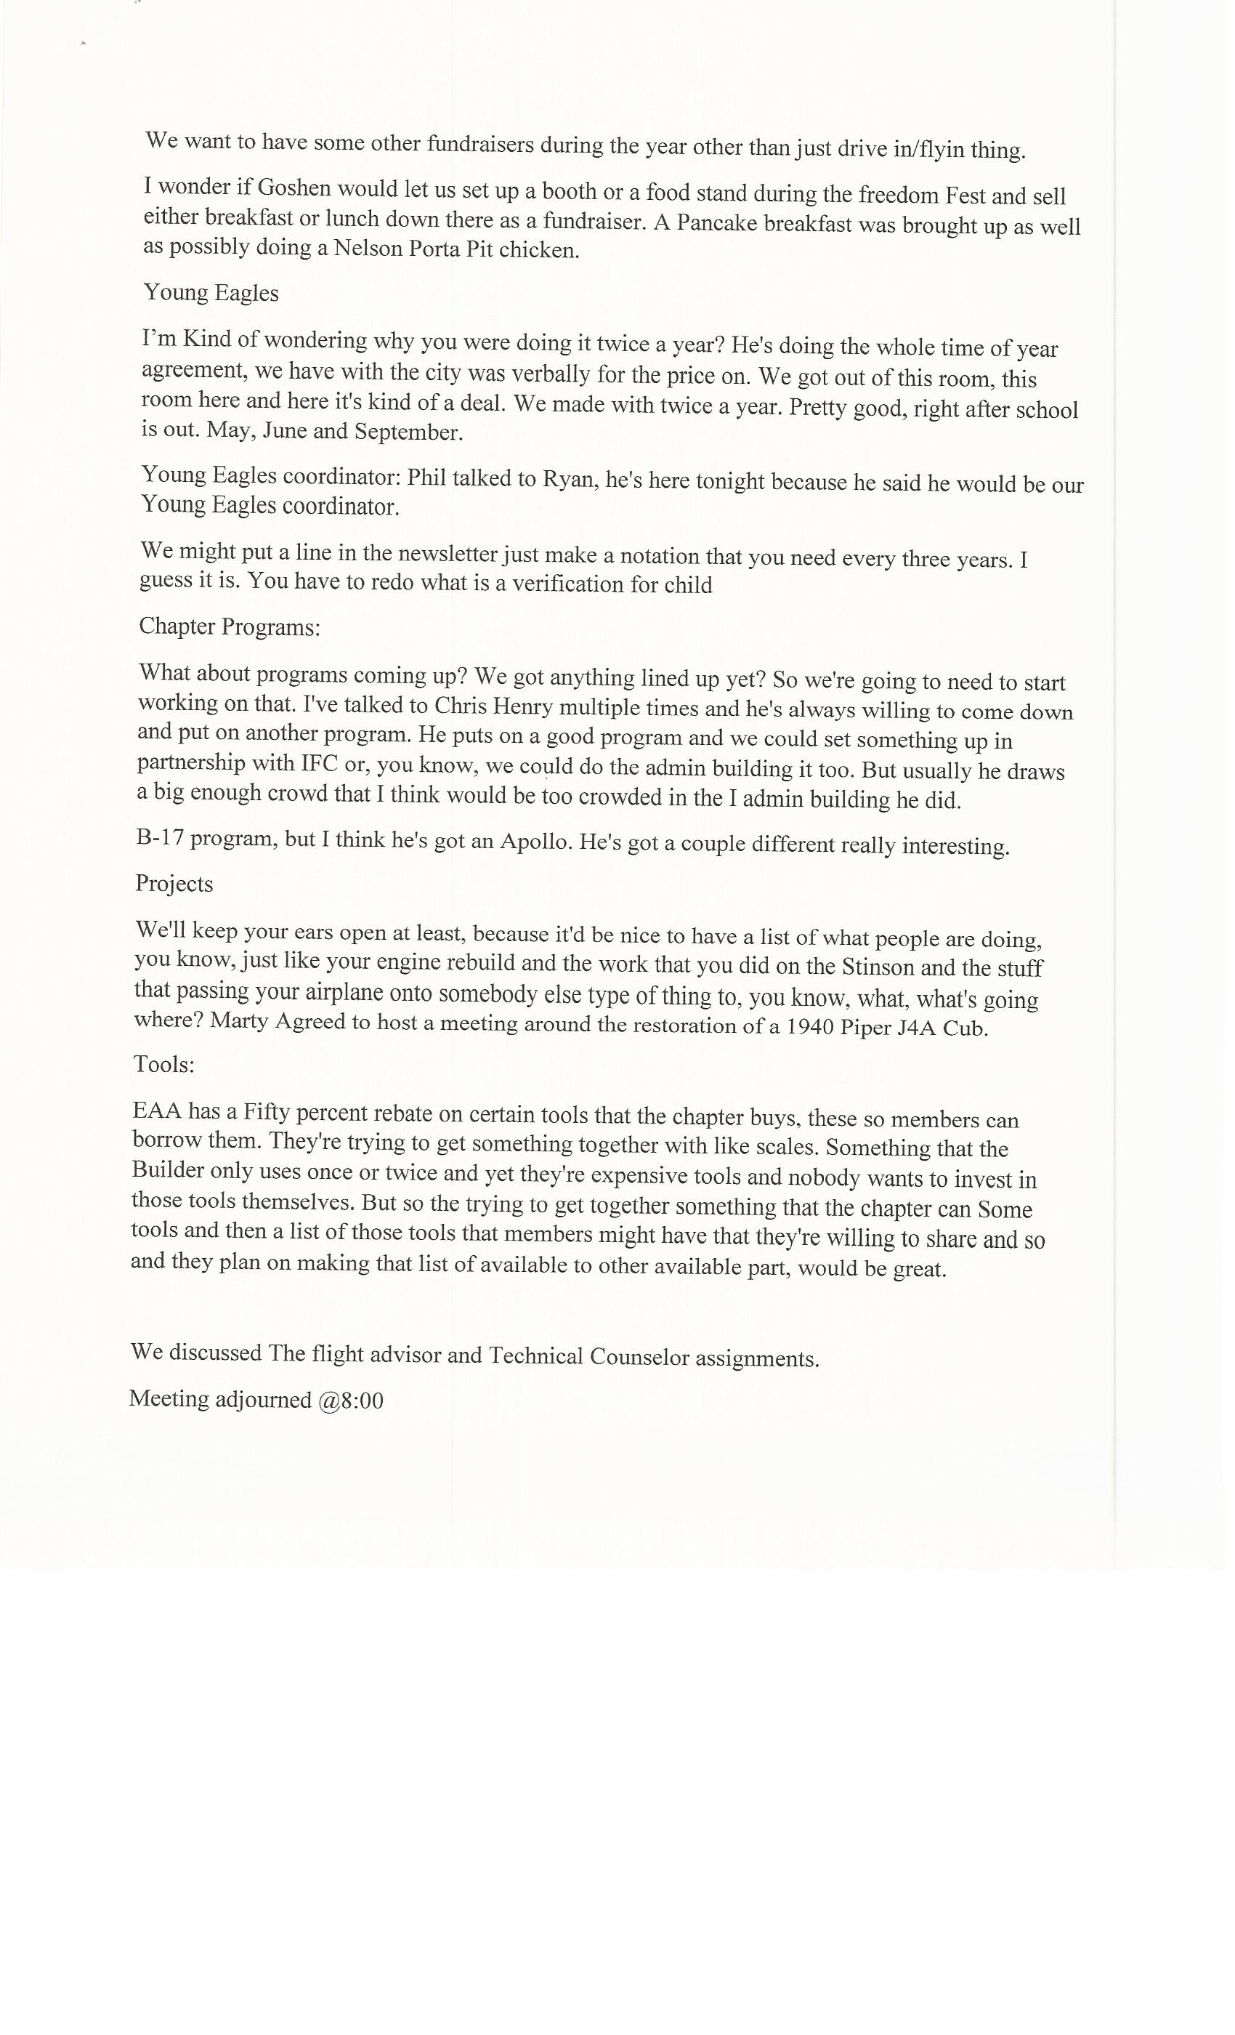
Email send by Doug Busch:
AeroCareers is a 501c3 charitable and educational organization that operates closely with EAA Chapter 64 to provide mentoring, scholarships, and low-cost flight training. Three teens have earned their private pilot certificate in our vintage Cessna 172 this past year and are learning hands-on skills helping rebuild a hurricane-damaged 1957 Cessna 172. We are currently raffling a 1946 Ercoupe to help fund our educational activities. Your assistance in publicizing our raffle is much appreciated.

The raffle flyer is attached and the link to enter is https://rafflecreator.com/pages/52380/aerocareers-aircraft-raffle.
If you’d like to learn more about AeroCareers, visit http://aerocareers.org/.

Thanks for your help!
Bob McDaniel
EAA64 Young Eagle Coordinator & AeroCareers President

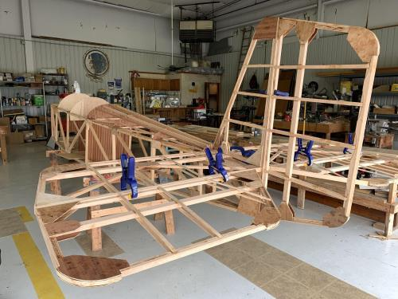

See Jim B & Steve L’s Experimental Aircraft Pietenpol project every Monday evening at 7pm at the EAA 57 hanger at the Elkhart Municipal Airport. They just added landing gear to their Pietenpol project. Have popcorn and meet with other
EAA Chapter 132 members too!

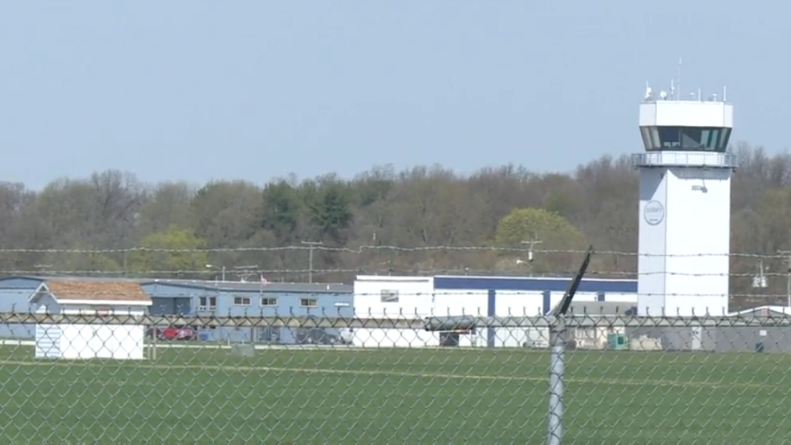

Jan 13, 2022 Board Meeting 7-8pm

See Board Meeting info above. The Membership Meeting members were given the info from the Board Meeting. Membership Meeting members got to go see the IFC old terminal that was updated.

