Purchase Your EAA AirVenture Oshkosh 2023 Tickets

July 24 - 30, 2023
Getting your EAA AirVenture Oshkosh 2023 tickets, parking, camping, and more is fast and easy! With a few simple steps, you'll be inside the gates in no time and ready to take in AirVenture. You'll simply select weekly or daily tickets, select optional add-ons like parking, camping, and flight experiences, and pay by credit card using our secure online system.

What's Included With Admission
- Access to all showplane parking areas, including homebuilts, vintage, aerobatic, warbirds, ultralights, lightplanes, rotorcraft, and seaplanes.
- AirVenture forums and workshops with no reservations required.
- A variety of evening programs, including nightly movies at the Fly-In Theater and programming at the Theater in the Woods.
- A variety of air show activities, including daily afternoon air shows and showcase flights, the Wednesday and Saturday night air shows, and Twilight Flight Fest.
- EAA membership information and merchandise areas.
- More than 1 million square feet of commercial exhibits, displays, and information from 800+ exhibitors.
- All AirVenture speaker venues, including Museum Speaker Showcase, Authors Corner, Warbirds in Review, and more.
- EAA Aviation Museum admission during the event.
- KidVenture located behind the museum at Pioneer Airport.

Methods of Payment
- Cash, personal checks, and traveler’s checks are accepted.
- Accepted credit cards: MasterCard, Visa, American Express, and Discover.
- ATMs are available on the grounds.
Please note: To access the Member Store, membership must be current through July 30, 2023, or your membership must be on auto-renew.
Please click the renew or join link and allow 2-3 minutes for processing before purchasing your tickets at member rates. For the best experience, log into your EAA.org account before clicking the "Member Store" button.

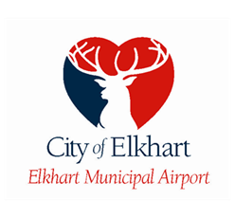

Email: andy.jones@coei.org or karen.shaw@coei.org

EAA Chapter 132 will need volunteers for May 20 & 21 for Breakfast and lunch for WWII re-enactment members. EAA Chapter 132 can also have volunteers for the WWll re-enactment as well. If you want to be a volunteer for Breakfast & Lunch, let us know at our EAA Chapter 132 April 27 membership meeting or let our president Phil know. If you want to volunteer for the WWII re-enactment part let Elkhart airport manager Andy know as soon as possible for any day(s) you want to volunteer for WWII re-enactment part.

Reminder:
Welcome to Monday night popcorn at 7pm in our EAA Chapter 132 hanger 57 at the Elkhart airport.
Saturday morning breakfasts from 8-9am at the our EAA Chapter 132 Clubhouse.

------------------------------------------------------------------------------------------------------------------------------------------

April 27, 2023 Membership Meeting 7 - 8:30 pm

Secretary Marty King gave us a briefing on the April 13, 2023 Board Meeting info. Phil gave us info for the WWII re-enactment breakfast and lunch.
We will need volunteers to serve breakfast/lunch on May 20th & 21st for the re-enactment members.
Elkhart airport Manager Andy let us know that the EKM could have a Ride In, Fly In & Drive In on a different day than June 10, 2023. Our EAA chapter Young Eagle will be June 10.

Marty won awards from the FAA for state of Michigan and Northern Indiana.

Phil will be in charge of getting food for our Saturday breakfast until Steve is okay after his surgery.
We also need cookers to assign for the Saturday breakfast until later in May.

May 13th 2-6pm Lowell is having birthday at a hanger in Goshen. Feel free to go to celebrate his birthday. We will know before which hanger in Goshen this will be in.

May 25th will be a PotLuck at the Chapter Hanger.

FAA FSDO Tim Sokol gave us a great presentation on what to look for about knowing all weight and balance of an airplane and how it affects flying and center of gravity of the plane.

We still need many of our members to renew their membership. So far, we only have 25 renewed. Before the covid pandemic, we had 50 renewed members.

Had a very good crowd of EAA members and friends at the membership meeting.

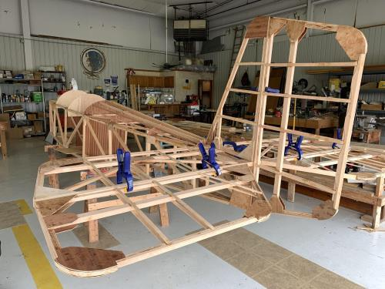

See Jim’s Experimental Aircraft Pietenpol project every Monday evening at 7pm at the EAA 57 hanger at the Elkhart Municipal Airport. He and Steve is adding elevator and rudder to their Pietenpol project. Have popcorn and meet with other
EAA Chapter 132 members too!

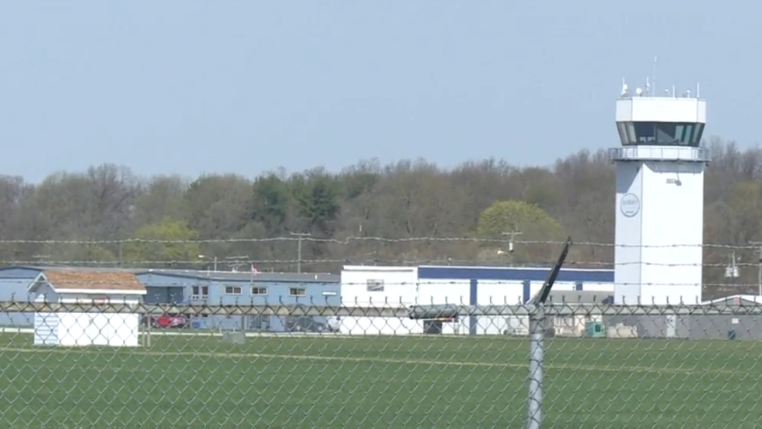

April. 13, 2023 Board Meeting 7:00-7:28pm
Phil, Wendy, Ryan, Dick, Marty, Tim, Jeremy, Jerry, Adam & Jash
Phil was in charge of the Board Meeting.
There was a briefing on the Formation Flight School Thursday & Friday May 18 & 19 this year. About 300 re-enactment people will be able to have breakfast and lunch by our EAA Chapter volunteers at the Coachman hanger. We have decided on what to have for the breakfast and lunch for the WWII re-enactment people. Breakfast 7-9 both days. Lunch 10-1 both days.
Elkhart Municipal Airport hosting WWII re-enactment and full airshow May 20 & 21 this year. Volunteers needed for re-enactment as well.
Lowell will have a birthday gathering at a hanger in Goshen airport May 13 at 2-6pm.
Our Young Eagle is Saturday June 10th
Tim Sokol (FSDO) will do a presentation on weight & Balance.
Membership renewal is requested as soon as possible early in 2023.

