

**May 30, 2024 EAA Chapter 132 Membership Meeting 7:00 - 8:30 PM**

Marty did a great presentation on his FAA Indiana / Michigan management and on EAA type aircraft maintenance.

Mishawaka Pilots Club did at Lunch at 11 am and Young Eagles on May 4th.

May 9th EAA Chapter 132 Board Meeting.

May 11th, 2024 EAA Chapter 132 breakfast 9-11am was by Ken and Bill.

May 18, 2024 EAA Chapter 132 Young Eagles from 9 am to Noon had 50 kids and 8 planes. Two pilots also flew the Elkhart tower guys in their airplane.

June 8, 2024 Don & Karen will do the EAA Chapter 132 breakfast from 9-11am.

Others can help as well.

Goshen, IN airport will have the Freedom Fest Airshow July 13, 2024 and EAA Chapter 132 will try and do the food and drink part on the Goshen airport ramps east side again.

August 18 is Ducks Lunch Fly in Drive in.

Some of our EAA chapter will be at the EAA Oshkosh Group Camp.

**Your Official Countdown to AirVenture 2024**  
**July 22 – July 28, 2024**  
Countdown is sponsored by: 

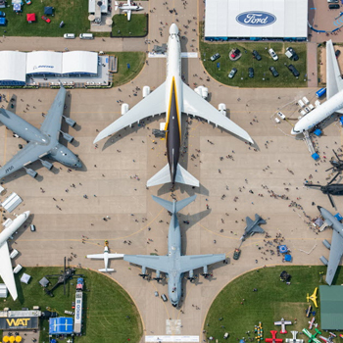

EAA Chapter 132 is putting together a Fisher Classic Biplane

that was donated to use by Micheal Smith from his dad that died

who was starting to build it a while ago.

Building it on Thursdays 5-8 pm in our hanger.

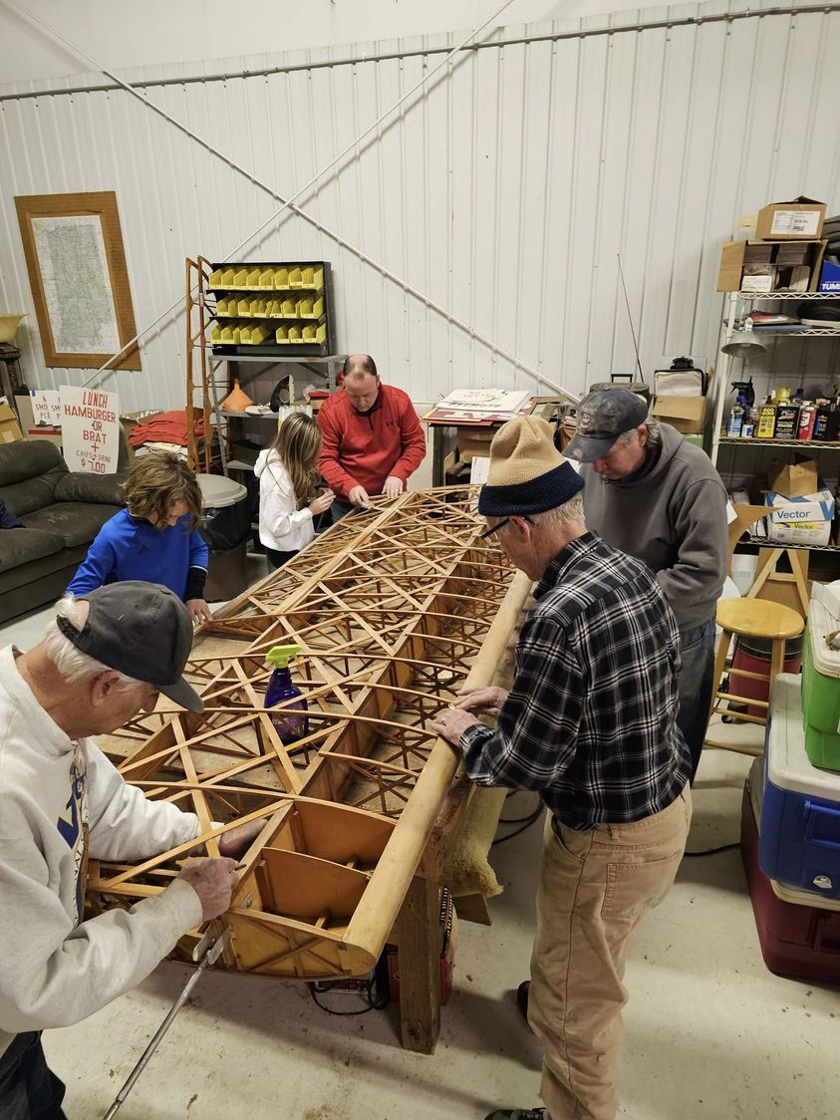

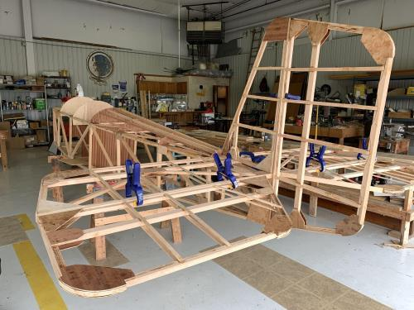

See Jim’s Experimental Aircraft Pietenpol project every Monday evening at 7pm at the EAA 57 hanger at the Elkhart Municipal Airport. He and Steve is adding elevator and rudder to their Pietenpol project. Have popcorn and meet with other

EAA Chapter 132 members too!

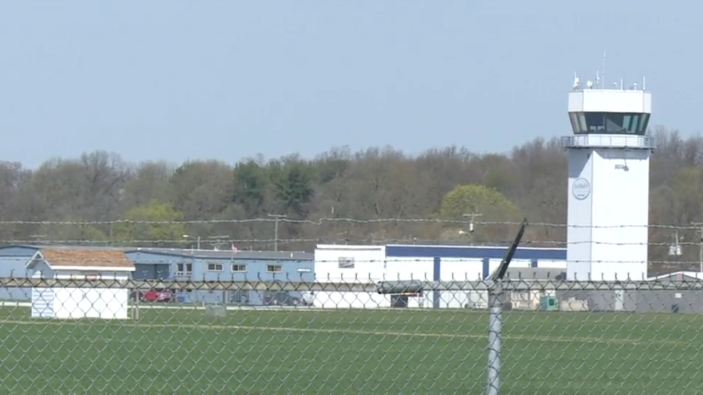

**May 9, 2024 Board Meeting 7:00-8:05 pm**

**Phil, Wendi, Tim, Ryan, Dick & Steve**

Marty will be at GMA (GAMA) Live May 8th

Young Eagle May 18, 2024. If Young eagle pilot, make sure your child config is current at EAA.

June 14 & 15, 2024 Mishawaka Pilots Club Fly In.

Goshen Freedom Fest Airshow July 13, 2024

August 18, 2024 Duck’s Lunch

Mike and Audra will be doing a presentation at our Sept membership meeting.

Might want to do a visit to Dayton Air Museum some weekend this year.

Might also need to do a fundraising activity for our chapter sometime soon.

Membership renewal is requested as soon as possible early in each year.

