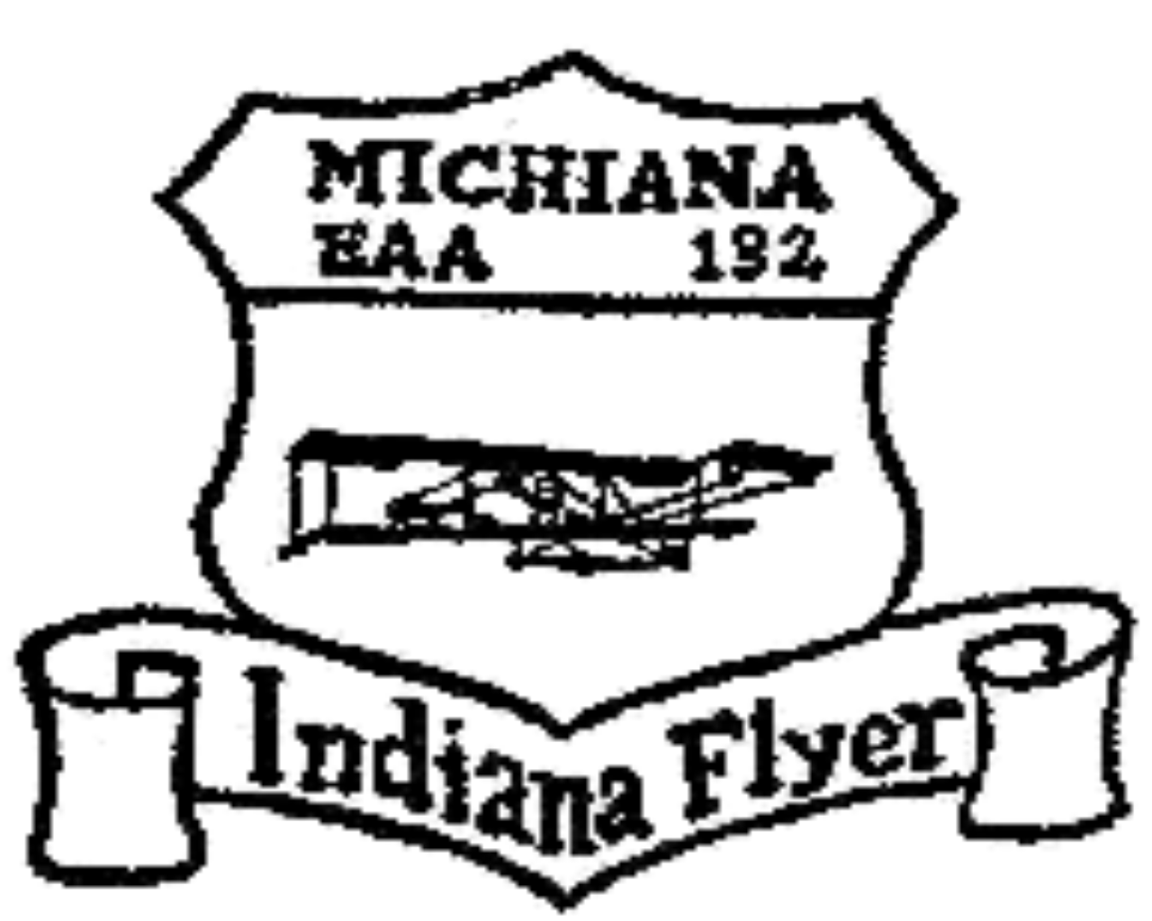

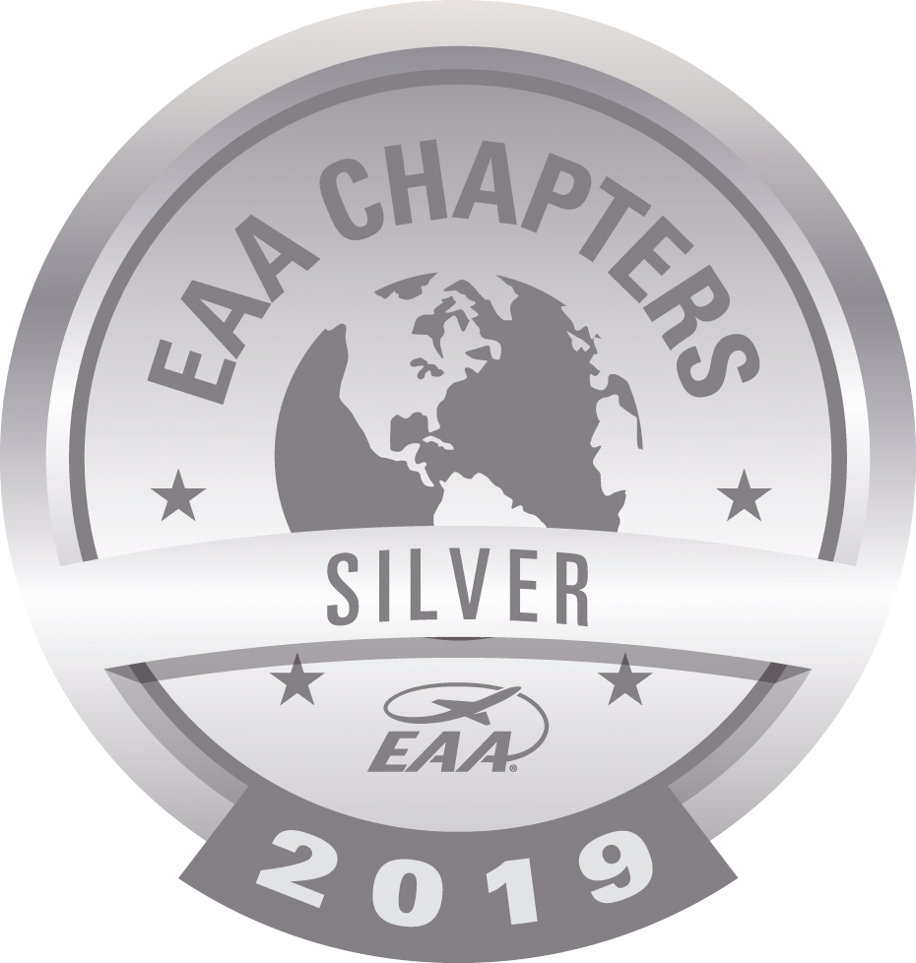

VORTEX
JUNE 2020 VOLUME 51 NUMBER 06

2020 CALENDAR

June 25, 2020 Chapter Meeting - Annual Potluck Supper
July 09, 2020 Board Meeting
August 13, 2020 Board Meeting
August 16, 2020 EAA/Duck's Picnic
September 10, 2020 Board Meeting
September 11, 2020 Air Mail / Fly In, Drive In, Ride In
September 24, 2020 Chapter Meeting
September 26, 2020 Young Eagles Day
October 08, 2020 Board Meeting
October 29, 2020 Chapter Meeting
November 12, 2020 Board Meeting
December 05, 2020 Chapter Christmas Party

ITEMS OF INTEREST:
MONDAY EVENING: There is a Monday Evening building get together at the hanger. They meet at 7:00 PM at the Hanger. I have also heard there is Popcorn involved at that meeting. Open to everyone ~~~~~
============================================================
Chapter meeting
JUNE 25, 2020
POTLUCK AT THE HANGER
Time for our annual Honoree Potluck Dinner. We will meet outside at the Hanger on the West end at 6:30, eat at 7:00 PM. Bring a salad and dessert to share with everyone. The Meat, Drink, and Table service will be furnished. We have an Honoree - Who is it? Come and see ~~~~~~~~~
We need an idea of how many coming - Please respond to our EAA email at: eaa132elkhart@gmail.com or Steve Lesher at: legistix@netzero.net
See you there!
~~~~~~~~~~~~~~~~~~~~~~~~~~~~~~~~~~~~~
Have you paid your annual dues??
Dues are $20.00 for the year. If you can not pay at the meeting you can also mail your dues to: Jerry Hostetler, 24640 Co. Road 54, Nappanee, IN 46550 or you can go online to: eaa132elkhart.weebly.com.
List of Paid Members:
David Ton Craig Duck Tim Duck Scott Duck
Tim Farrell David Swift Bernard Vandervliet Ted Woodill
Arden Adamson Robert Smith Don/Karen Duck Richard Wagner
Roy Bickel Vic Pixey Sam Kaczor Marty King
Phil Knox Dan Ramsey Michellle Wantz Jeremy Quick
Andy Finke Steve Gerencser, Sr. Jerry Hostetler Donna Sisk
James Bousson Lowell Farrand John Horvath Paul Ditsler
Augie Sands Ryan Sherwood Bill Waymouth Tim Green
Jeff Moser Dave Krantz Sam Pavel Michael Hall
Chuck marshall Doug Busch Ken Kasner
If your name is not on this list, then your dues are due at this time.
We need the dues to pay our bills to keep the heat & electric on at the Chapter House and the Hanger. Please help us.
======================================================================

Dear EAA 132 Family,

Summer is upon us and the desire to get outside, get up among the clouds and reconnect with those we love is very compelling. We are on the tail end (we hope) of a pandemic, likes of which we haven’t seen for over a century. As history tends to repeat itself, we also need to remember what we’ve been through to appreciate where we are and to give us context for where we are going. Remembering those on whose shoulders we now stand is essential and I for one never want to forget those trailblazers who went before us and hopefully those who come centuries after us will fondly look back on the actions we take today and history will remember us fondly as well.

This is the year where everything we take for granted, must become intentional, like going to a restaurant, even shaking a friend’s hand or giving a hug to those we care for. We are asking you to be intentional for the days ahead as well, remaining vigilant to stay healthy physically while being wise to connect with your friends in the aviation community. So we are seeing many events, festivals and fun to be cancelled, but those that are moving forward, we need your 100% support. We’ve seen the cancelation of Young Eagle events, Airventure, Sun-n-Fun, so the large events aren’t happening this year, but wait there’s more...

...on September 11th we will be participating in the AirMail100 Post-Pandemic Celebration at Elkhart Airport. We will be having our Ride-In, Fly-in, Drive-in on this Friday. We will be having good food, good fun, Eagle Flights, and having a part in a flight stop in the recreation of the first transcontinental airmail delivery which happened 100 years ago. We will soon be allowing you to have the opportunity to buy a postcard that will be carried leg by leg across the country as it was a century ago, then given to be canceled in San Francisco Postmaster and let the modern USPS bring you home an heirloom to cherish knowing you were part of something significant. For more info go to https://youtu.be/1xyx8DGXV50

We also have a number of fly-outs scheduled for the summer, so don’t stay silent, we want to have all the seats filled and fun to be had by all. If you haven’t participated in a fly-out in a while, sign-up share in the cost of gas and have a great meal with friends in a way only few get to experience. Going to Merk’s at Muncie, AirZoo at Kalamazoo & Propeller Pete’s in Schaumburg. Email the club at eaa132elkhart@gmail.com if you’ve got a seat or two in your plane and want to fly or if you’d like to fill a seat for some fun adventures. Check out more details on FaceBook and our website.

Be sure to make it to the outdoor Honoree potluck banquet on June 25th by the EAA Hangar on the Northwest side of EKM. We will be honoring a great person who has served our community with distinction, share a meal with friends, playing some fun games, and hopefully bringing on a Communications Officer and a Historian to our board. If you’d like to be considered or help in either of these positions, please email us or show up to learn more.

This is the year we need you to intentionally participate more than you have before. We’ve gotten used to being scared into staying home and ordering delivery, but every precaution is being taken to protect the health and well being of all participants, so get engaged, make new friends and re-connect with some old friends and make memories this summer they will be talking about a century from now!

Serving at your side,

Dr. J. Douglas Busch
EAA 132 President 2020

Seek Today to Improve the Lives of Others,
Dr. J. Douglas Busch
========================================================================

Board Meeting June 11, 2020 7:00pm to 8:33pm

Don, Karen, Bill, Steve, Jerry, Dr. Doug, Jim, Cindy, Tim F, Roy
Tim G and Michelle via Zoom

Karen has submitted her resignation as the VORTEX editor effective June 30, 2020.
Karen has been our newsletter editor for over 20 years. As much as we hate to see this happen as she has done an outstanding job, it is also understandable. Thank you, Karen, for all the hard work you put into our newsletter.

Doug has proposed two new officer positions;
A Communications Officer who in addition to be the Vortex editor, will coordinate communications to the club via email, print, FB, Twitter, Instagram and websites.
Will ensure a consistent message and look on all platforms and will spread news via multiple platforms to members, prospects and media.
Tim Farrell has volunteered for the position and will start immediately.

The second is a Historian / Legacy Preservation Officer.
This person will report on a monthly basis people and events from both our Chapter and EAA.
They will be responsible for spotlighting and the preservation of artifacts.
They will capture the stories of people and adventures of members.
This position is open for a member with a passion for our Chapters history and the members it encompasses.
Anyone interested in this position should contact a board member.

On September 11, 2020 a celebration of the 100th anniversary of the Air Mail Service will be stopping at the Elkhart Airport. It was decided to combine this with our annual FI/DI/RI.
The FI/DI/RI will run from 3:00pm to 7:00pm with the Beech 18 landing at 4:00pm and leaving at 6pm.
For fund raising our Chapter will sell food and possibly post cards which would be added to the air mail route and then delivered back to the recipient once the plane reaches its West coast destination.
A four-person committee was formed to help coordinate the event.
Dick, Bill, Michelle and Tim G

We will attempt to do some Saturday brunch fly-outs.
Anyone with a plane is invited and the goal is to have no empty seats.
Passengers would share the cost of the fuel and fun would be had by all.
The following dates / locations have been proposed:
June 20 – Merks @ Muncie (93 nm)
July 11 – Prop Blast @ Coldwater (51nm)
July 25 – AirZoo @ Kalamazoo (42nm)
Aug 8 – Pilot Petes @ Schaumburg (109)
Contact Doug if you wish to go as either a pilot or passenger.

June 25 is our annual Honoree / Pot-Luck member meeting.
This year it will be held outside along “EAA Row” which is the row of hangers where our Chapter hanger and many of our members hangers are located.
The Chapter will provide burgers, brats and drinks. And our members are asked to bring BOTH a side dish and a dessert.

August 16 is the annual Duck Fly-In.
September 26 is our Fall Young Eagles event.

Starting with the June member meeting we will start a 50/50 drawing.
$1.00 per ticket or five for $5.00

The two signs on the front (CR 6) of our Chapter building have been taken down and we are getting quotes on a vinyl wrap for them.
========================================================================

NEW HATS FOR THE SUMMER
DO YOU HAVE YOURS?
We have new hats. Pretty Blue and White summer hats. The cost is $15.00. See Steve Lesher or go on line to: eaa132elkhart.weebly.com.
========================================================================
2 New Officer Positions:
1. COMMUNICATIONS OFFICER:
Coordinate communications of club via email, print, FB, Twitter, Instragram & websites.
Ensure a consistent message and look on all platforms.
Spreads news via multiple platforms to members, prospects & media.
Vote for office
Nominations for position
2. Historian / Legacy Preservation Officer
Monthly report on people and events from EAA, EAA132
Artifacts preservation and spotlights
Capture stories of people and adventures of members
Vote for office
Nominate for position
Would you like to volunteer for one of these positions? Doug would love to have someone volunteer - See Doug to inquire about it.
========================================================================
Note from the Editor: After much thought I have decided after 20+ years of writing this Newsletter it is time for some one else to take it over. This is my last writing of the Newsletter - I am retiring. Thank you for putting up with my writing, I have had a lot of fun and enjoyed doing it.
"Signing off" Karen Duck
================================================ 2020 OFFICERS

President Doug Busch Young Eagles Coordinator: Doug Busch & Tim Green
(719) 671-7385 (719) 671-7385
drjdbusch@gmail.com drjdbusch@gmail.com / tgreengab@aol.com

Vice-Pres: Tim Green Vortex Editor: Karen Duck
( ) (269) 699-7721
tgreengab@aol.com momduck29@frontier.com

Secretary Jim Butler Chapter Chaplin: Brian Taylor
jimb131@gmail.com

Treasure: Jerry Hostetler (574) 773-5855
hostetler.jerry@gmail.com
Directors:
Michelle Wantz (574) 971-8498
Steve Lesher (574) 264-7320
Roy Bickel (574) 298-8800
Dan Ramsey (269) 228-1205

Board Meetings: 2nd Thursday of each month

Building Meetings: Monday Evening 7:00 PM

Regular Meetings: Last Thursday of the month unless
Other Plans are made
7:00 PM at Chapter House Chapter

GUESTS AND NEW MEMBERS ARE ALWAYS WELCOME

Karen Duck
21825 Mason Street
Edwardsburg, MI 49112

