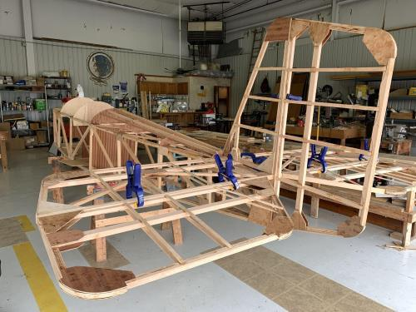

See Jim’s Experimental Aircraft Pietenpol project every Monday evening at 7pm at the EAA 57 hanger at the Elkhart Municipal Airport. He and Steve is adding elevator and rudder to their Pietenpol project. Have popcorn and meet with other
EAA Chapter 132 members too!

Your Official Countdown to AirVenture 2024
July 22 – July 28, 2024
Countdown is sponsored by:

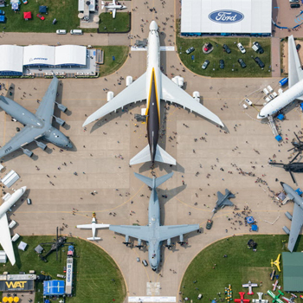
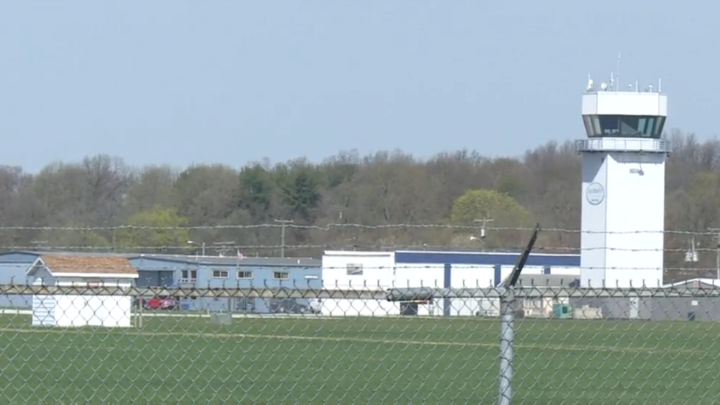

Dec 14, 2023 Board Meeting 7:00-7:45 pm
Phil, Wendi, Ted, Tim, Mike, Ryan, Steve, Audry and Yeager

The Dec 2nd EAA Chapter 132 Christmas party was awesome. EAA chapter 132 got $340 from the silent auction. We had at least 38 of us at the party. Angie Sherwood got 20 out of the 30 Christmas Quiz right. Wendy read us 20 quizzes about aviation. Tim read us 10 of the Christmas type quizzes. Amelia read our EAA version Twas the Night Before Christmas.
Dec 9th EAA Chapter 132 breakfast had about 14 at our clubhouse.
No Dec 28th membership meeting due to Christmas. Have a Merry Christmas!
Jan 11, 2024 EAA Chapter 132 Board Meeting
Jan 13, 2024 EAA Chapter 132 breakfast 9-11am by Phil and Wendy
Jan 25, 2004 EAA Chapter 132 Membership Meeting will be at the IFC at 7pm with Chris Henry doing his presentation.
Micheal Smith might be donating a Fisher Classic 2 seat biplane to our chapter so we can build it and then we will send money to Micheal in his dad’s name once the plane if built and sold to someone.
Our clubhouse bathroom needs a few things fixed or replaced. A faucet and toilet.
We still need a new popcorn machine because our current one is not working good or at all.
Membership renewal is requested as soon as possible early in each year.
Our chapter new Director officers Wendy and Dick have been elected for 2024-2025. Mike is now our treasure and Ryan is our vice president for 2024-2025.
Feb 10th, 2024 EAA Chapter 132 breakfast 9-11am by Don & Karen

