Reminder:
Welcome to Monday night popcorn at 7pm in our EAA Chapter hanger.
Saturday morning breakfast will start again the Saturday after Labor Day Weekend
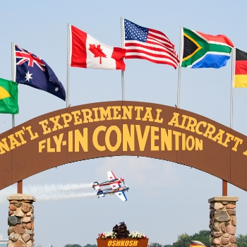
Get Your AirVenture 2022 Tickets
It's never too early to start planning for your favorite week of the year! Early bird pricing is in effect until June 15, 2022.
Read More

American Freedom Fest
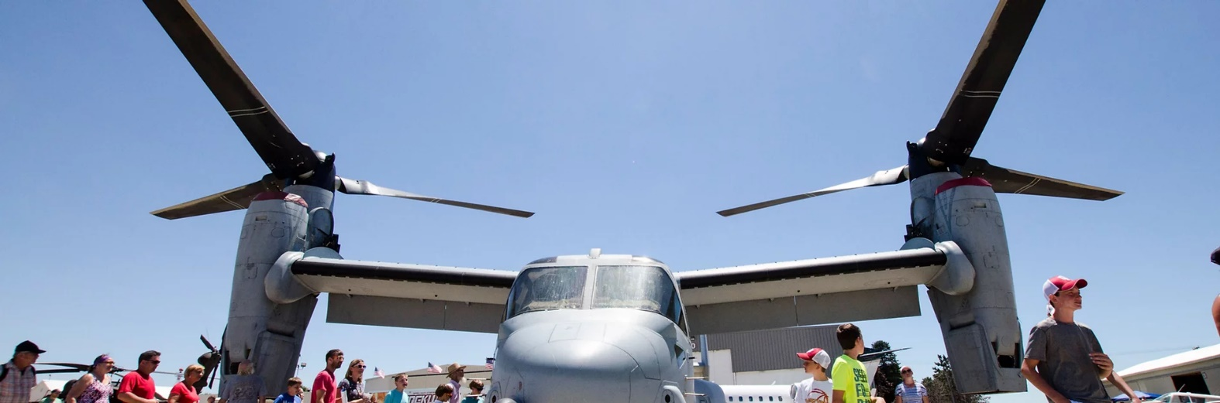
July 9, 2022 at Goshen Municipal Airport

ADMISSION

GATE (cash only)
Adult (13 and over): $20
Child (ages 6-12): $10
Children 5 and under: Free
Veterans with valid Military ID: Free

ADVANCE TICKETS
Adult (13 and over): $15
Child (ages 6-12): $8
PARKING
​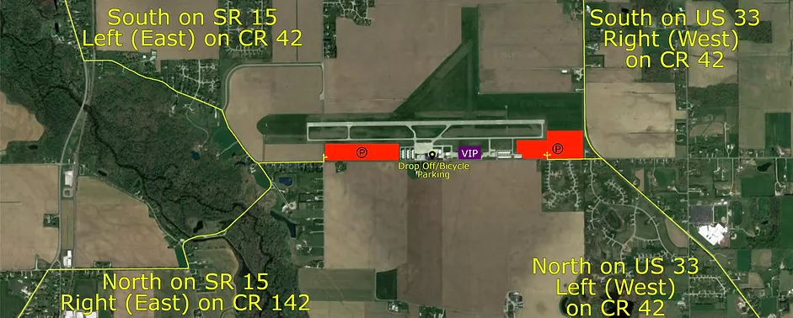

Friday Fly-In Lunches Start April 1st 11:30am to 1:00pm
Donations recommended

Goshen Airport (KGSH) will have every 1st Friday lunch from April to December
Smith Field Airport (KSMD) will have every 2nd Friday lunch from April to October
Elkhart Airport (KEKM) will have every 3rd Friday lunch from April to October at the Indiana Flight Center old passenger terminal.
La Porte Airport (KPPO) will have every 4th Friday lunch from April to October
Fulton Co Airport (KRCR) will have any 5th Friday lunch from April to October.

-------------------------------------------------------------------------------------------------------------------------

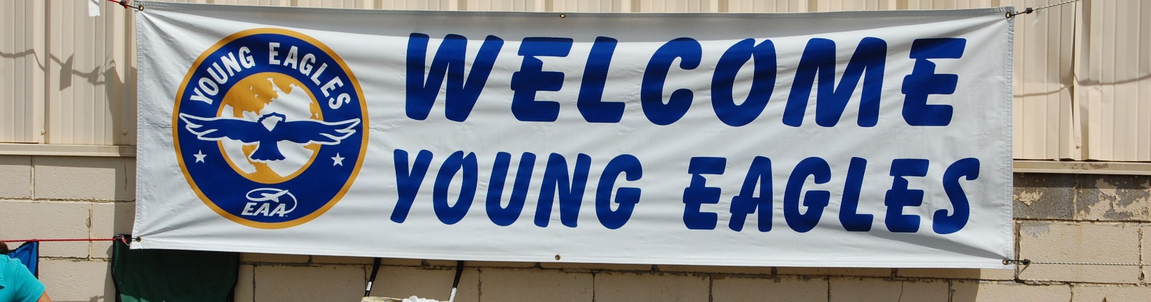
Elkhart, IN 2022 Spring Event
EAA Chapter 132 at Elkhart Municipal Airport
Saturday May 21, 2022 @ 9:00am – 12:00pm
Contact: Ryan Sherwood – (574) 370-2279

Reminder: Pilots and Young helpers will need to have there 3 year Child Protection renewed at https://youngeaglesday.org/

May 26, 2022 EAA Chapter 132 Membership Meeting at 7 pm

President Phil opened the meeting.

Board Meeting minutes were read. There will be a setup to Randy Gingrich when Tim returns from vacation on a number of airshow topics.

Jerry reported we have 3K in checking. 13K in the Linton Saving account and $3965.00 in the chapter savings. Steve said there is about $400 in food services cash.

Phil is having the Kite fly at his house on June 11th at his farm. Hamburgers/Hotdogs will be available. Needs directions to get there to his place.

July 9th Freedom Fest Airshow: Friday night setup is possible on the 8th.

Wendy is checking prices at Gordon’s for Ice Cream sandwiches, etc.
S& H carbonic was suggested as a source for dry ice.
Shirt size need to get to Wendy. There will be an email to members.
Chapter Banner: Ryan will retrieve it from the Admin hanger.
Other interest: Wendy arranged for Phil in a P-51 Gunfighter at the upcoming Fort Wayne flyin on the July 4th.

Note: Jerry H leaves for Oshkosh July 3rd so monies need to be transferred prior to the 9th.

Our first of two Young Eagle event this year was cancelled due to rainy weather that day.

Bob Carr had to cancel his program for the membership meeting.

50/50 raffle was forgotten to be done,

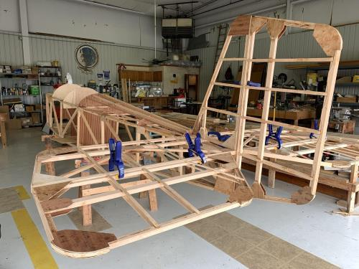

See Jim B & Steve L’s Experimental Aircraft Pietenpol project every Monday evening at 7pm at the EAA 57 hanger at the Elkhart Municipal Airport. They just added landing gear to their Pietenpol project. Have popcorn and meet with other
EAA Chapter 132 members too!

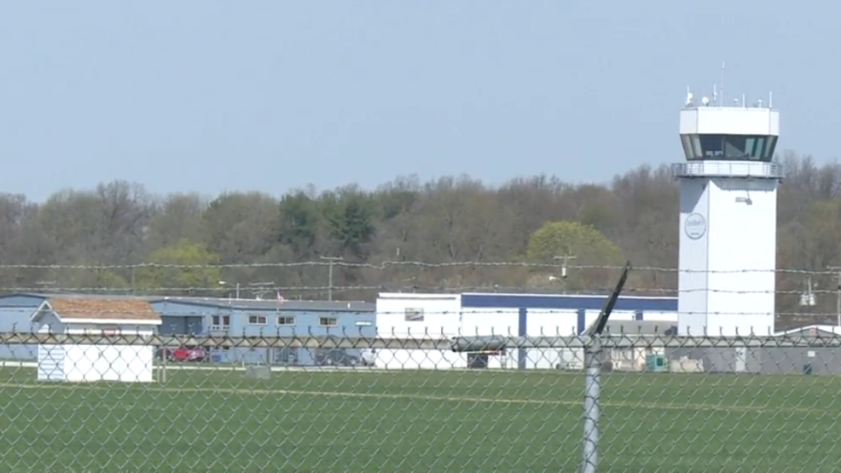

May 12, 2022 Board Meeting 7-8:00pm
Phil, Wendy, Marty, Jerry, Steve, Ryan, Tim, Don, Ted & Dick.

Secretary Marty King read us the May Membership Meeting minutes.

Young Eagle event May 21st. Pilot Meeting 8 am, Tower Meeting 8:30am, event 9am to noon. Pilots using slow planes would be at 1800 ft being shorter to the north. Pilots using fast planes would be at 2300 ft going to Diamond Lake and back. 60 kids signed up. Reminder: Child protection is required every three years.

Phil mentioned he will have Hamburgers/Hotdogs at the Phil Kite Event.

Goshen’s Freedom Fest will be this year and our chapter wants to make some funds by having a food court or beverage/ice cream court as well as advertising our Young Eagles and EAA Membership. Wendy is in charge of the water and ice cream items. She is also asking for shirts for the event. Wendy is making some signs as well. Ted is lettings us use his RC plane to be put in the tent at the event.

Jerry said that 33 members have pad renewal dues this year so far.

Bob Carr (EAA Calendar photographer) will program at the membership meeting.

EAA Chapter 132 needs to fix ceiling panels in the clubhouse.

