Reminder:
Welcome to Monday night popcorn at 7pm in our EAA Chapter hanger.
Saturday morning breakfasts from 8-9am at the our EAA Chapter Clubhouse.
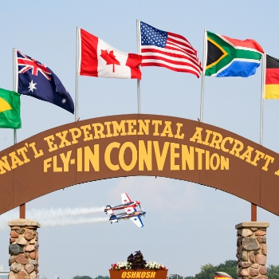

Get Your AirVenture 2022 Tickets
It's never too early to start planning for your favorite week of the year! Early bird pricing is in effect until June 15, 2022.
Read More

American Freedom Fest
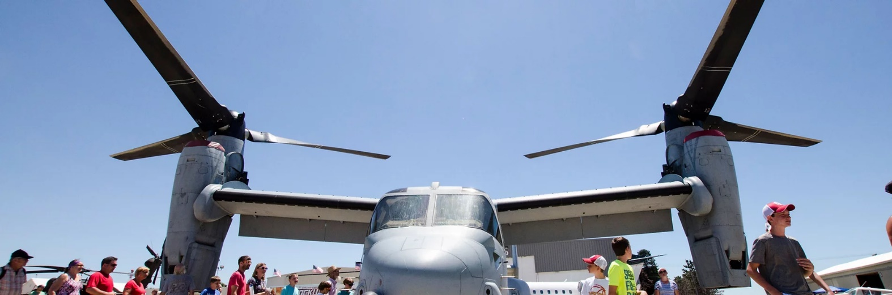
July 9, 2022 at Goshen Municipal Airport

ADMISSION

GATE (cash only)
Adult (13 and over): $20
Child (ages 6-12): $10
Children 5 and under: Free
Veterans with valid Military ID: Free

ADVANCE TICKETS
Adult (13 and over): $15
Child (ages 6-12): $8
PARKING
​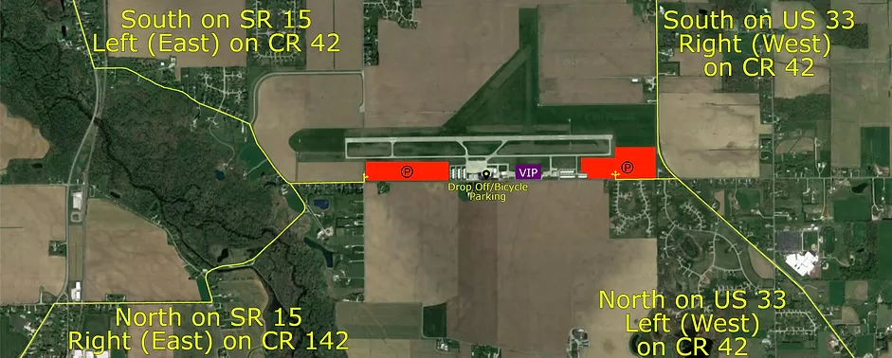

Feb 24, 2022 EAA Chapter 132 Membership Meeting at 7 pm

13 members at the membership meeting.
Secretary Marty King again read us minutes from the January meetings.
Phil is looking into a date for the EAA Oshkosh Maintenance Weekend that we can attend.
So far, the Oshkosh maintenance weekend date is either late April or early May.
Tim F. is looking into what is available for us in the Goshen Freedom Fest event. So far it will cost us $175 to do a food court which we can then make some funds off of. If we do Aircraft/Automobile marshalling may also be able to make us some additional funds as well.
Phil is also having a Kite fly at his house on either June 4th or 11th.
We will try and have two Young Eagle events (late spring and early fall).
Our Fly-In, Ride In, Drive In event will also be sometime later this year.
EKM airport manager Andy Jones presented us updates that will help the airport.
Runway 9/27 may be closed at certain times this year so runway lights can be replaced with heated LED lights that will be lot less in electric cost.
Runway 18/36 will be repaved next year or after do to limited funds available each year.
Taxiway Delta will also be redone depending on time of funds available in the next 5 years.
Some new hangers are also trying to be built soon.
Some old hangers may need some fixing as well.
Andy is getting a couple events to happen this year at EKM. Warbirds fly-in and the Military Re-enactment.
Andy also thinks we might have less to pay for utilities later this year.

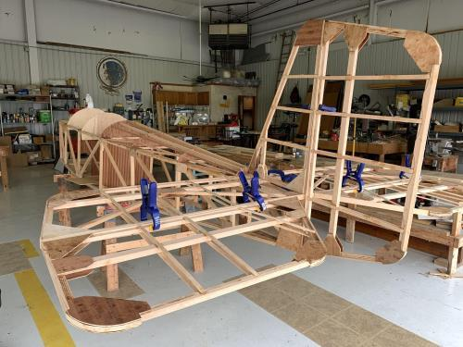

See Jim B & Steve L’s Experimental Aircraft Pietenpol project every Monday evening at 7pm at the EAA 57 hanger at the Elkhart Municipal Airport. They just added landing gear to their Pietenpol project. Have popcorn and meet with other
EAA Chapter 132 members too!

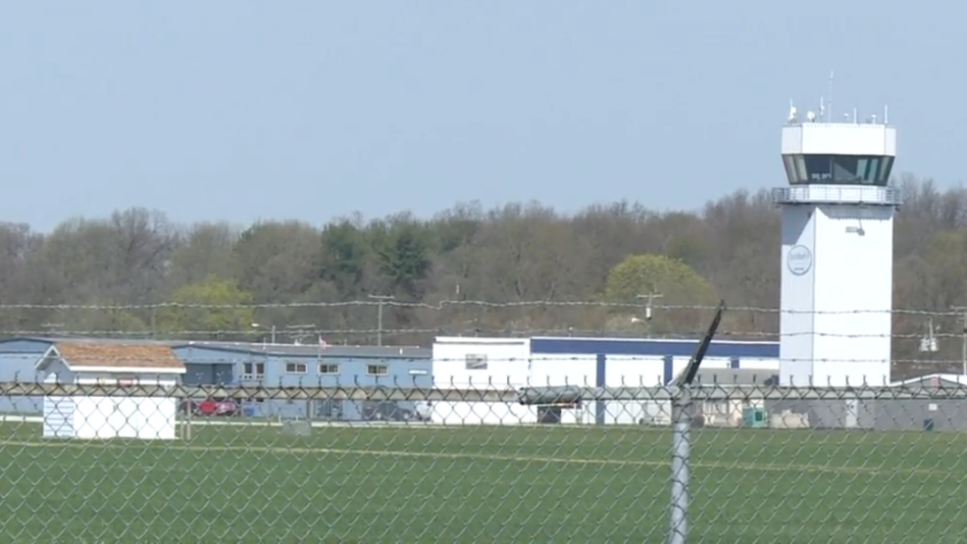

Feb 10, 2022 Board Meeting 7-8pm
Phil, Dick, Steve, Tim, Jerry, Marty & Don.

Secretary Marty King read us the January Membership Meeting minutes.
High prices on electric and gas utilities for EAA chapter 132 clubhouse and 57 hanger.
Saturday clubhouse breakfast donation recommended to be at least $5 per person.
STEM program was suggested.
Oshkosh EAA maintenance weekend was recommended.
A tour of the Indiana Flight Center old terminal was established for the January member meeting members after the meeting time.
Extra ways to get event(s) funding for our chapter.

Ryan Sherwood is our new Young Eagle Coordinator for our chapter!

Goshen’s Freedom Fest will be this year and our chapter wants to make some funds by having a food court or beverage/ice cream court as well as advertising our Young Eagles and Fly-In events.

Elkhart Municipal Airport Manager will be at the February Membership meeting to talk about Elkhart airport updates.

