

October 29 - Member Meeting 7:00 PM

FAA Maintenance – Tim Sokol

Our guest presenter is Tim Sokol from the FAA sharing maintenance best practices for all aircraft types. We will be in the blue Administration Hangar, but all participants must enter through the gate in the fence and through the door on the ramp and not through the pilot's lounge as it is still closed due to covid.  All participants will be spaced out and need to provide and wear their own masks while in the city facilities.

50/50 Raffle

Are You Smarter Than A “Buzzard Pilot” Quiz

(Need three contestants)







**JOIN EAA CHAPTER RECOGNITION PROGRAM**

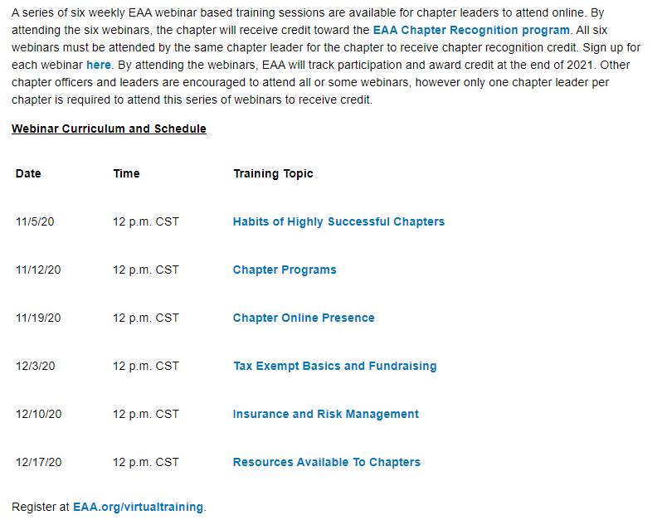

**A Challenge to Members to Share the Gift of EAA**

By: David Leiting, EAA Lifetime 579157

Vice President of EAA Chapter 252

EAA Membership Development Manager

Good Afternoon, from EAA HQ in Oshkosh!

 My name is David Leiting, and I am EAA’s Manager of Membership Development. I recently moved into this role. However, for the past 4.5 years I was on the Chapters team.  Since moving into this new role, one of my hopes was to work closely with the EAA Chapter network. Having seen the strength of the network, while also recognizing the support EAA HQ can provided, I knew there were plenty of opportunities.

 Well, today I am sharing an article with all the Newsletter Editors within the chapter network. Being a former Newsletter Editor for Chapter 1342, I understand there is always a need for more content, so I hope you find this article helpful. The article goes into detail about EAA’s new Legacy membership campaign, which encourages current members to gift an EAA membership to someone they know is deserving to carry aviation’s touch. My thought has always been that introducing a new member to EAA via a local chapter is the best way to show them what the EAA community is all about.

 If you are willing to share the attached article in the November newsletter, I would be extremely grateful. In addition, this would go a great distance in helping share the magic of EAA with the next generation of members. Again, I hope this article also helps you in your search for content for the November newsletter.

 Thank you for your continued support of your local chapter, and for being an EAA member!

 Please, let me know If you have any questions.

Tailwinds,

**David Leiting Jr., PPL ASEL, EAA Lifetime #579157,**

**EAA Warbirds #596249, EAA Vintage #724081**Membership Development Manager **EAA—*The Spirit of Aviation***

 Phone: 920.426.6116

Fax: 920.426.6560

[www.eaa.org](http://www.eaa.org/)

***See you at EAA AirVenture Oshkosh 2021 —*** ***July 26 to August 1, 2021***

The past 10 months have flipped the world upside down for many of us, but they have also allowed us to spend more time focusing on our families and our passions. For all of us, the shared passion is aviation. It is what brought us together, and has been the one constant we can look to when the days get rough.

The flying club I am a member of shut down operations for 90 days as we evaluated how we could safely operate amongst the COVID-19 pandemic. It pained me to stay out of the cockpit for more than three months. This was the first time since I passed my private pilot check ride that I was out of my 90-day currency! Additionally, my local EAA chapter put all of our events on hold. Although we were able to conduct virtual gatherings and board meetings, it wasn’t the same as our usual in-person events.

This lack of aviation activity caused me to reflect on my passion for aviation, and remind myself how easy it is to take for granted the aviation opportunities afforded by EAA. Like many of you, much of what I use to fuel my passion for aviation has come from EAA. EAA AirVenture Oshkosh, my Young Eagles flight, the relationships built through my local chapters, and the educational opportunities. Without EAA, I am not quite sure where I would find myself on my aviation journey.

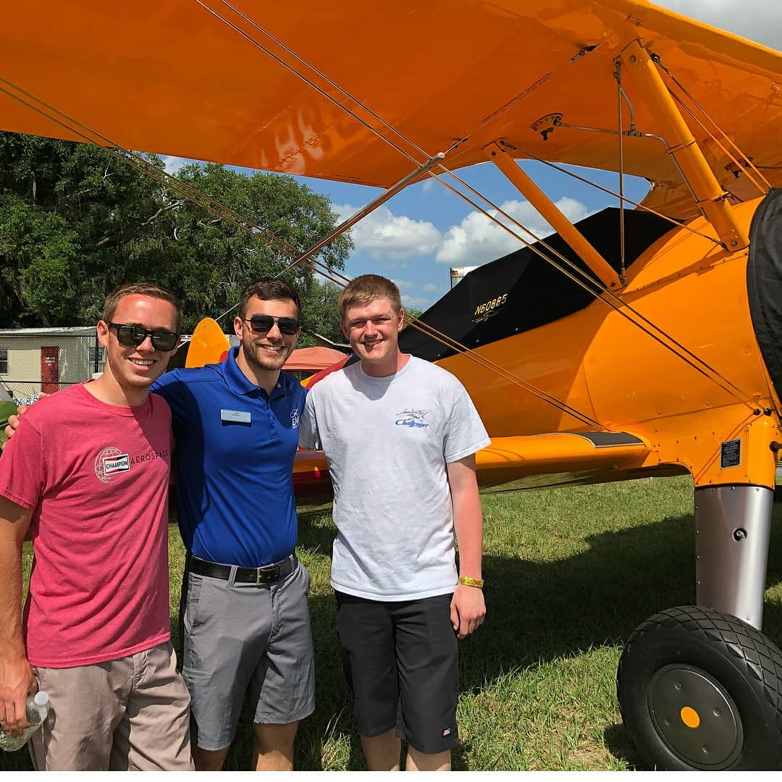

One of the great pillars of EAA is the opportunity to give back, and pass the torch to future members. Perhaps you have given a Young Eagles flight that led to a career aviator, or lent a helping hand to a friend building their own aircraft. There is also a great chance that you have benefited from the generosity of a fellow EAAer. It is the lifeblood of our organization!

We all remember our mentor who introduced us to aviation and are forever grateful for the gift they gave us. That mentor may still be a close friend of yours within your EAA chapter. EAA is now asking you to join us in helping to preserve the legacy of EAA Founder Paul Poberezny, and of all our past and current members, by gifting an EAA membership to someone you feel will continue to carry on EAA’s mission within The Spirit of Aviation.

It is EAA members such as yourself that can bring aboard the next generation of members. Your involvement in your local chapter is even a greater reason to introduce them to EAA. Chapter members are the most engaged and passionate members you’ll find within EAA. There is no better group than a local chapter to welcome a newcomer to EAA.

**Once you identify whom you’d like to sponsor, simply visit** [**www.EAA.org/Legacy**](http://www.EAA.org/Legacy) **to register EAA’s newest member.** After you gift this membership, invite the individual to your chapter, and show them the opportunities and community that exist in their own backyard. By gifting a membership and becoming a Legacy sponsor, you will receive a Legacy sponsor pin and patch.

EAA cannot thank you enough for your continued support of the organization, and especially of your local chapter. Chapters are the lifeblood of EAA, and without them the impact of EAA would be fraction of what it is today. Enjoy your holiday season, and we hope to see you in Oshkosh this July!

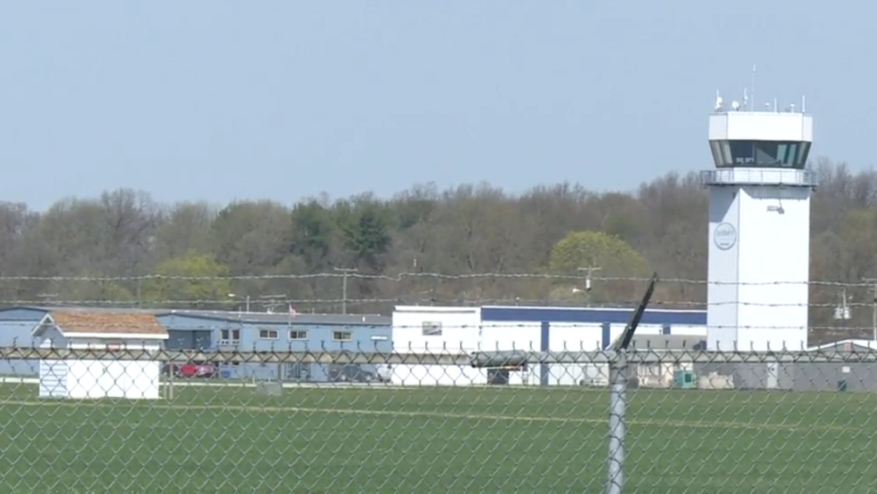

**Board Meeting Minutes**

**October 8, 2020 7:00PM – 8:30 PM**

**(Not the official report but a summary)**

Doug assigned a few board members to come up with about three catering food sources so we can choose one for our Christmas party dinner.

EAA Chapter 132 By Law confirmed that only two board directors will need to be elected or re-elected this year.

With it being cold out now, Doug requests that our member meetings be in the Admin hanger so that there can be social distancing and be nice and warm. Board meetings can still be at Clubhouse for most and possibly by Zoom for some if needed.

Looking for presenters to advise us on things happening in aviation at member meetings.

Looking for some safe fly-in/drive-in that are available even though COVID is still shutting some down.

Also looking into completing EAA projects.

Saturday morning member breakfast still on hold due to COVID.

