NIGHT BEFORE CHRISTMAS

Twas the night before Christmas, and out on the ramp,
Not an airplane was stirring, not even a Champ.
The aircraft were fastened to tiedowns with care,
In hopes that come morning, they all would be there.
The fuel trucks were nestled, all snug in their spots,
With gusts from two-forty at 39 knots.
I slumped at the fuel desk, now finally caught up,
And settled down comfortably, resting my butt.
When the radio lit up with noise and with chatter,
I turned up the scanner to see what was the matter.
A voice clearly heard over static and snow,
Called for clearance to land at the Elkhart airport below.
He barked his transmission so lively and quick,
I’d have sworn that the call sign he used was “St. Nick”.
I ran to the panel to turn up the lights,
The better to welcome this magical flight.
He called his RNAV runway 27 position, no room for denial,
“St. Nicholas One, turnin’ left onto runway 27 final.”
And what to my wondering eyes should appear,
But a EAA 132-built sleigh, with eight Rotax Reindeer!
With RNAV to final, down the glideslope he came,
As he passed all fixes, he called them by name:
“Now Goshen! Now Dinye! Now Fediv and Cogne!
On Comet! On Cupid!” What pills was he takin’?
While controllers were sittin’, and scratchin’ their head,
They phoned to my office, and I heard it with dread,
The message they left was both urgent and dour:
“When Santa pulls in, have him please call the tower.”
He landed like silk, with the sled runners sparking,
Then I heard “Right at Bravo 3,” and “Taxi to parking.”
He slowed to a taxi, turned off of two seven
And stopped on the ramp with a “Ho, ho-ho-ho…”
He stepped out of the sleigh, but before he could talk,
I ran out to meet him with my best set of chocks.
His red helmet and goggles were covered with frost
And his beard was all blackened from Reindeer exhaust.
His breath smelled like peppermint, gone slightly stale,
And he puffed on a pipe, but he didn’t inhale.
His cheeks were all rosy and jiggled like jelly,
His boots were as black as a cropduster’s belly.
He was chubby and plump, in his suit of bright red,
And he asked me to “fill it, with hundred low-lead.”
He came dashing in from the snow-covered pump,
I knew he was anxious for drainin’ the sump.
I spoke not a word, but went straight to my work,
And I filled up the sleigh, but I spilled like a jerk.
He came out of the restroom, and sighed in relief,
Then he picked up a phone for a Flight Service brief.
And I thought as he silently scribed in his log,
These reindeer could land in an eighth-mile fog.
He completed his pre-flight, from the front to the rear,
Then he put on his headset, and I heard him yell, “Clear!”
And laying a finger on his push-to-talk,
He called up the tower for clearance and squawk.
“Take taxiway Bravo, the northbound direction,
Turn right three-two-zero at pilot’s discretion”
He sped down the runway, the best of the best,
“Your traffic’s a Mooney, inbound from the west.”
Then I heard him proclaim, as he climbed through the night,
“Merry Christmas to all! I have traffic in sight.”

December 8, 2020 – EAA is mourning the death of Brig. Gen. Chuck Yeager, one of America's preeminent aviators who also supported EAA in a variety of ways over a 30-year period. Yeager died Monday evening in California at age 97.
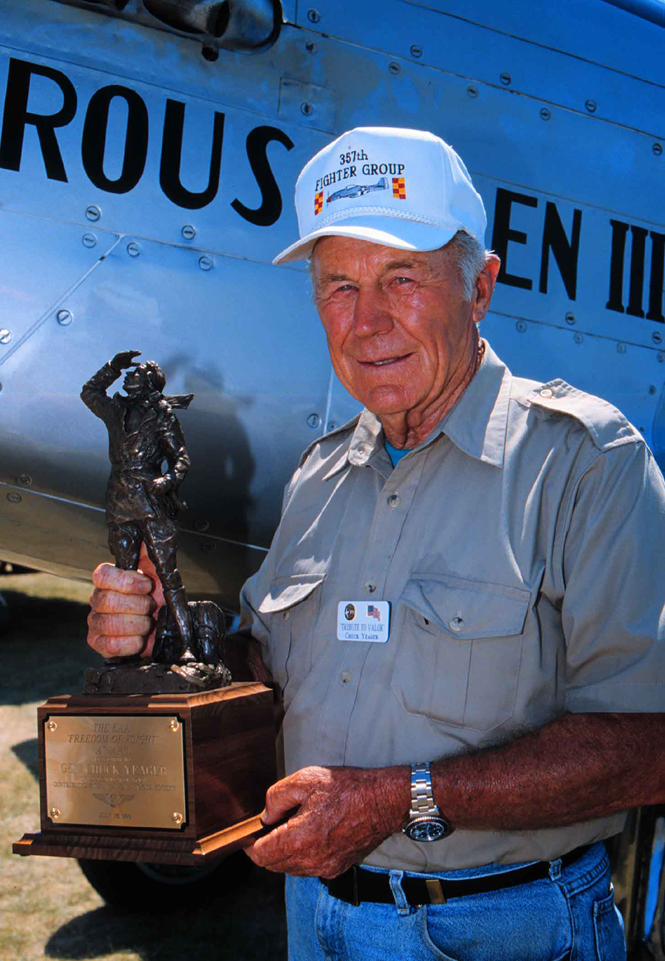
Gen. Yeager, EAA Lifetime 258188, was best known as the first man to fly faster than the speed of sound when he flew the Bell X-1 at Mach 1 in October 1947. He also had a decorated military career as an Army Air Forces ace in World War II and flew combat missions in the Korean and Vietnam Wars prior to retiring from the military in 1975.
To EAA members, however, Yeager's influence was most noticeable in two areas: As the second chairman of EAA's Young Eagles program for a decade, and for his regular appearances at EAA AirVenture Oshkosh over a 30-year period.
"Chuck Yeager's aviation accomplishments are well documented and legendary," said Jack J. Pelton, EAA's CEO and Chairman of the Board. "His personal support of EAA and its programs helped take them to new levels, and thousands of people had the opportunity to meet and hear him when he was at Oshkosh. We will remember Gen. Yeager for those generous commitments of his time to EAA, along with his immortal aviation achievements."
Yeager became the second chairman of the Young Eagles program in 1994, succeeding the late Cliff Robertson. Yeager was an active chairman, regularly flying Young Eagles including at Oshkosh. He also used his visibility to promote Young Eagles and youth involvement in aviation. He personally flew more than 250 Young Eagles during his time as the program's chairman. He also flew the 1 millionth Young Eagle, Illinois resident Andrew Grant, on an honorary flight in early 2004 as a tribute to the volunteers who reached the goal of flying 1 million Young Eagles by the centennial of powered flight commemorated at EAA's Countdown to Kitty Hawk program in North Carolina in December 2003. In September 2004, Yeager turned the chairman reins over to actor and pilot Harrison Ford.
Yeager was also a frequent visitor and presenter at EAA AirVenture Oshkosh, both at Theater in the Woods and in the Warbirds area. One notable presentation was a reunion with his 357th Fighter Group at the 1992 EAA fly-in convention that included Yeager and follow WWII ace Bud Anderson. At Oshkosh he also had the regular opportunity to reunite with his wingman from the 1947 supersonic flight, legendary pilot Bob Hoover.
EAA recognized Yeager's commitment to the organization by presenting him with EAA's highest honor, the Freedom of Flight Award, in 1995.
"Much will be spoken and written of Gen. Yeager's aviation exploits in honor of his passing, and deservedly so," Pelton said. "To us, he was all of that, but we will also remember him as a fellow EAA member who gave greatly of his time and talent to encourage and promote aviation, and motivate his fellow EAA members to join him as well."

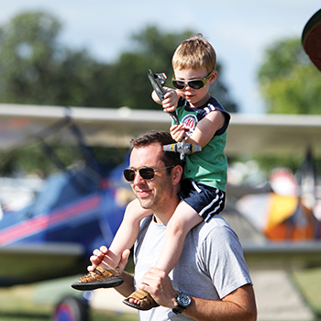

Buy Your 2021 EAA AirVenture Oshkosh Tickets
Purchase your EAA AirVenture Oshkosh admissions, camping, parking, flight experiences, and merchandise in advance.
It's fast and easy! With a few simple steps, you'll be inside the gates in no time and ready to take in AirVenture. You'll simply select weekly or daily tickets, enter the number of tickets you'll need for each category, pay by credit card using our secure online system, print your bar-coded ticket(s), present your ticket at any entry point to receive your AirVenture wristband, and breeze through the lines. If you purchased tickets at the preferred EAA member rate, please be prepared to provide proof of membership when you have your e-ticket scanned at the gate.
AirVenture 2021 dates: Monday, July 26-Sunday, August 1. You may purchase a daily ticket for any of the seven days, or a weekly pass, which includes all seven days.
Note: If your EAA membership is not current, please click here to renew, and allow 48 hours for processing before purchasing your tickets at member rates.

Early bird discounted pricing ends June 15, 2021.
NEW THIS YEAR! Free youth admission ages 18 and under has been generously supported in part by:
For more information on ticket purchasing, visit
https://www.eaa.org/airventure/eaa-airventure-tickets
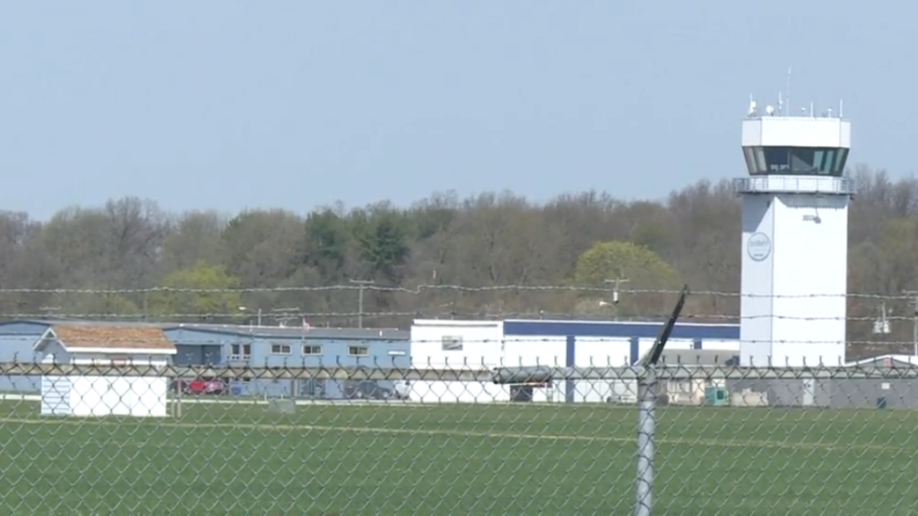
Board Meeting
December 3, 2020 7:00 pm to 8:00 pm

Jerry, Doug, Jim, Tim F, Michelle

This board meeting time was made to determine the December 5th Christmas Dinner options.

2021 Calendars are available at the Chapterhouse for $8.00 each.

December 5th EAA Chapter 132 Christmas Dinner was decided to happen.
Members attending would have their meals, desserts & drinks as planned as well as some entertainment.
Christmas Dinner location is the Elkhart Municipal Airport Admin Hanger.
50/50 raffle would be available. Silent Auction would be delayed due to the small amount of members/family attending the Christmas Dinner and only a few silent auction items available.
Only 15 were attending this year’s Christmas Dinner due to the Covid 19 pandemic.

