Purchase Your EAA AirVenture Oshkosh 2023 Tickets

July 24 - 30, 2023
Getting your EAA AirVenture Oshkosh 2023 tickets, parking, camping, and more is fast and easy! With a few simple steps, you'll be inside the gates in no time and ready to take in AirVenture. You'll simply select weekly or daily tickets, select optional add-ons like parking, camping, and flight experiences, and pay by credit card using our secure online system.

What's Included With Admission
- Access to all showplane parking areas, including homebuilts, vintage, aerobatic, warbirds, ultralights, lightplanes, rotorcraft, and seaplanes.
- AirVenture forums and workshops with no reservations required.
- A variety of evening programs, including nightly movies at the Fly-In Theater and programming at the Theater in the Woods.
- A variety of air show activities, including daily afternoon air shows and showcase flights, the Wednesday and Saturday night air shows, and Twilight Flight Fest.
- EAA membership information and merchandise areas.
- More than 1 million square feet of commercial exhibits, displays, and information from 800+ exhibitors.
- All AirVenture speaker venues, including Museum Speaker Showcase, Authors Corner, Warbirds in Review, and more.
- EAA Aviation Museum admission during the event.
- KidVenture located behind the museum at Pioneer Airport.

Methods of Payment
- Cash, personal checks, and traveler’s checks are accepted.
- Accepted credit cards: MasterCard, Visa, American Express, and Discover.
- ATMs are available on the grounds.
Please note: To access the Member Store, membership must be current through July 30, 2023, or your membership must be on auto-renew.
Please click the renew or join link and allow 2-3 minutes for processing before purchasing your tickets at member rates. For the best experience, log into your EAA.org account before clicking the "Member Store" button.

June 27, 2023 EAA Chapter Membership Meeting 7 pm

Phil was in charge of the membership meeting.

Marty gave us info on the May board/membership meetings.

Ted and his wife did a great job talking about he and his wife being in Australia a while ago and he and other pilots flying aircrafts together all around a lot of Australia.

Email/Facebook Problem:
Tim F is having an issue with our EAA Chapter 132 gmail email account. His part of the account has been deleted two or three times in the last 6 months from his access. He was able to fix until this June thinking the gmail account has been hacked by someone or made more unstable by more securities gmail is using. Over 6 months ago, he was hacked on the EAA Chapter 132 facebook account as well and unable for him to use our facebook account. He can still do our EAA vortex and send it to our EAA Chapter 132 website. He just can’t send email to all anymore. If another member is good at the gmail account and can seed emails that would be great.

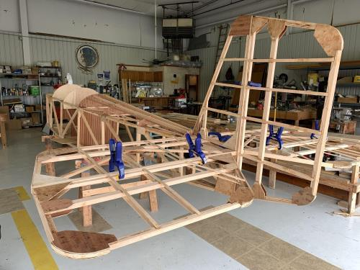

See Jim’s Experimental Aircraft Pietenpol project every Monday evening at 7pm at the EAA 57 hanger at the Elkhart Municipal Airport. He and Steve is adding elevator and rudder to their Pietenpol project. Have popcorn and meet with other
EAA Chapter 132 members too!

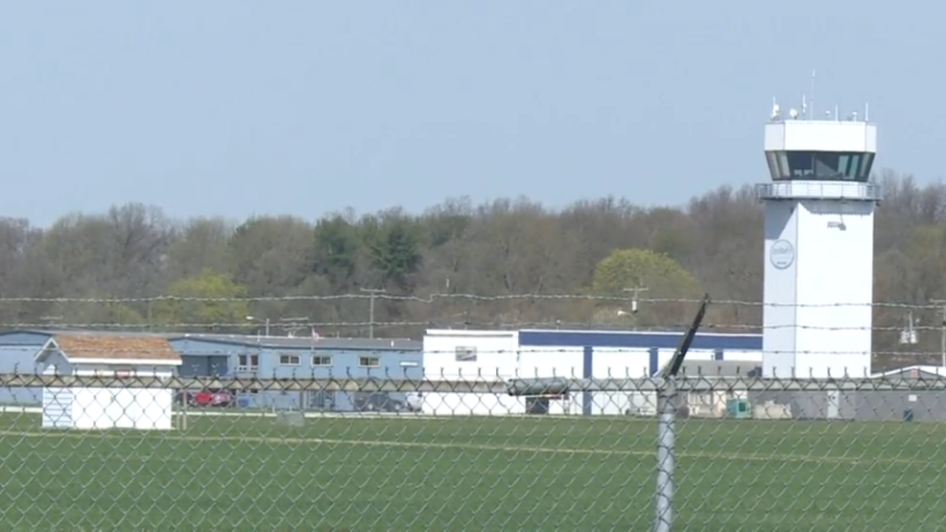

June 8, 2023 Board Meeting 7:00-7:45pm
Phil, Wendy, Marty, Tim, Ted, Ryan & Yeager
Phil was in charge of the Board Meeting.
We got $700 in tips from WWII patriots on the WWII Re-Enactment breakfast and lunch. Elkhart Airport gave us $1000 and food for WWII breakfast and lunch.
Elkhart Airport is going to do an RC jets airshow in 2024. Will do another WWII Re-Enactment in 2025.
Our Young Eagle is Saturday June 10th. Almost 100 kids signed up.
June 29 membership meeting will have Ted do a presentation about his trip and flying a plane in Australia he did a while ago.
June 13 board meeting but no June 27 membership meeting due to EAA Oshkosh.
We may be helping in a STEM in Aviation that should start around September at the Mishawaka Pilot Club airport.
Membership renewal is requested as soon as possible early in each year.

