

Hello,

 I am a new resident to the state of Indiana and a member of Women in Aviation, Purdue Graduate, former member of Civil Air Patrol and current member of the 99’s. I work for KSBN as the Operations Manager and I wanted to see if the Indiana chapter of the 99’s had any interest in the following.

 We are starting the planning for our **Aviation Education Day** here at South Bend International Airport on **Saturday, August 28, 2021** and I wanted to do a preliminary email to reach out to everyone, and anyone interested in participating. I myself was not here for the last Aviation Education Day in 2019, but I know that this event draws in major community involvement and I wanted to poll our partners to see if your organization wanted to or would be willing to be a part?! We have about two months to plan, finalize and execute the logistics.

 The details are being ironed out, but for right now, I am asking people on this email chain to reply to me and let me know if you think your chapter would like to participate. That can include recruiting booths for jobs, showing of your private airplane for attendees, fun activities for kids, airfield tours lby Ops, you name it, we will consider it- all ideas are welcome. If your chapter has a cool product or aviation related item that you would like to display-let me know!

 I would like to have responses back and finalized as soon as possible. I look forward to making this event fun, and educational and most of all a partnership with all of you to show everyone why we love working in aviation. 😊

 Ashley Thorsen

 Ashley Thorsen, M.S., C.M., ASC

Operations Manager

St. Joseph County Airport Authority

4477 Progress Drive

South Bend, IN 46628

P: 574-282-4590 ext. 240



**EAA Chapter 132 Hoosier Fun to Fly 2021**

Tentative scheduling so far. Contact Tim at [tsfarrell28630@gmail.com](mailto:tsfarrell28630@gmail.com) if there are other cool places to go.

Some of these may be postponed or changed due to other EAA Chapter events such as Young Eagles.

June 27th (Sunday) – **Niles Pancake Breakfast**

EAA Chapter 865

July 10th (July 17th as alternate) - **Gambling at the Casino**

Shelbyville, IN airport (KGEZ). Call Casino and they will pick you up from the airport.

August 22nd (Sunday)– **EAA/Duck’s Fly-In and Drive In** Food Starting at 1:00. 2,400’ grass airstrip.

September 18th (Sept 25th as alternate) – **Air Force Birthday**

Columbus, IN airport (KBAK). Air Museum (Free or Donation) Blackerby’s Hanger 5 Restaurant. Both at airport.

October 9th (Oct 16th as alternate) – **Corsair Café**

Terre Haute, IN airport (KHUF) Corsair Café at airport terminal. Holocaust museum in city.

November 6th (Nov 13th as alternate) - **Lighthouse or Tweedle Dee’s Restaurants**

Rochester, IN Fulton County airport (KRCR). Both right next to the airport.

# AirVenture 2021 Tickets Available Now

# Buy Your 2021 EAA AirVenture Oshkosh Tickets

Purchase your EAA AirVenture Oshkosh admissions, camping, parking, flight experiences, and merchandise in advance.

**It's fast and easy!** With a few simple steps, you'll be inside the gates in no time and ready to take in AirVenture. You'll simply select weekly or daily tickets, enter the number of tickets you'll need for each category, pay by credit card using our secure online system, print your bar-coded ticket(s), present your ticket at any entry point to receive your AirVenture wristband, and breeze through the lines. If you purchased tickets at the preferred EAA member rate, please be prepared to provide proof of membership when you have your e-ticket scanned at the gate.

AirVenture 2021 dates: Monday, July 26-Sunday, August 1. You may purchase a daily ticket for any of the seven days, or a weekly pass, which includes all seven days.

Note: If your EAA membership is not current, please [**click here to renew**](https://www.eaa.org/eaa/renew-eaa/renew-membership), and allow 48 hours for processing before purchasing your tickets at member rates.

## Early bird discounted pricing ends June 15, 2021.

**NEW THIS YEAR! Free youth admission ages 18 and under has been generously supported in part by:** Boeing

For more information on ticket purchasing, visit

<https://www.eaa.org/airventure/eaa-airventure-tickets>

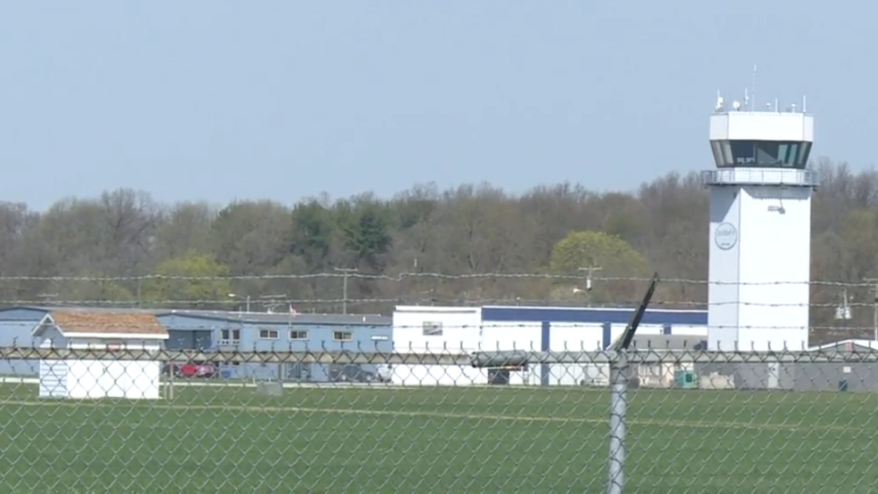

**July 8, 2021 Board Meeting 7-8pm**

Tim F, Dick, Jim, Cindy, Doug, Darren, Steve

Darren introduced himself. He works at Wheels Up and although has not flown in a while is wanting to get back. Possibility he may become an EAA Technical Advisor.

Young Eagles - Pilots and ground volunteers need to make sure and recertify their youth protection credentials.

Doug has arranged a couple of guest speakers for the August member meeting. It was suggested having a potluck beforehand and to be held at the Admin Hanger.

FI/DI/RI – Dick has handed out 250 flyers, but he has plenty more for the rest of the members to hand out. Need someone to approach local media. Different food venues were discussed but what is most profitable for the Chapter is for us to do as we have done in the past and sell sandwich/chips/drinks. 50/50 will also be available.

Our Saturday morning breakfasts will start back up on September 11. Board approved the purchase of two new griddles which Steve will take care of getting. Food will be same as in years past. Members sign up for any given Saturday and although the Chapter will have eggs, sausage and pancake mix on hand, it will be up to the volunteer(s) to chose whatever they want to prepare. The Chapter will reimburse any receipts turned in.

