

Chapter Meeting August 27, 2021 7:04pm to 8:18pm

12 Present

Pledge of Allegiance

Project and flying updates

Annual Duck Fly-In was well attended and liked by all.

Doug reported on Young Eagles. Pilots will only do six flights and all volunteers need to recertify via EAA to be able to work with children.

Dick gave an update on this years FI/DI/RI. Over 600 posters have been distributed. Ted & Vic will not be doing the food this year, so we are in need of volunteers to take over.

Marcus CFI safe flying minute: topic was unusual attitudes. How they happen and how to recover.

Still in need of a Chapter VP, historian and photographer.

Tim’s are you smarter than a student pilot: group participation and no we are not.

Tim reported on Chapter house cleanup/spruce up: walls are being cleaned and will be painted. Question was asked, when the last time the chimney was cleaned. Lots of publications need to determine whether to keep or recycle.

Guest speaker for the month was Martin Pauly.

Martin’s hobby is YouTube content on a variety of aviation subjects.

He is originally from Germany but moved to Cedar Rapids in 1998.

Martin covered his aviation background (started flying gliders in Germany at the age of 14) and then why and how he makes his YouTube videos.

One of his current projects is the making and auctioning off posters all signed by social media personalities. The money raised will be given to Woody Williams Foundation (for Gold Star family’s) and AOPA Air Safety Institute.

His YouTube channel can be found at: martin pauly youtube videos

And his poster auction at: [www.martin.aero/poster](http://www.martin.aero/poster)

The 50/50 drawing $9.00 was won by Tabetha Busch.

Hello,

 I am a new resident to the state of Indiana and a member of Women in Aviation, Purdue Graduate, former member of Civil Air Patrol and current member of the 99’s. I work for KSBN as the Operations Manager and I wanted to see if the Indiana chapter of the 99’s had any interest in the following.

 We are starting the planning for our **Aviation Education Day** here at South Bend International Airport on **Saturday, August 28, 2021** and I wanted to do a preliminary email to reach out to everyone, and anyone interested in participating. I myself was not here for the last Aviation Education Day in 2019, but I know that this event draws in major community involvement and I wanted to poll our partners to see if your organization wanted to or would be willing to be a part?! We have about two months to plan, finalize and execute the logistics.

 The details are being ironed out, but for right now, I am asking people on this email chain to reply to me and let me know if you think your chapter would like to participate. That can include recruiting booths for jobs, showing of your private airplane for attendees, fun activities for kids, airfield tours lby Ops, you name it, we will consider it- all ideas are welcome. If your chapter has a cool product or aviation related item that you would like to display-let me know!

 I would like to have responses back and finalized as soon as possible. I look forward to making this event fun, and educational and most of all a partnership with all of you to show everyone why we love working in aviation. 😊

 Ashley Thorsen

 Ashley Thorsen, M.S., C.M., ASC

Operations Manager

St. Joseph County Airport Authority

4477 Progress Drive

South Bend, IN 46628

P: 574-282-4590 ext. 240



**EAA Chapter 132 Hoosier Fun to Fly 2021**

Tentative scheduling so far. Contact Tim at [tsfarrell28630@gmail.com](mailto:tsfarrell28630@gmail.com) if there are other cool places to go.

Some of these may be postponed or changed due to other EAA Chapter events such as Young Eagles.

August 22nd (Sunday)– **EAA/Duck’s Fly-In and Drive In** Food Starting at 1:00. 2,400’ grass airstrip.

September 18th (Sept 25th as alternate) – **Air Force Birthday**

Columbus, IN airport (KBAK). Air Museum (Free or Donation) Blackerby’s Hanger 5 Restaurant. Both at airport.

October 9th (Oct 16th as alternate) – **Corsair Café**

Terre Haute, IN airport (KHUF) Corsair Café at airport terminal. Holocaust museum in city.

November 6th (Nov 13th as alternate) - **Lighthouse or Tweedle Dee’s Restaurants**

Rochester, IN Fulton County airport (KRCR). Both right next to the airport.

-------------------------------------------------------------------------------------------------------------------------------------------

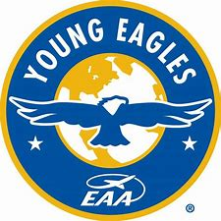

EAA Chapter 132 Young Eagles Flights Saturday Sept. 25, 2021 at Elkhart Municipal Airport.

# AirVenture 2021 Tickets Available Now

# Buy Your 2021 EAA AirVenture Oshkosh Tickets

Purchase your EAA AirVenture Oshkosh admissions, camping, parking, flight experiences, and merchandise in advance.

**It's fast and easy!** With a few simple steps, you'll be inside the gates in no time and ready to take in AirVenture. You'll simply select weekly or daily tickets, enter the number of tickets you'll need for each category, pay by credit card using our secure online system, print your bar-coded ticket(s), present your ticket at any entry point to receive your AirVenture wristband, and breeze through the lines. If you purchased tickets at the preferred EAA member rate, please be prepared to provide proof of membership when you have your e-ticket scanned at the gate.

AirVenture 2021 dates: Monday, July 26-Sunday, August 1. You may purchase a daily ticket for any of the seven days, or a weekly pass, which includes all seven days.

Note: If your EAA membership is not current, please [**click here to renew**](https://www.eaa.org/eaa/renew-eaa/renew-membership), and allow 48 hours for processing before purchasing your tickets at member rates.

## Early bird discounted pricing ends June 15, 2021.

**NEW THIS YEAR! Free youth admission ages 18 and under has been generously supported in part by:** Boeing

For more information on ticket purchasing, visit

<https://www.eaa.org/airventure/eaa-airventure-tickets>

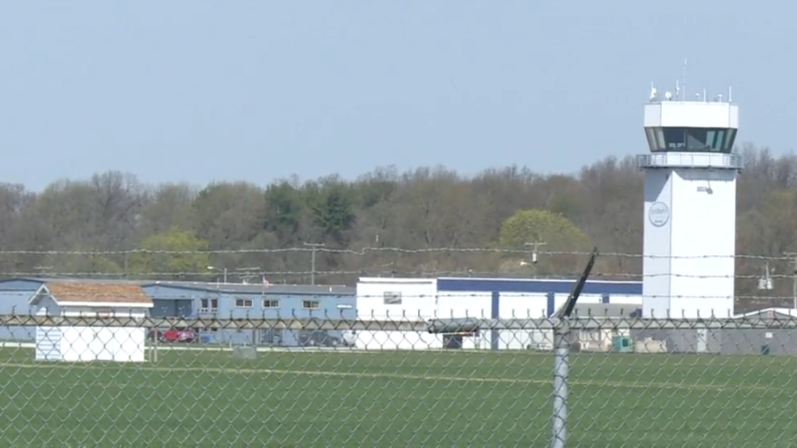

**Aug 12, 2021 Board Meeting 7-8pm**

Tim F, Dick, Jim, Cindy, Doug, Steve

Young Eagles - Pilots and ground volunteers need to make sure and recertify their youth protection credentials.

Doug has arranged a couple of guest speakers for the August member meeting. It was suggested having a potluck beforehand and to be held at the Admin Hanger.

EAA Chapter 32 Clubhouse painting/cleaning will be started end of August and mostly done before Sept. 11 Breakfast. Phase II will have to be started sometime afterward. Plastic film on windows can be fixed/replaced then window areas can be painted.

FI/DI/RI – Dick has handed out 250 flyers, but he has plenty more for the rest of the members to hand out. Need someone to approach local media. Different food venues were discussed but what is most profitable for the Chapter is for us to do as we have done in the past and sell sandwich/chips/drinks. 50/50 will also be available.

Our Saturday morning breakfasts will start back up on September 11. Food will be same as in years past. Members sign up for any given Saturday and although the Chapter will have eggs, sausage and pancake mix on hand, it will be up to the volunteer(s) to chose whatever they want to prepare. The Chapter will reimburse any receipts turned in.

