

Reminder:

Welcome to Monday night popcorn at 7pm in our EAA Chapter hanger.

Saturday morning breakfasts from 8-9am at our EAA Chapter 132 Clubhouse.

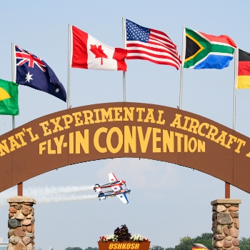**Get Your AirVenture 2022 Tickets**

It's never too early to start planning for your favorite week of the year! Early bird pricing is in effect until June 15, 2022.

[**Read More**](https://www.eaa.org/airventure/eaa-airventure-tickets)

**American Freedom Fest**

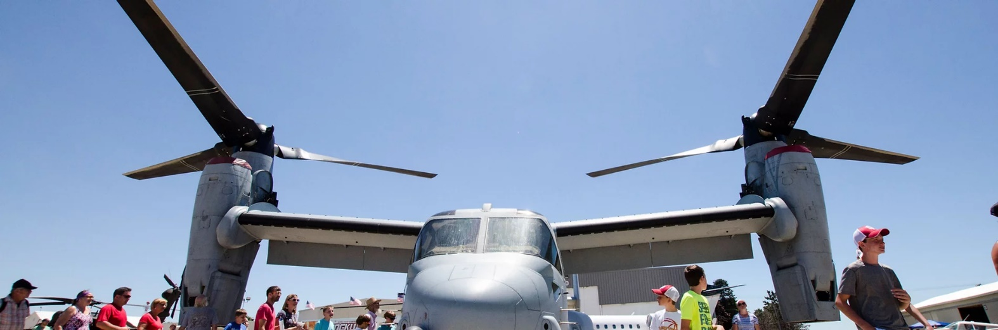

July 9, 2022 at Goshen Municipal Airport

##### ADMISSION

##### GATE (cash only)

Adult (13 and over): $20

Child (ages 6-12): $10

Children 5 and under: Free

Veterans with valid Military ID: Free

##### ADVANCE TICKETS

Adult (13 and over): $15

Child (ages 6-12): $8

PARKING

​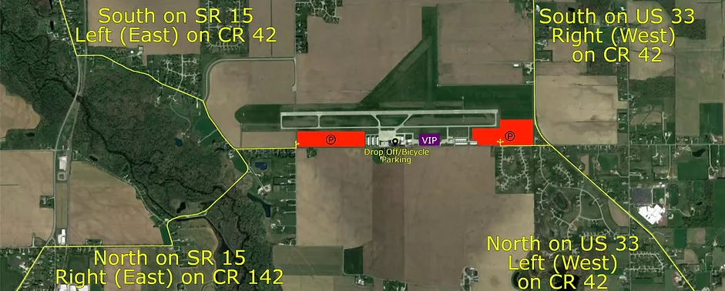

ELKHART MUNICIPAL AIRPORT NOTAM

All,

Working with Mayor Rod Roberson and the Board of Aviation Commissioners, I am pleased to inform you that last fall the airport received grant funds from the Federal Aviation Administration that will pay 90% of the costs associated with upgrading the current Runway 9/27 lighting to LED. The Indiana Department of Transportation Aeronautics Section will participate by contributing 5% of the project’s cost, and the remaining 5% will be paid by City of Elkhart. I thank everyone involved for their unwavering support of the Elkhart Airport and helping to secure these funds!

During construction, contractor ground vehicles will be present on RW 9/27. Obviously during those times RW 9/27 will be unusable. With the goal in mind of minimizing the inconvenience to our airport users, our Air Traffic Controllers, Indiana Flight Center, Construction Contractors, Project Manager, and other airport users, have developed a runway 9/27 use during construction schedule. The most current construction dates and use schedule is below along with information about the necessity for taking certain navigational aids out of service during construction. If any of you has questions or concerns about the schedule please don’t hesitate to contact us. I recommend you first reach out to Jeremy Yahwak from Butler Fairman & Seufert Engineers  (317) 459-4518. Jeremy has an office here in the Airport Administration Building located at 1211 Co. Rd. 6 W. Jeremy will be in daily contact with the contractors, therefore likely to be the best person to answer your questions and help to provide solutions to most any challenge you may encounter associated with this construction project. You are also welcome to call me about this or any other airport related issue, observations, concerns, requests, etc. (574) 903-4815.

Andy Jones

**Airport Director**

**Elkhart Municipal Airport**

**1211 CR 6 W**

**Elkhart, IN 46514**

**Cell: 574-903-4815**

**Office: 574-264-5217**

The earliest possible start date is Monday April 4.  There is a possibility of beginning April 11.

We are planning to have temporary openings during the day throughout the project.  The contractor is planning to work 7 a.m. to 5 p.m.  Before 7 a.m. and after 5 p.m. during daylight the runway is planned to be open.  With daylight savings time the morning opening may not be possible at the beginning of April.  We also are planning to have a window around lunch (noon to 1 p.m.) to temporarily open the runway.  We should have the start date nailed down in the next few days.

As far as what is going to be closed, here is what we are planning to close assuming a start date of April 4:

 NOTAM: Some of the working be done had to have time and dates being done revised due to some of the lights being delivered was delayed.

A few things worth noting:

Taxiing on B1 and D3 will be available during Sequence 1.

The contractor has said they don’t have an issue providing access to Turf Runway 8-26.  Whether it’s by B3 or B4 depends on where they are working when the need arises.

The contractor is not planning to work weekends unless it is needed.  This means the runway should be available on most weekend days.

During the temporary openings, Runway 9-27 will be limited to VFR.  From beginning to end the Runway 9-27 lights will not be operational.  FAA navigation aids for Runway 9-27 will also be shut off for the duration of the project.  All other airfield lighting will be operational.

I’ve attached the Construction Safety and Phasing Plan sheets for your use.  If you have any more questions or need clarification, please let me know.  I’m happy to meet with you to discuss as well.

Best Regards,

**Jeremy Yahwak, P.E., CPESC**   
**Project Engineer**

Butler, Fairman & Seufert, Inc.  
8488 Georgia Street, Suite C | Merrillville, IN 46410-6249  
p 219-769-2333 | f 219-769-2377 | c 317-459-4518  
[Jyahwak@bfsengr.com](mailto:Jyahwak@bfsengr.com) | www.BFSEngr.com  
  
  
  
Kren Shaw

Office Manager

Elkhart Municipal Airport

Karen.shaw@coei.org

**Friday Fly-In Lunches Start April 1st 11:30am to 1:00pm**

**Donations recommended**

Goshen Airport (KGSH) will have every 1st Friday lunch from April to December

Smith Field Airport (KSMD) will have every 2nd Friday lunch from April to October

Elkhart Airport (KEKM) will have every 3rd Friday lunch from April to October at the Indiana Flight Center old passenger terminal.

La Porte Airport (KPPO) will have every 4th Friday lunch from April to October

Fulton Co Airport (KRCR) will have any 5th Friday lunch from April to October.

-------------------------------------------------------------------------------------------------------------------------

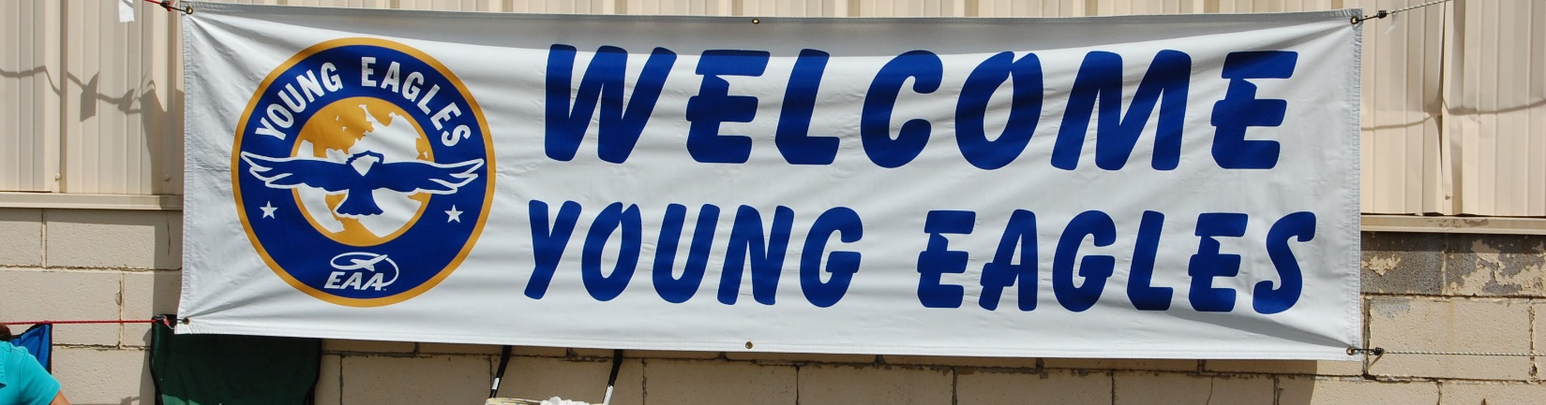

**Elkhart, IN 2022 Spring Event**

**EAA Chapter 132 at Elkhart Municipal Airport**

**Saturday May 21, 2022 @ 9:00am – 12:00pm**

**Contact: Ryan Sherwood – (574) 370-2279**

**Reminder: Pilots and Young helpers will need to have there 3 year Child Protection renewed at** [**https://youngeaglesday.org/**](https://youngeaglesday.org/)

**April 28, 2022 EAA Chapter 132 Membership Meeting at 7 pm**

At the KingAreo hanger, Marty let us know what had to be done to revise a J4 airplane from scratch. The plane was many decades old and many of the parts have to be revised, fixed or replaced.

Marty also read us minutes from the April board meetings.

Some of us went to the Oshkosh Maintenance Work Weekend is April 23 & 24 and some if us had to cancel going as well.

Tim F. let us know that the $175 check Jerry made for Freedom fest was delivered by Tim to Goshen airport member Randy Gingrich. We have so far been approved to be at the main food court. We can use our 20 x 20 foot tent. We can tell folks about Young Eagles events and EAA Chapter membership. Ted let us know that Phil’s wife (and Phil) will probably be in charge of our food court at the Freedom Fest event. FYI – Any unpacked foods will have to be inspected by Elkhart Co Health Department. Beverages and packages Ice Cream bars might be a good thing. We might be able to do marshalling for planes/cars as well. Tim is wanting to do some marshalling.

Our first of two Young Eagle events will be May 21st.

Phil is also having a Kite fly at his house on either June 4th or 11th.

50/50 raffle was forgotten to be done at Marty’s hanger.

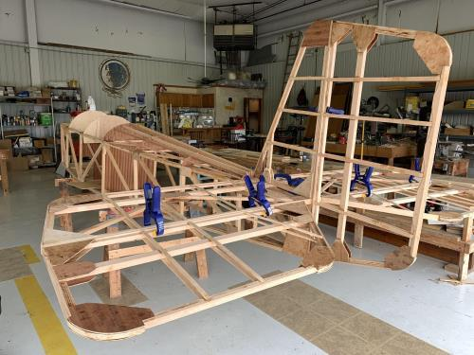

See Jim B & Steve L’s Experimental Aircraft Pietenpol project every Monday evening at 7pm at the EAA 57 hanger at the Elkhart Municipal Airport. They just added landing gear to their Pietenpol project. Have popcorn and meet with other

EAA Chapter 132 members too!

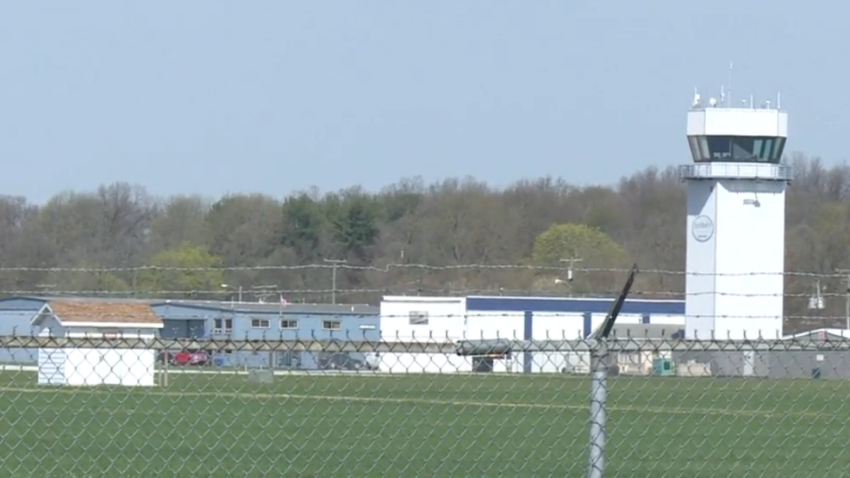

**April 14, 2022 Board Meeting 7-8:00pm**

Phil, Marty, Jerry, Steve, Ryan, Tim, Ted & Dick.

Secretary Marty King read us the March Membership Meeting minutes.

Marty will present J4 airplane information needed to redo the airplane from scratch at the April EAA Chapter 132 Membership Meeting in the KingAero hanger.

High prices on electric and gas utilities for EAA chapter 132 clubhouse and 57 hanger. Still hoping to get some reduced.

Oshkosh EAA work weekend was picked for April 23 & 24 at Oshkosh.

Phil mentioned he will have Hamburgers/Hotdogs at the Phil Kite Event.

Young Eagles spring event at EKM on May 21st.

Ryan Sherwood is our new Young Eagle Coordinator for our chapter!

Reminder: Child protection is required every three years.

Goshen’s Freedom Fest will be this year and our chapter wants to make some funds by having a food court or beverage/ice cream court as well as advertising our Young Eagles and Fly-In events.

Charley Whitney passed away. Ryan visited his estate and looked into airplanes that he had that we thought might be available at an auction. A 150, 170B, 172 and ultra light looked to be unsavable. These had been outside for many years. There is a Wagaero cub that might be available for auctioning.

EAA Chapter 132 needs to fix ceiling panels in the clubhouse.

