





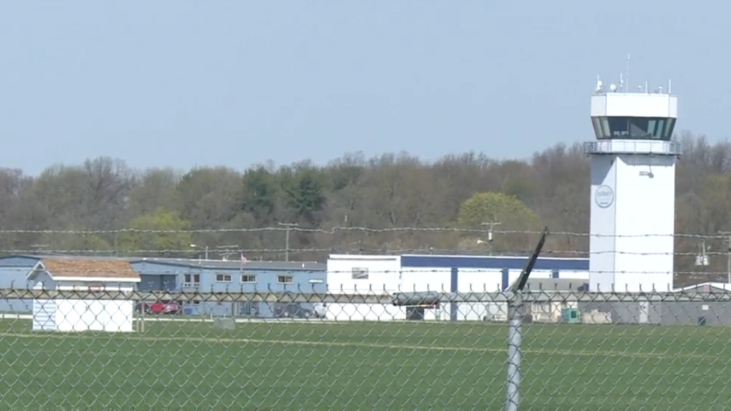

**Board Meeting Minutes**

**September 10, 2020**

No Board Meeting



