Purchase Your EAA AirVenture Oshkosh 2023 Tickets

July 24 - 30, 2023
Getting your EAA AirVenture Oshkosh 2023 tickets, parking, camping, and more is fast and easy! With a few simple steps, you'll be inside the gates in no time and ready to take in AirVenture. You'll simply select weekly or daily tickets, select optional add-ons like parking, camping, and flight experiences, and pay by credit card using our secure online system.

What's Included With Admission
- Access to all showplane parking areas, including homebuilts, vintage, aerobatic, warbirds, ultralights, lightplanes, rotorcraft, and seaplanes.
- AirVenture forums and workshops with no reservations required.
- A variety of evening programs, including nightly movies at the Fly-In Theater and programming at the Theater in the Woods.
- A variety of air show activities, including daily afternoon air shows and showcase flights, the Wednesday and Saturday night air shows, and Twilight Flight Fest.
- EAA membership information and merchandise areas.
- More than 1 million square feet of commercial exhibits, displays, and information from 800+ exhibitors.
- All AirVenture speaker venues, including Museum Speaker Showcase, Authors Corner, Warbirds in Review, and more.
- EAA Aviation Museum admission during the event.
- KidVenture located behind the museum at Pioneer Airport.

Methods of Payment
- Cash, personal checks, and traveler’s checks are accepted.
- Accepted credit cards: MasterCard, Visa, American Express, and Discover.
- ATMs are available on the grounds.
Please note: To access the Member Store, membership must be current through July 30, 2023, or your membership must be on auto-renew.
Please click the renew or join link and allow 2-3 minutes for processing before purchasing your tickets at member rates. For the best experience, log into your EAA.org account before clicking the "Member Store" button.

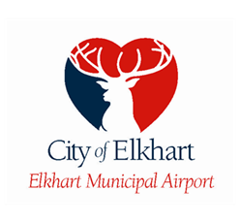

March 27, 2023

Letter of invitation to Salute to Veterans WWII Reenactment and Airshows Press Conference

Dear friends and sponsors,

On March 30, 2023, Mayor Rod Roberson will be holding a press conference to announce the return of Salute to Veterans WWII reenactment and the Airshows to Elkhart Municipal Airport (EKM). Speaking will be Mayor Roberson, the event’s host Elkhart Festivals Inc. President Ben Decker, and EKM Director Andy Jones.
We formally invite you and your guests, all journalists and members of the press to this conference.
Kindly note below the full details of the event:
Date: 30th March 2023
Time: 3:00 PM
Location: 1211 County Road 6 W. EKM Administration Building North Ramp
RSVP is encouraged but not required. Email: andy.jones@coei.org or karen.shaw@coei.org

EAA Chapter 132 will need volunteers for May 20 & 21 for Breakfast and lunch for WWII re-enactment members. EAA Chapter 132 can also have volunteers for the WWll re-enactment as well. If you want to be a volunteer for Breakfast & Lunch, let us know at our EAA Chapter 132 April 27 membership meeting or let our president Phil know. If you want to volunteer for the WWII re-enactment part let Elkhart airport manager Andy know as soon as possible for any day(s) you want to volunteer for WWII re-enactment part.

Reminder:
Welcome to Monday night popcorn at 7pm in our EAA Chapter 132 hanger 57 at the Elkhart airport.
Saturday morning breakfasts from 8-9am at the our EAA Chapter 132 Clubhouse.

------------------------------------------------------------------------------------------------------------------------------------------

Mar 30, 2023 Membership Meeting 7 - 8:30 pm

Secretary Marty King gave us a briefing on the Mar 9, 2023 Board Meeting info.
We will need volunteers to serve breakfast/lunch on May 20th & 21st for the re-enactment members.
Elkhart airport Manager Andy let us know that the EKM could have a Ride In, Fly In & Drive In on a different day than June 10, 2023. Our EAA chapter looks like the Young Eagle will be June 10.

Andy also let us know that Elkhart airport will have another WWII Re-enactment in 2025. He and airport manager Randy Sharkey of Goshen doing airshows every other two years separately.

Unfortunately, Phil has let us know that Oshkosh doesn’t want work party group any more.

Marty won awards from the FAA for state of Michigan and Northern Indiana.

Phil will be in charge of getting food for our Saturday breakfast until Steve is okay after his surgery.
We also need cookers to assign for the Saturday breakfast until later in May.

May 13th 2-6pm Lowell is having birthday at a hanger in Goshen. Feel free to go to celebrate his birthday. We will know before which hanger in Goshen this will be in.

Alan Cuthbert made a presentation about his journey giving his Ercoupe skis to fly on days with snow on the ground. He did a great job making skis to be put on as well as putting tires back on when snow is gone. Alan showed us a video of him flying the Ercoupe with Skis. He also showed that is young son also flew the Ercoupe and landed it with skis perfect. Brandon Herzong also helped Alan make the video with a drone.

Had a good crowd of EAA members and friends at the membership meeting.

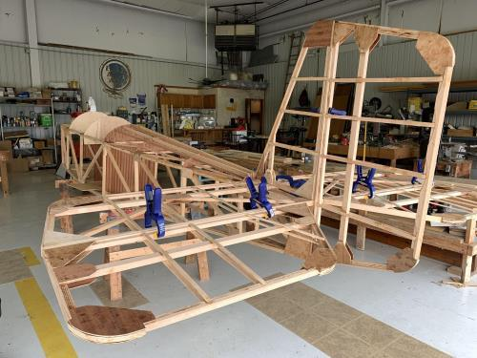

See Jim’s Experimental Aircraft Pietenpol project every Monday evening at 7pm at the EAA 57 hanger at the Elkhart Municipal Airport. He and Steve is adding elevator and rudder to their Pietenpol project. Have popcorn and meet with other
EAA Chapter 132 members too!

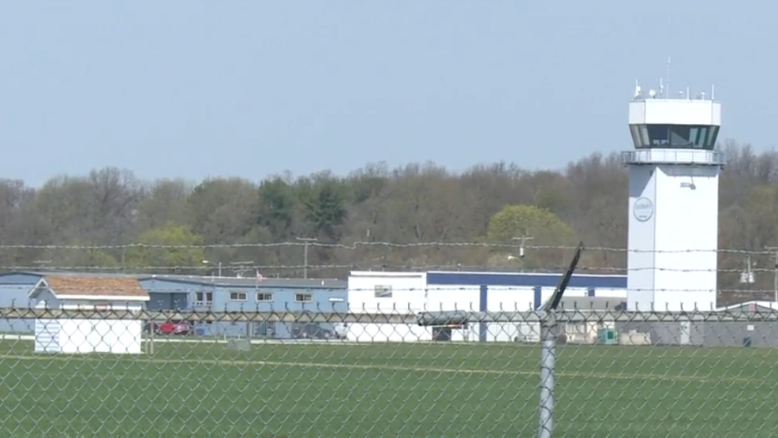

Mar. 9, 2023 Board Meeting 7:05-7:28pm
Phil, Steve, Marty, Tim, Wendy, Jeremy, Don and Yeager
Phil was in charge of the Board Meeting.
There was a briefing on the Formation Flight School Thursday & Friday May 18 & 19 this year. Elkhart Municipal Airport hosting WWII re-enactment and full airshow May 20 & 21 this year as well.
Lowell will have a birthday gathering at a hanger in Goshen airport May 13 2-6pm.
Our Young Eagle is Sat June 10th unless Andy wants EKM to have the RDF-IN on the same date.
Alan Cuthbert will do a presentation on his Ercoupe.
Membership renewal is requested as soon as possible early in 2023.

