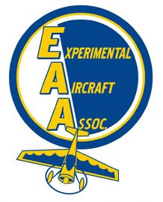
11/25/19
Chapter 544
Hastings, NE

EAA Chapter 544 met at 7pm at the Hastings Air FBO in Hastings NE
Meeting called to order at 7:00 p.m.

In attendance:
• Mitch Krull, Steve Wilson, Aaron Schardt, Glen Bredthauer, Troy Johnson, Bryon Jorgensen, Roy Dwinell

Minutes from the previous meeting were unavailable

Treasurer Report:
• $3280
• Note to members that dues are to be renewed in January

Club Project
Discussed Long EZ project – perhaps buid the fuse and try that out to see how much time it might take. Also discussed the empennage kit of an RV7 or RV14 as a winter project and the Long EZ as a summer project.

Election of Officers will be next meeting
Discussed hosting the State Fly In in 2021 or 2022. We are on the tentative schedule for the B-17 host airport for Father’s Day 2021. Aaron motioned to support a 2021 bid for the Nebraska State Fly In, Byron 2nd. Motion Passed.

Glen and Aaron reviewed the Duncan Tour last month. We had eight students and four adults attend with three aircraft flying to Lincoln. The CEO of Duncan gave us a personal three our tour and it was a great success.

Aviation Merit badge for Boy Scout Camp in 2020 was discussed. It was the highest rated badge at camp last year and they want us to do it for two weeks this year. More details to come.

Mitch gave a report on Hastings Air joining the CAA which directs corporate aircraft traffic to Hastings. It’s a great win for Hastings Air as only four FBO’s in the State are designated CAA FBO’s.

Next meeting will be January 6th, 2020.

Meeting Adjourned at 8:32 p.m.

