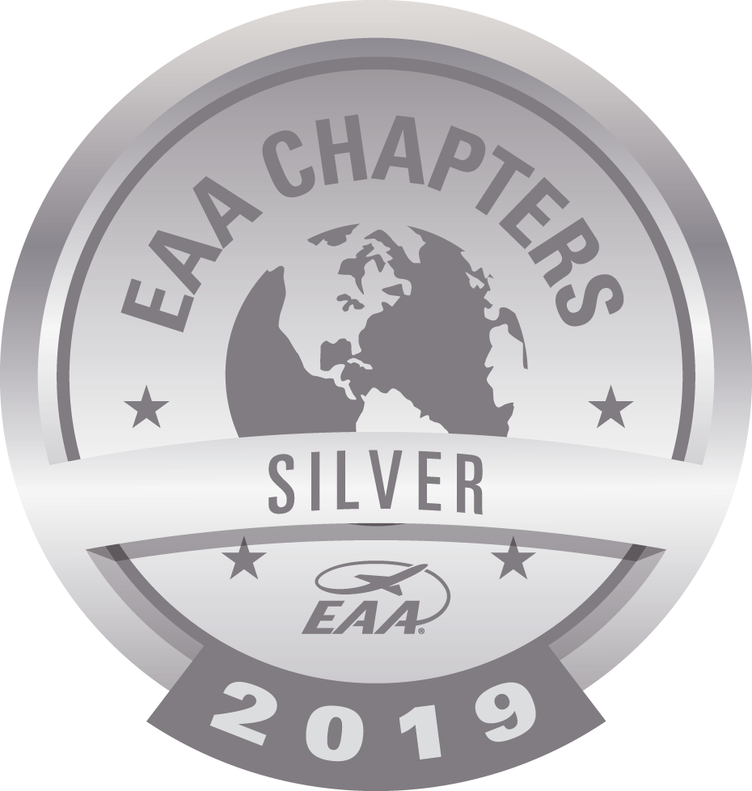
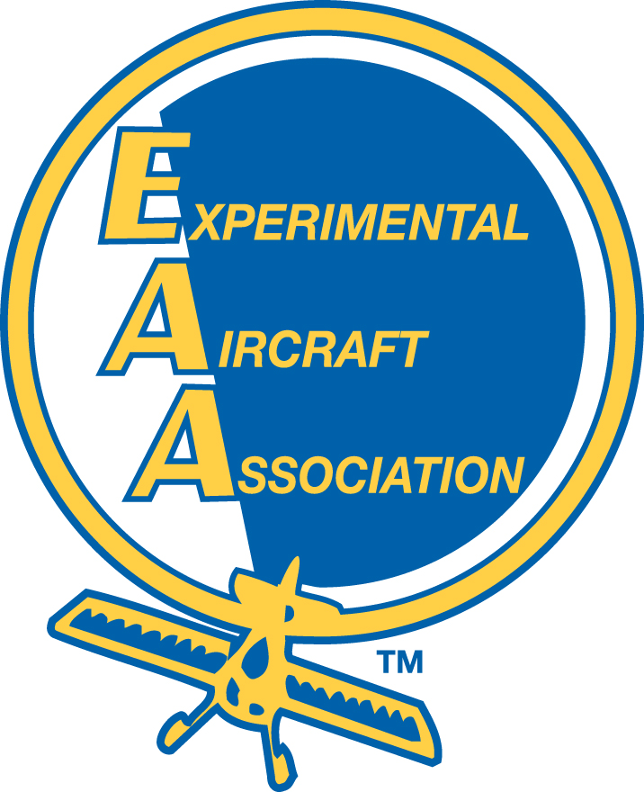
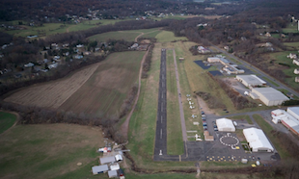
EAA 324 Simsbury, CT

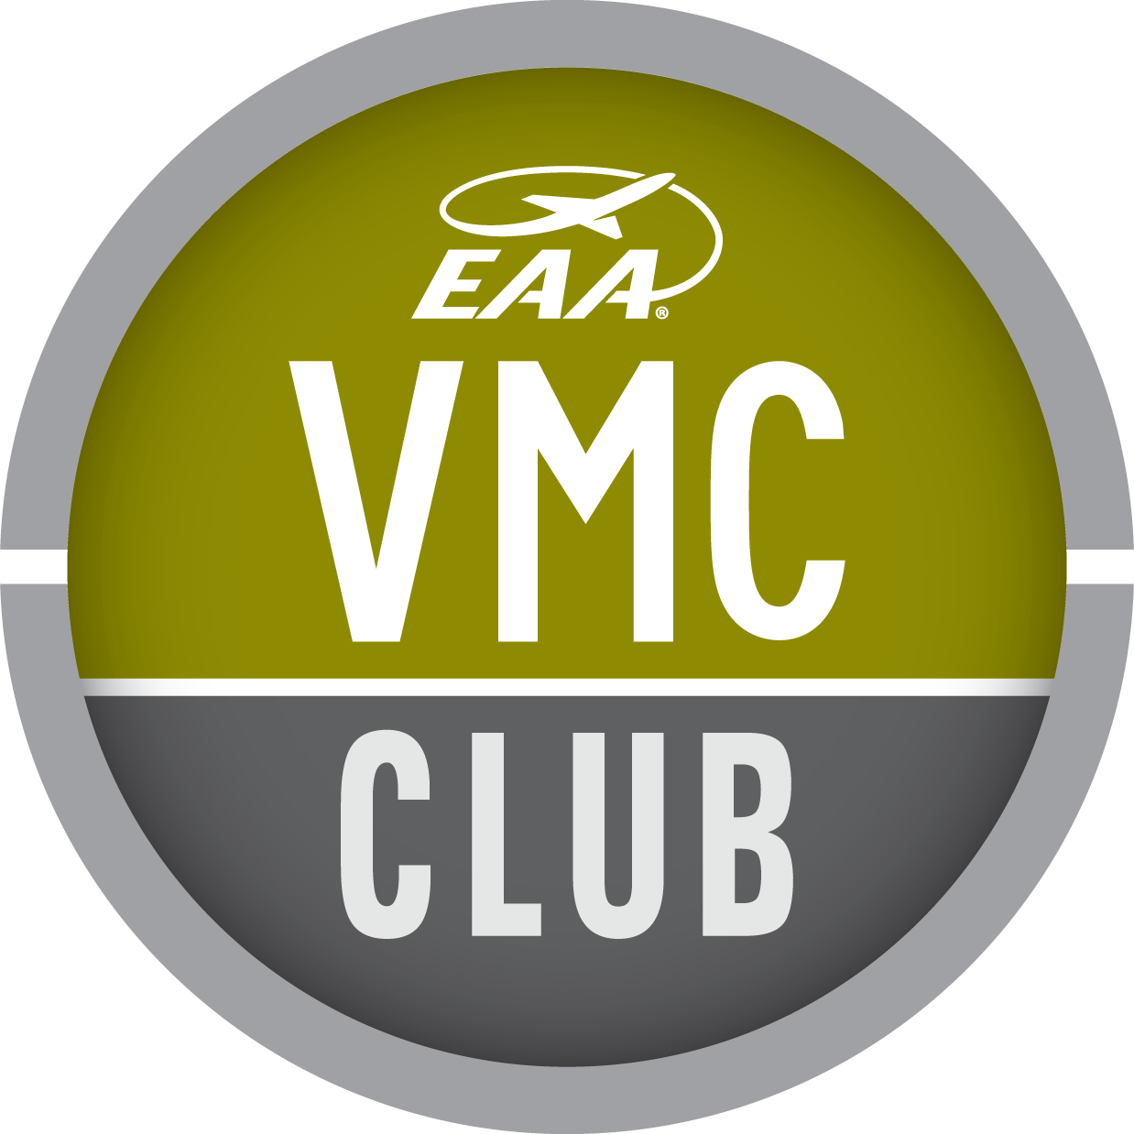
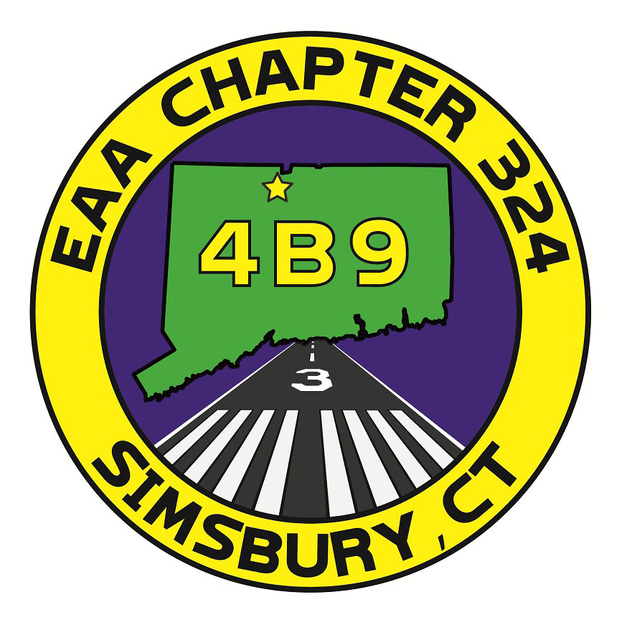

February 2022

Pictured Above: Alton Bay, NH (photo credit: Wired, March 2015)
Calendar
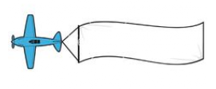Feb 5 Alton Bay, NH opens

Mid-Feb VMC Club, date TBD
Simsbury Airport Clubhouse
7pm

Mar 2 EAA 324 Gathering
7 pm
Food, drink, project updates, topics of interest, videos and general storytelling

Mid-Mar VMC Club, date TBD
Simsbury Airport Clubhouse
7pm

Sep 24-25 Simsbury Fly-In events
Chapter Happenings:
It was great to be able to meet again and we had a good turnout. We welcomed new members and visitors:
Jim Whelan (building an RV-14)
Jeff Neumann (building an RV-10)
John Henry (restoring and flying gliders) –visiting our chapter
VMC Club is ready to start up again, with Charlie Luke and Laura Doherty leading. They will let us all know what date is set for February and I’m sure will have an interesting and informative topic for us to discuss.
We were sad to hear of local pilot and aviation enthusiast Adam Anderson’s passing at the end of January. Condolences to his family especially as Adam was on the younger side. Adam was a great supporter of the annual Fly-In at Simsbury Airport.
We talked about having both a Young Eagles event, in conjunction with International Young Eagles Day, on May 21, as well as a Flying Start event in conjunction with International Learn to Fly Day on June 11. More details to follow.
Read more about this month’s happenings on the following pages!

Project Updates:

- Doug is now the sole owner of his RV-6. Doug mentioned some avionics issues he is having with his comm and Phil was quick to offer to help troubleshoot and solve this issue. Duly noted: Phil’s background is avionics with both the military and also Kaman in the private sector!
- Peter’s new hangar construction is moving forward and he is now in the research phase of finding hangar doors and having the ramp access completed.
- New member Jeff has ordered an RV-10 kit scheduled for delivery beginning December ‘22/January ’23. Jeff had some questions on wiring and sourced a great class on electrical wiring in Oshkosh. If you’re also interested in the class, talk to Jeff about his experience.
- Although Mark has been really busy with work, he’s also very close to having his Super Cub ready to fly. He’s also working on prepping his shop at home so that he can work on his RV-7 project.
- Charlie has had some issues with his propeller - a possible hub seal leak. The manufacturer said it will seal up over time. Unrelated, the manufacturer sent him new prop blades as part of an overhaul. His RV-7A is coming up on a condition inspection.
- The tops of Eric’s wing skins on his RV-7 project are completely riveted and he’s working on the aileron and flap braces.
- Dave brought a rib from the 1941 J-5 project he is refurbishing and explained to us the work that goes into refurbishing each of the 15 ribs (per wing). He noted to us the ribs are aluminum and the rivets are hollow steel, so sourcing parts is challenging! He recommends, for Cub enthusiasts, the Cub Club site online as a great source for information.

Pictured below: Dave Buyak and his 1941 J-5 parts from his show and tell:
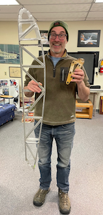

Thank You
for the following donations:

Walter generously donated an IFLY 700 GPS

Ellen generously donated a wonderful, old RAF Landplanes manual

Dave shared a great video on the Piper factory in 1941:

https://www.youtube.com/watch?v=Q6q1VKsTeKQ

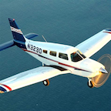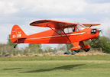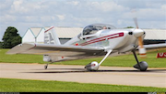

More Chapter News:

- Mark gave out chapter awards from EAA National for members who’ve been in leadership positions for the past year (2021, 2020 awards were given out in December), as well as for MVP, which was awarded to Laura Doherty who is such a wonderful help as needed to our chapter, as well as Ray Aviation Scholarship Coordinator.
- Laura Doherty was nominated and accepted the position of 2022 Chairwoman of the Connecticut Chapter of the 99’s. Congratulations!
- For those who love a winter challenge, Alton Bay, NH and Rangley, ME ice landing strips are opening this first weekend of February. The strip in Rangley is on Mooselookmeguntic Lake.
- Thomas continues working his food truck business, “Barnstormers”. If you haven’t visited, it’s well worth it! You can find him at Norbrook Brewery in Colebrook, CT on Wednesdays.
- We’ll plan an Airport Fun Day with another landing contest for Spring, in lieu of what has typically been a mid-winter social dinner. More details to come.
- Simsbury Fly-In, Classic Car Show and Food Truck Festival is confirmed for September 24-25 (food trucks only on Saturday, the whole deal on Sunday). Be sure to mark your calendars as our chapter plays a big part in putting on this annual event.

Treasurer’s Report:

Our Treasurer, Vince Carucci, has the most recent statement on file.

News from EAA:

Two video segments were shared from National EAA including,
- Charlie Becker from headquarters gave an update of happenings with EAA nationally and opportunities at the local level. You can find that segment here:
https://eaa.org/eaa/eaa-chapters/eaa-chapter-resources/resources-from-hq/eaa-chapter-video-magazine
(Download the February file from that site)
- From the video cache at EAA, check out “One plus One equals 110”, a great video about a “builder/pilot” who put two Yak 55’s together to make a one-of-a-kind aircraft.
https://youtu.be/gO_iknbxiCs

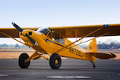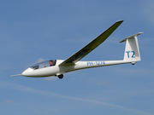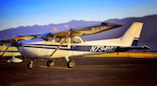

EAA has a very useful tool in the Online Builder’s Log. Find it and enroll in their program here:
https://eaabuilderslog.org/

