Feb 13th 6th Mi Tierra Mexican Lunch Fly-In

Weather was cold but mostly sunny. Plenty of snow at Elkhart Municipal Airport and at Griffith-Merrillville airport (05C)
Only had a couple of EAA Chapter 132 member planes that went there to enjoy a wonderful Mexican lunch at the airport restaurant.
Tim Farrell and Jeremy Quick flew their Cherokee’s there with Doug Busch, Doug’s friend Mike and Jeremy’s employee.
Griffith-Merrillville airport was in good condition. Had lots of snow on the side of the runway and its taxiway does not connect end to end of the runway. There is usually some back taxi needed.
The food was great. Mi Tierra Mexican fly-in will be made once again on May the 1st (May 8th as alternate) for a Cinco De Flyo.
Hope to see you there in the month of May!

Our next fly-in lunch we be Saturday March 6th for 11:00AM ish at Tweedle Dee’s. If Tweedle Dee’s is too busy or not open, we can go to Lighthouse as an alternate. Both are across the streets of the Rochester Fulton County airport (KRCR).

February 25th Membership Meeting 7:06pm to 7:52PM

9 Members present

Doug was unable to attend so Steve led the meeting.

Pledge of Allegiance

Reading of January chapter meeting minutes which were passed.

Treasures report: Jerry reported that only 11 members had paid 2021 dues.

Old business: Jerry read list of names who have paid 2021 dues.
We still need a Vice President.
Those present gave a brief report on their projects and airplanes. Discovered that Arden has not looped or rolled his Citabria…yet.

Don & Karen have moved their annual picnic/fly-in to August 22. This is one week later than usual. Don also mentioned that they will be following the same COVID procedure as last year which is no potluck food. Everything will be served and/or packaged. Donations will be accepted to cover the cost of the food.

Marcus Wallis (our newest member) who is a CFI has some openings for students. He will also be working toward being able to give tailwheel instruction. His contact information will be included in the Vortex.

Jerry’s homebuilt airplane will be soon for sale. Contact Jerry for additional information.

Both Sun-N-Fun and Airventure (Oshkosh) are still a go for 2021, however Freedom Fest in Goshen has been canceled.

Bill is still working on Chapter archives and has requested any information on the early days of our Chapter.

Arden won the 50/50 drawing.

After the meeting adjourned, Tim talked about the previous Saturdays fly-out to MI Tierra Restaurant and handed out a tentative schedule for fly-outs f or the rest of 2021.
EAA Chapter 132 Hoosier Fun to Fly 2021
Tentative scheduling so far. Contact Tim at tsfarrell28630@gmail.com if there are other cool places to go.
Some of these may be postponed or changed due to other EAA Chapter events such as Young Eagles.

March 6th (March 13th as alternate) - Lighthouse or Tweedle Dee’s Restaurants
Rochester, IN Fulton County airport (KRCR). Both right next to the airport.

April 10th (April 17th as alternate) – Saturday Morning Pilots Gathering
Greencastle, IN Putnam Co. Airport (KGPC). Restaurant at the airport.

May 1st (May 8th as alternate) – Cinco De Flyo
MI TIERRA Restaurant 11AM their time @ Griffith-Merrillville, IN airport (05C)
May 22nd (May 23rd as alternate) – Indianapolis/Indy 500
Eagle Creek, IN airport (KEYE). Rick’s Café Boatyard, Indy 500 qualification & Indy Museum.
May 29th – Memorial Day Weekend
Grissom Air Reserve Base / Museum – Peru, IN (KGUS). Vintage Military Aircraft Museum outside.

June 12th (June 17th as alternate) – Merk’s Restaurant
Muncie, IN Delaware County Airport (KMIE). Restaurant at the airport.

July 10th (July 17th as alternate) - Gambling at the Casino
Shelbyville, IN airport (KGEZ). Call Casino and they will pick you up from the airport.

August 22nd (Sunday)– EAA/Duck’s Fly-In and Drive In Food Starting at 1:00. 2,400’ grass airstrip.

September 18th (Sept 25th as alternate) – Air Force Birthday
Columbus, IN airport (KBAK). Air Museum (Free or Donation) Blackerby’s Hanger 5 Restaurant. Both at airport.

October 9th (Oct 16th as alternate) – Corsair Café
Terre Haute, IN airport (KHUF) Corsair Café at airport terminal. Holocaust museum in city.

November 6th (Nov 13th as alternate) - Lighthouse or Tweedle Dee’s Restaurants
Rochester, IN Fulton County airport (KRCR). Both right next to the airport.

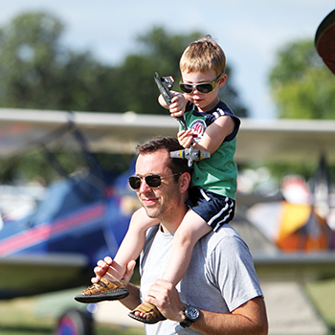

Buy Your 2021 EAA AirVenture Oshkosh Tickets
Purchase your EAA AirVenture Oshkosh admissions, camping, parking, flight experiences, and merchandise in advance.
It's fast and easy! With a few simple steps, you'll be inside the gates in no time and ready to take in AirVenture. You'll simply select weekly or daily tickets, enter the number of tickets you'll need for each category, pay by credit card using our secure online system, print your bar-coded ticket(s), present your ticket at any entry point to receive your AirVenture wristband, and breeze through the lines. If you purchased tickets at the preferred EAA member rate, please be prepared to provide proof of membership when you have your e-ticket scanned at the gate.
AirVenture 2021 dates: Monday, July 26-Sunday, August 1. You may purchase a daily ticket for any of the seven days, or a weekly pass, which includes all seven days.
Note: If your EAA membership is not current, please click here to renew, and allow 48 hours for processing before purchasing your tickets at member rates.

Early bird discounted pricing ends June 15, 2021.
NEW THIS YEAR! Free youth admission ages 18 and under has been generously supported in part by:
For more information on ticket purchasing, visit
https://www.eaa.org/airventure/eaa-airventure-tickets
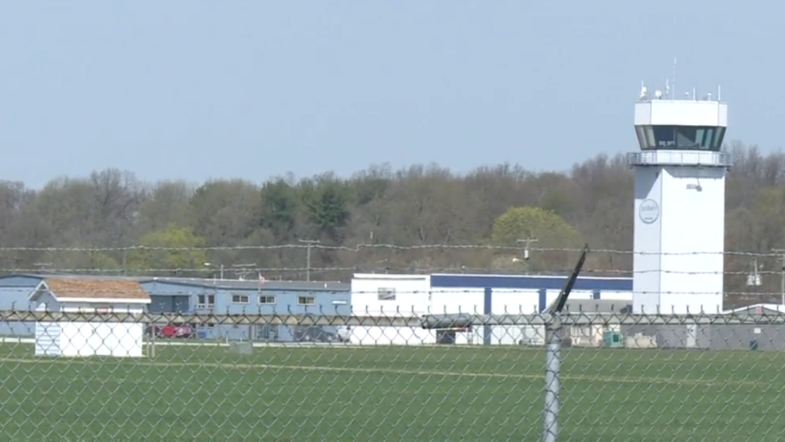
Board Meeting February 11, 2021 7:00pm to 8:30pm

Jim was unable to attend due to other engagement.

Tim – Quiz at January membership meeting had an issue that needs work.
Mass texting for fly-outs, meetings, etc.

Jobs:
Facilities: Jerry, Bill
Set-up: Steve, Doug
Marketing & Outreach: Dave, Doug
Communications: Tim
I.T. & Merchandising: Tim
Clean-up: Jeremy

Need program/speaker for the February membership meeting.
Possibly;
Tom Konzora / FAA Grand Rapids.
Andy what’s on schedule for work around the airport this year.
ATC from SBN on radio rules.
Aircraft ownership maintenance by AP/IA.
Facilities upgrade for Chapterhouse.

Authority given to Steve L to rid Chapterhouse of old, unusable kitchen equipment.
Communication? Website thru Facebook & EAA / mass emails & text messages.
Ideas for 132 aircraft build project – Suggestions of both RV10 and Hummel H5.

