March Membership Meeting with Guest Presenter -
Randy Sharkey a helicopter DPE, helicopter company management & Goshen Airport Manager was at our March meeting telling us about helicopter training, flight and issues.
------------------------------------------------------------
A March restaurant flight to Fulton Co. (KRCR)
for breakfast /lunch at Tweedle Dee’s. A few
EAA members and some pilots from Northeast Indiana and Sturgis Michigan made the flight to a nice restaurant.
-------------------------------------------------------------------------
EAA Chapter 132 Membership Fee needed for 2021. Please renew your membership via https://chapters.eaa.org/eaa132 website using paypal or come to the next membership meeting. Thank You!
--------------------------------------------------------------------------------
EAA 132 NOTAM-
EAA Hanger asphalt in front of the hangers is going to be re-paved starting March 29th ending in about a week.
-------------------------------------------------------------------------------
Karen Duck won March 50/50 raffle.
-----------------------------------------------------------------------
Quizglobal.com quiz game was tested and seems to work but will get some updating so members can use smartphones, tables or paper.

EAA Chapter 132 Hoosier Fun to Fly 2021
Tentative scheduling so far. Contact Tim at tsfarrell28630@gmail.com if there are other cool places to go.
Some of these may be postponed or changed due to other EAA Chapter events such as Young Eagles.

April 10th (April 17th as alternate) – Saturday Morning Pilots Gathering
Greencastle, IN Putnam Co. Airport (KGPC). Restaurant at the airport.

May 1st (May 8th as alternate) – Cinco De Flyo
MI TIERRA Restaurant 11AM their time @ Griffith-Merrillville, IN airport (05C)
May 22nd (May 23rd as alternate) – Indianapolis/Indy 500
Eagle Creek, IN airport (KEYE). Rick’s Café Boatyard, Indy 500 qualification & Indy Museum.
May 29th – Memorial Day Weekend
Grissom Air Reserve Base / Museum – Peru, IN (KGUS). Vintage Military Aircraft Museum outside.

June 12th (June 17th as alternate) – Merk’s Restaurant
Muncie, IN Delaware County Airport (KMIE). Restaurant at the airport.

July 10th (July 17th as alternate) - Gambling at the Casino
Shelbyville, IN airport (KGEZ). Call Casino and they will pick you up from the airport.

August 22nd (Sunday)– EAA/Duck’s Fly-In and Drive In Food Starting at 1:00. 2,400’ grass airstrip.

September 18th (Sept 25th as alternate) – Air Force Birthday
Columbus, IN airport (KBAK). Air Museum (Free or Donation) Blackerby’s Hanger 5 Restaurant. Both at airport.

October 9th (Oct 16th as alternate) – Corsair Café
Terre Haute, IN airport (KHUF) Corsair Café at airport terminal. Holocaust museum in city.

November 6th (Nov 13th as alternate) - Lighthouse or Tweedle Dee’s Restaurants
Rochester, IN Fulton County airport (KRCR). Both right next to the airport.

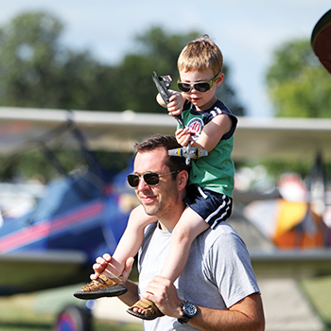

Buy Your 2021 EAA AirVenture Oshkosh Tickets
Purchase your EAA AirVenture Oshkosh admissions, camping, parking, flight experiences, and merchandise in advance.
It's fast and easy! With a few simple steps, you'll be inside the gates in no time and ready to take in AirVenture. You'll simply select weekly or daily tickets, enter the number of tickets you'll need for each category, pay by credit card using our secure online system, print your bar-coded ticket(s), present your ticket at any entry point to receive your AirVenture wristband, and breeze through the lines. If you purchased tickets at the preferred EAA member rate, please be prepared to provide proof of membership when you have your e-ticket scanned at the gate.
AirVenture 2021 dates: Monday, July 26-Sunday, August 1. You may purchase a daily ticket for any of the seven days, or a weekly pass, which includes all seven days.
Note: If your EAA membership is not current, please click here to renew, and allow 48 hours for processing before purchasing your tickets at member rates.

Early bird discounted pricing ends June 15, 2021.
NEW THIS YEAR! Free youth admission ages 18 and under has been generously supported in part by:
For more information on ticket purchasing, visit
https://www.eaa.org/airventure/eaa-airventure-tickets
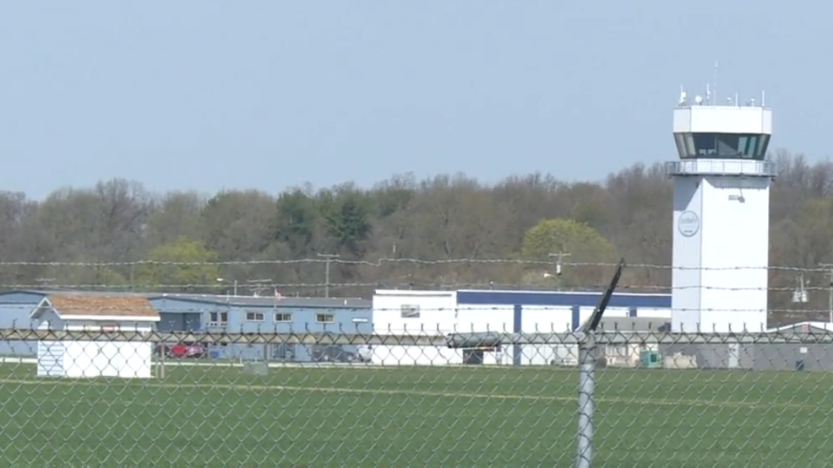
Board Meeting March 11, 2021 7:00pm – 8:18pm
Bill, Doug, Tim F, Jerry, Jim, Steve, Jeremy

Doug reviewed Fly-Out scheduled submitted by Tim.

Still need a Vice President.

Dave O’Conner has resigned from the Board due to schedule/work conflicts.

Looking to receive an official go-ahead from Andy for any Chapter events to be held on airport property.

Randy Sharky will be the guest speaker at our March Chapter meeting.

Jerry is going to put his Glastar up for sale. Asking $45,000. 460 hours on aircraft. Contact Jerry for any additional questions and/or interest.

Chapter house remodel ideas were discussed. Door repairs are at the top of the list.

We will be starting back with our Saturday morning breakfast the first Saturday after Labor Day (Sept 11).

September 25 is tentative date for a Fall Young Eagles event.

October 2 is tentative date for FI/DI/RI event.

Fly-Outs have been well received. Non-chapter members have been attending. Reminder to take pictures of both pilots and airplanes.

Bill is working on organizing the Chapter house. Bill will be rounding up excess books and magazines located at both the Chapter house and Chapter hanger. Members will be invited to take what they wish and there will be a free-will donation container available. In addition to the door(s) fixed, it was suggested a coat of paint and some additional bookcases. The two sofas will be removed and anyone who would like them is invited to take.

