Mar 28, 2024 EAA Chapter 132 Membership Meeting 7:00 PM

Phil had the March 28, 2024 Membership Meeting be about 15 minutes and then had a popcorn available and watched the Memphis Bell movie which was assume.

Ryan is having the Young Eagles on May 18, 2024.

Goshen, IN airport will have the Freedom Fest Airshow July 13, 2024 and EAA Chapter 132 will try and do the food and drink part on the Goshen airport ramps east side again.

Some of our EAA chapter will be at the EAA Oshkosh Group Camp.

Mar 9th, 2024 EAA Chapter 132 breakfast 9-11am by Phil & Wendi.
More can also help cook as well.

Sorry the March vortex was late getting here because Tim F who does the vortex was in Amsterdam March 28 to April 7th.

April 10th Board Meeting:
April 11, 2024 board meeting was changed to April 10th this month.
April 25, 2024 Membership Meeting will be a Pot Luck Dinner at the clubhouse. Will be hamburger and hot dogs. Please bring another type food or drink for all.
Marty will be at GMA (GAMA) Live May 8th
Mike and Audra will be doing a presentation at our Sept membership meeting.
August 18, 2024 Duck’s Lunch
If Young eagle pilot, make sure your child config is current at EAA.
May want to do a visit to Dayton Air Museum some weekend this year.
May also need to do a fundraising activity for our chapter sometime soon.

Your Official Countdown to AirVenture 2024
July 22 – July 28, 2024
Countdown is sponsored by:

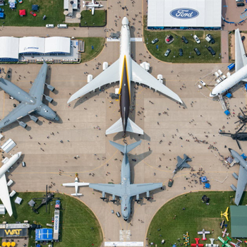

EAA Chapter 132 is putting together a Fisher Classic Biplane
that was donated to use by Micheal Smith from his dad that died
who was starting to build it a while ago.

Building it on Thursdays 5-8 pm in our hanger.

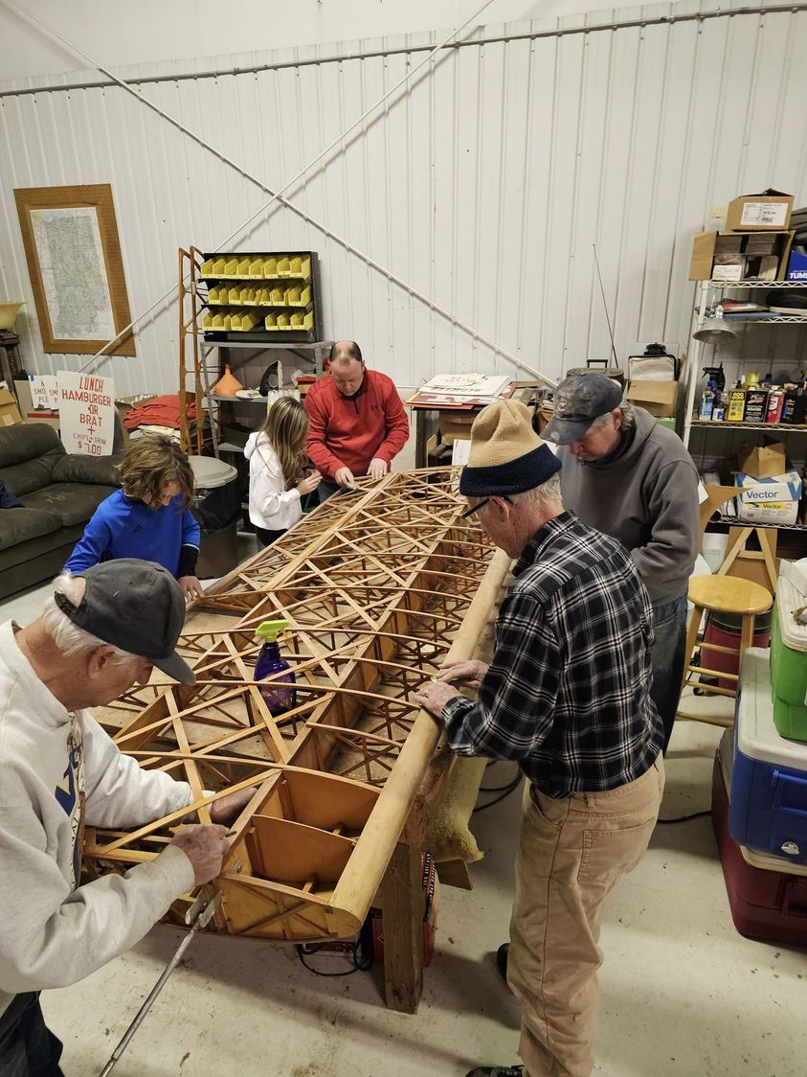
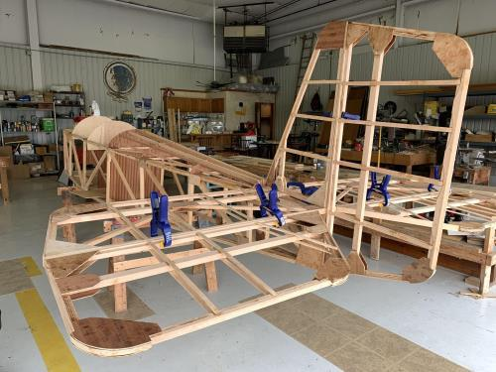

See Jim’s Experimental Aircraft Pietenpol project every Monday evening at 7pm at the EAA 57 hanger at the Elkhart Municipal Airport. He and Steve is adding elevator and rudder to their Pietenpol project. Have popcorn and meet with other
EAA Chapter 132 members too!

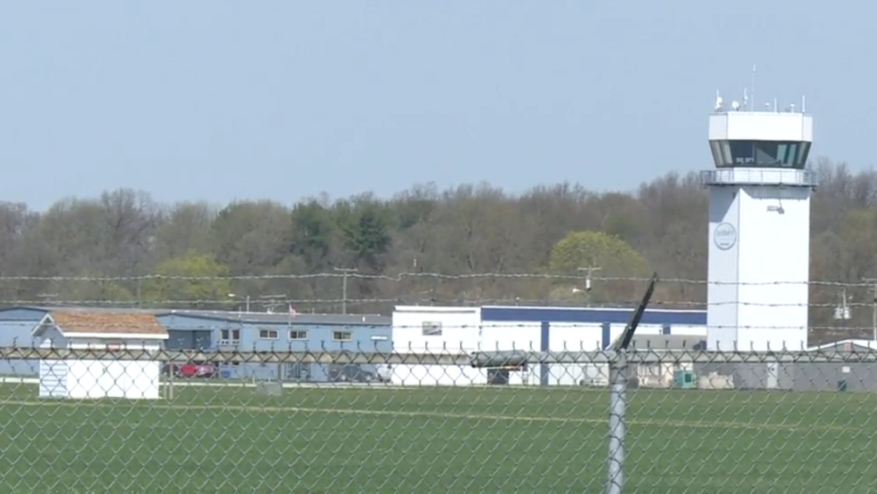

Mar 14, 2024 Board Meeting 7:00-8:05 pm
Phil, Wendi, Dick, Tim, Mike, Audra, Marty & Steve

March 9th breakfast was donated $80.
Young Eagle May 18, 2024. If Young eagle pilot, make sure your child config is current at EAA.
Goshen Freedom Fest Airshow July 13, 2024
April 25, 2024 membership meeting will also be a Pot Luck Dinner at our clubhouse.
March 28, 2024 membership meeting will also be popcorn and movie night.

Membership renewal is requested as soon as possible early in each year.

