Feb 29, 2024 EAA Chapter 132 Membership Meeting 7:00-8:00 PM

EAA Chapter 132 February Breakfast was great. It had lots of people who had flown or drove there. EAA had $157 donated by people at breakfast.

Michael Smith was here telling us about his dad having the Fisher-Classic 2 seat Biplane and how he started putting it together in his house. Michael showed us a lot of pictures of his dad and the Fisher-Classic as well as some of the planes and people at Oshkosh.

Ryan is trying to have the Young Eagles on May 18, 2024.

Goshen, IN airport will have the Freedom Fest Airshow July 13, 2024 and EAA Chapter 132 will try and do the food and drink part on the Goshen airport ramps east side again.

Some of our EAA chapter will be at the EAA Oshkosh Group Camp.

EAA Chapter clubhouse bathroom toilet and sink was replaced and fixed.

Mar 9th, 2024 EAA Chapter 132 breakfast 9-11am by Phil & Wendi.
More can also help cook as well.

Your Official Countdown to AirVenture 2024
July 22 – July 28, 2024
Countdown is sponsored by:

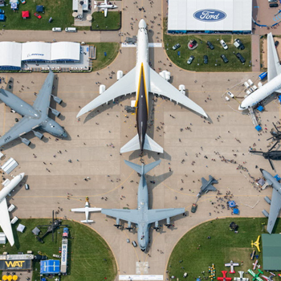

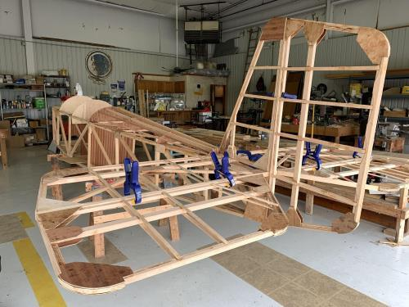

See Jim’s Experimental Aircraft Pietenpol project every Monday evening at 7pm at the EAA 57 hanger at the Elkhart Municipal Airport. He and Steve is adding elevator and rudder to their Pietenpol project. Have popcorn and meet with other
EAA Chapter 132 members too!

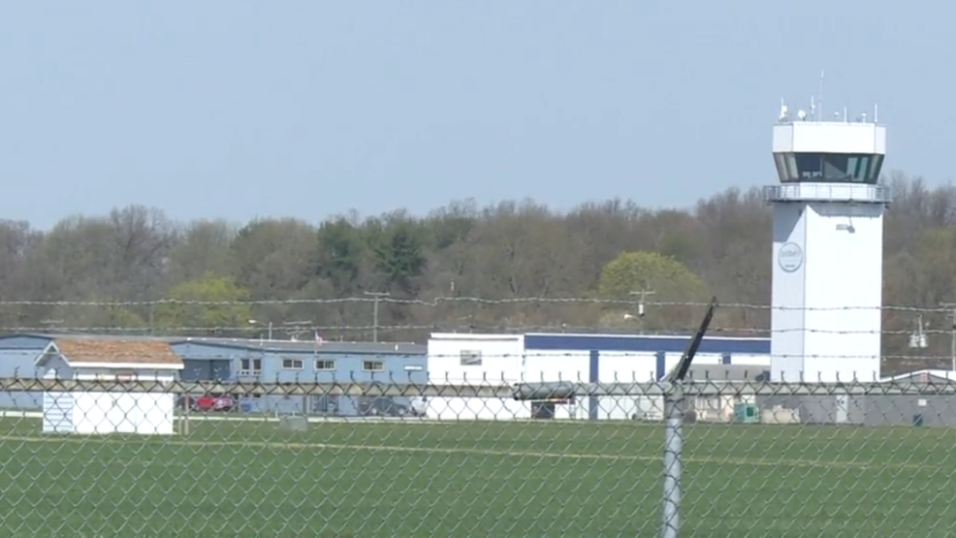

Feb 8, 2024 Board Meeting 7:00-7:45 pm
Phil was talking about the Fisher-Classic Biplane being cleaned and built.
Micheal Smith donated the Fisher Classic 2 seat biplane to our chapter so we can build it and then we will send money to Micheal in his dad’s name once the plane if built and sold to someone.
Our clubhouse bathroom needs a few things fixed or replaced. A faucet and toilet.
Membership renewal is requested as soon as possible early in each year.
Mar 9th, 2024 EAA Chapter 132 breakfast 9-11am by Phil & Wendi

