

Chapter Meeting June 24, 2021 7:00pm – 8:50 pm

19 attended

FAA Experimental Maintenance Extravaganza by FAA agent Tim J. Skokl. Mr. Skokl talked a lot about what happens when building or maintaining experimental aircraft.

Chapter needs new board members for Vice President, Photographer, Historian & Technical Consultant.

Marcus gave us High Flying Minute for Aviation as a CFI.

Doug mentioned that the chapter will need to clean/update clubhouse & hanger.

EAA Chapter Board meeting in July but no July Membership meeting due to EAA Oshkosh AirVenture July 26th to Aug 1st.

Aviation Quiz had 5 questions about aviation and EAA.

Tim F won 50/50 raffle.

Upcoming EAA Chapter Events:

August 22 – EAA / Duck’s Fly-In & Drive-In at Duck’s Pasture

Sept 25 – EAA Chapter 132 Young Eagles Event

Oct 2- EAA Chapter 132 Fly-In, Drive-In, Ride-In Event.

|  |  |  |
| --- | --- | --- |
| Here's an EAA event near you! [View this email online](http://pages.eaa.org/index.php/email/emailWebview?mkt_tok=OTEwLVNFVS0wNzMAAAF9vmVNzebUf0LTm6RIhW6oBAyS0DjAzi3uqJsOKNPDKj4arlFcmTQ5u3iIrveWjO__A9QahYXldBpdPk31peCiEFp11mWh5CAMGLoHp4mPmM-SHA&md_id=19530) | | |
|  | | |
|  | **EAA Chapter 865 34th Annual Fly-In Breakfast Niles, MI Sunday, June 27, 8 a.m. - 12 p.m.**  **WHAT:** You are invited to join us for our annual fly-in breakfast. $8 all-you-can-eat pancakes and sausage or biscuits and gravy, plus real orange juice and regular or decaf coffee to drink! Door prizes will be awarded! Team MiniMax factory will be open!  We are located on the east end of the airport grounds on Lake Street. Fly in or drive in! Parking is free.  We look forward to seeing you there!  **WHERE:** Jerry Tyler Memorial Airport 2030 Lake St. Niles, MI 49120  CONTACT US**:** Ralph Ballard, Secretary 269-340-2945 or raphyboi02@msn.com  [Click here](http://go.eaa.org/OTEwLVNFVS0wNzMAAAF9vmVNzFhkuZPBPBTr9J134YAyFozbYefFsoisvESBiWoTDpCdx7JM7MxVQE3Ov2E-FgPu7ic=) for more information. |  |

|  |
| --- |
| [Join EAA](http://go.eaa.org/OTEwLVNFVS0wNzMAAAF9vmVNzJvkzCx08cxfzmSBWjmqRhFR91PMEtbGf8HGuqgEqqVb3bFtR3FL4rZNOpOX739fiFs=)  |  [Member Benefits](http://go.eaa.org/OTEwLVNFVS0wNzMAAAF9vmVNzF16vZpP_6LCo7Mm9gfNoskOkfxRPKj8c1UWm3pE26jIG4hnwmTm-xwfrlOKQGfhCUI=)  |  [Chapters](http://go.eaa.org/OTEwLVNFVS0wNzMAAAF9vmVNzFagFaFOubA5df2cM8ed_7SteznInNIqy6joU7AnmUWbNKzdR3sddF-Rrc4zt_YpQ0c=) |  [Contact Us](http://go.eaa.org/OTEwLVNFVS0wNzMAAAF9vmVNzLu3o2mhYrDU24C9XW88YwqfGn-crz9gdcaxy-rreNg7royNCbJRTi5MY624VPcjISQ=) |

Hello,

 I am a new resident to the state of Indiana and a member of Women in Aviation, Purdue Graduate, former member of Civil Air Patrol and current member of the 99’s. I work for KSBN as the Operations Manager and I wanted to see if the Indiana chapter of the 99’s had any interest in the following.

 We are starting the planning for our **Aviation Education Day** here at South Bend International Airport on **Saturday, August 28, 2021** and I wanted to do a preliminary email to reach out to everyone, and anyone interested in participating. I myself was not here for the last Aviation Education Day in 2019, but I know that this event draws in major community involvement and I wanted to poll our partners to see if your organization wanted to or would be willing to be a part?! We have about two months to plan, finalize and execute the logistics.

 The details are being ironed out, but for right now, I am asking people on this email chain to reply to me and let me know if you think your chapter would like to participate. That can include recruiting booths for jobs, showing of your private airplane for attendees, fun activities for kids, airfield tours lby Ops, you name it, we will consider it- all ideas are welcome. If your chapter has a cool product or aviation related item that you would like to display-let me know!

 I would like to have responses back and finalized as soon as possible. I look forward to making this event fun, and educational and most of all a partnership with all of you to show everyone why we love working in aviation. 😊

 Ashley Thorsen

 Ashley Thorsen, M.S., C.M., ASC

Operations Manager

St. Joseph County Airport Authority

4477 Progress Drive

South Bend, IN 46628

P: 574-282-4590 ext. 240



**EAA Chapter 132 Hoosier Fun to Fly 2021**

Tentative scheduling so far. Contact Tim at [tsfarrell28630@gmail.com](mailto:tsfarrell28630@gmail.com) if there are other cool places to go.

Some of these may be postponed or changed due to other EAA Chapter events such as Young Eagles.

June 12th (June 17th as alternate) – **Merk’s Restaurant**

Muncie, IN Delaware County Airport (KMIE). Restaurant at the airport.

June 27th (Sunday) – **Niles Pancake Breakfast**

EAA Chapter 865

July 10th (July 17th as alternate) - **Gambling at the Casino**

Shelbyville, IN airport (KGEZ). Call Casino and they will pick you up from the airport.

August 22nd (Sunday)– **EAA/Duck’s Fly-In and Drive In** Food Starting at 1:00. 2,400’ grass airstrip.

September 18th (Sept 25th as alternate) – **Air Force Birthday**

Columbus, IN airport (KBAK). Air Museum (Free or Donation) Blackerby’s Hanger 5 Restaurant. Both at airport.

October 9th (Oct 16th as alternate) – **Corsair Café**

Terre Haute, IN airport (KHUF) Corsair Café at airport terminal. Holocaust museum in city.

November 6th (Nov 13th as alternate) - **Lighthouse or Tweedle Dee’s Restaurants**

Rochester, IN Fulton County airport (KRCR). Both right next to the airport.

# AirVenture 2021 Tickets Available Now

# Buy Your 2021 EAA AirVenture Oshkosh Tickets

Purchase your EAA AirVenture Oshkosh admissions, camping, parking, flight experiences, and merchandise in advance.

**It's fast and easy!** With a few simple steps, you'll be inside the gates in no time and ready to take in AirVenture. You'll simply select weekly or daily tickets, enter the number of tickets you'll need for each category, pay by credit card using our secure online system, print your bar-coded ticket(s), present your ticket at any entry point to receive your AirVenture wristband, and breeze through the lines. If you purchased tickets at the preferred EAA member rate, please be prepared to provide proof of membership when you have your e-ticket scanned at the gate.

AirVenture 2021 dates: Monday, July 26-Sunday, August 1. You may purchase a daily ticket for any of the seven days, or a weekly pass, which includes all seven days.

Note: If your EAA membership is not current, please [**click here to renew**](https://www.eaa.org/eaa/renew-eaa/renew-membership), and allow 48 hours for processing before purchasing your tickets at member rates.

## Early bird discounted pricing ends June 15, 2021.

**NEW THIS YEAR! Free youth admission ages 18 and under has been generously supported in part by:** Boeing

For more information on ticket purchasing, visit

<https://www.eaa.org/airventure/eaa-airventure-tickets>

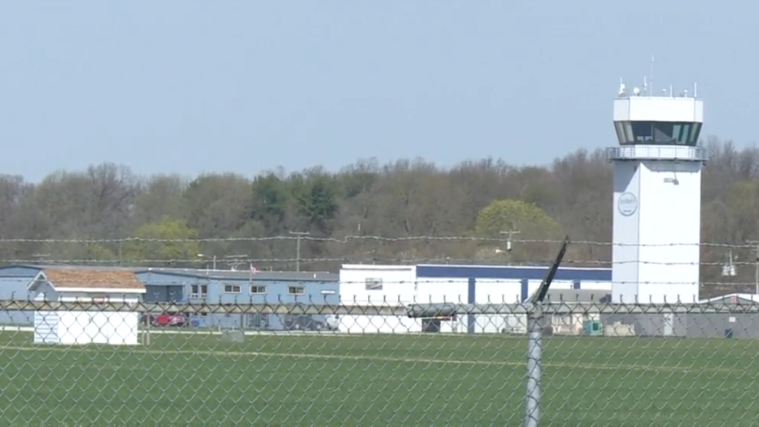

**Board Meeting June 10, 2021 7:00pm – 8:30 pm**

Tim F, Dick, Doug & Steve

Dick Wagner gave us information on what was needed for the EAA Chapter 132 Fly-In, Drive-In & Ride-In event to happen on Oct 2.

Due to Covid messing up last year, pilots will need to check for needed updates for Young Eagle event Sept. 25 to fly young eagles and register to pilot.

Doug was getting a representative speaker for the June membership meeting.

Steve & Jim still working on their aircraft build.

Recommendations made:

New griddles for winter Saturday breakfasts to be replaced at EAA chapter 132 clubhouse.

Replace main door at clubhouse.

Make Clubhouse more like a library. Paint clubhouse. Fix lights and signs at clubhouse.

Plan to build an EAA Woody’s Pusher experimental aircraft in the EAA Chapter 132 hanger by including high school teens wishing to be part of EAA chapter, then giving them the opportunity to fly in it with the PIC. A & P’s will be needed to help us out. Maybe planning on a twice a week process building the aircraft.

New members wanted as well as present members paying the yearly registration fee when needed. New appointed officers are needed to replace others that have resigned officer title or that have passed away.

