April 25, 2024 EAA Chapter 132 Membership Meeting 7:00 - 8:30 PM

Phil and Wendi did a great job making the April Membership Meeting the Pot Luck Dinner. Phil and Marty used grills to cook hamburgers and hot dogs. Most every one brought other dished for all as well. It was awesome!

Marty gave information on the April EAA Chapter Board Meeting.

Mishawaka Pilots Club will be having at Lunch at 11 am and Young Eagles on May 4th.

May 9th EAA Chapter 132 Board Meeting.

May 11th, 2024 EAA Chapter 132 breakfast 9-11am by Ken and Bill.
More can also help cook as well.

EAA Chapter 132 is having the Young Eagles on May 18, 2024 9 am to Noon. Pilots will have to be there at 8 am and in the tower 8:30 am.

Marty will do a presentation on the May 30th EAA Chapter Membership Meeting.

Goshen, IN airport will have the Freedom Fest Airshow July 13, 2024 and EAA Chapter 132 will try and do the food and drink part on the Goshen airport ramps east side again.

August 18 is Ducks Lunch Fly in Drive in.

Some of our EAA chapter will be at the EAA Oshkosh Group Camp.

Your Official Countdown to AirVenture 2024
July 22 – July 28, 2024
Countdown is sponsored by:

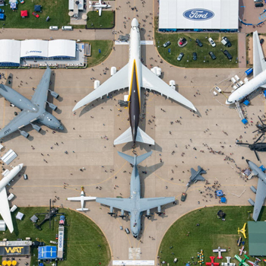

EAA Chapter 132 is putting together a Fisher Classic Biplane
that was donated to use by Micheal Smith from his dad that died
who was starting to build it a while ago.

Building it on Thursdays 5-8 pm in our hanger.

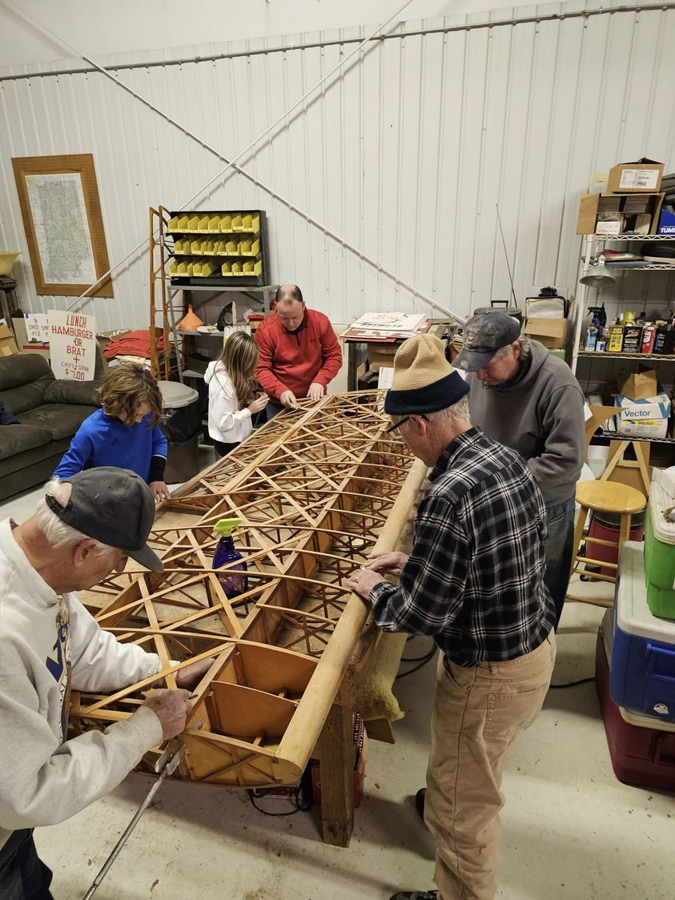
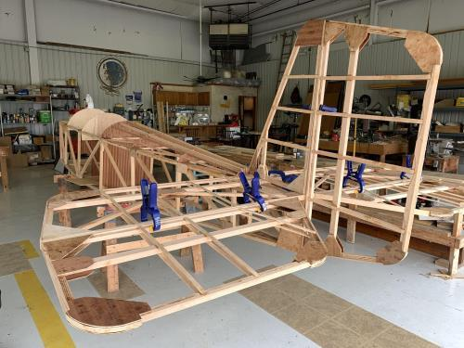

See Jim’s Experimental Aircraft Pietenpol project every Monday evening at 7pm at the EAA 57 hanger at the Elkhart Municipal Airport. He and Steve is adding elevator and rudder to their Pietenpol project. Have popcorn and meet with other
EAA Chapter 132 members too!

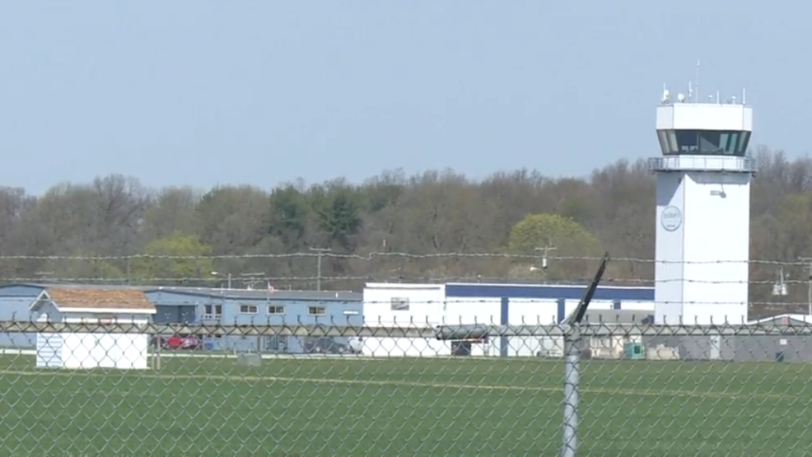

April 10, 2024 Board Meeting 7:00-8:05 pm
Phil, Tim, Mike, Audra, Ryan, Marty & Steve

April 11, 2024 board meeting was changed to April 10th this month.
April 25, 2024 Membership Meeting will be a Pot Luck Dinner at the clubhouse. Will be hamburger and hot dogs. Please bring another type food or drink for all.
Marty will be at GMA (GAMA) Live May 8th
Young Eagle May 18, 2024. If Young eagle pilot, make sure your child config is current at EAA.
Goshen Freedom Fest Airshow July 13, 2024
August 18, 2024 Duck’s Lunch
Mike and Audra will be doing a presentation at our Sept membership meeting.
Might want to do a visit to Dayton Air Museum some weekend this year.
Might also need to do a fundraising activity for our chapter sometime soon.

Membership renewal is requested as soon as possible early in each year.

