

**January 30th Lighthouse Breakfast Fly-In**

**Although this was a last minute event, we had about 18 pilots and passengers sitting together eating breakfast at Lighthouse Restaurant which is right next to the Rochester Fulton County (KRCR) airport.**

**Some pilots actually taxied their aircraft on turf past the Fire Station to park right across the street from the Lighthouse Restaurant (which is allowed). FYI - You just can’t go into the Fire Station area. You can go behind the Fire Station area to taxi toward the restaurant.**

**A few pilots parked at the FBO ramp where Doug Busch was able to use the KRCR courtesy van to take those pilots and passengers to the Lighthouse restaurant in less than a few minutes.**

**Pilots met at the restaurant at about 9:00 am as planned. Not only did planes come from Elkhart Municipal, some came from Dowagiac MI, Mishawaka Pilots Club, Coldwater MI and elsewhere.**

**The food was great. Lighthouse was a busy place. Being together was awesome even when Doug Busch showed everyone the AirMail 100 mail bag that was used for the sending of cards on the historic route. Shaun and Doug flew a small part of the historic route during the 100 year Airmail anniversary.**

**The Airmail 100 mail bag is now going to be at the Smithsonian Museum.**

**Sorry this breakfast fly-in wasn’t planned earlier for all.**



**Saturday, February 13th Mexican Lunch Fly-In**

**MI Tierra Restaurant at Griffith-Merrillville, IN (05C) airport.**

**Plan to be at the MI Tierra Restaurant at around 11:00 am.**

[Mi Tierra Mexican Restaurant (mitierragriffith.com)](https://www.mitierragriffith.com/)

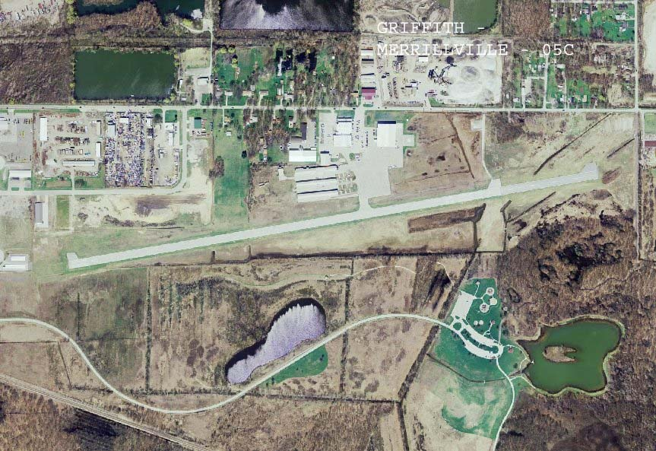

**Please RSVP to Chapter 132 by replying to the eaa132elkhart.gmail.com sent to you.**

**Thanks and hope to see you there. Have a safe flight.**

On January 26, 1953, EAA Founder Paul Poberezny called the first official meeting of the Experimental Aircraft Association at Curtiss-Wright Field (now Timmerman) in Milwaukee, Wisconsin. The group originally gathered together to share ideas and encouragement as amateur aircraft builders. But EAA quickly grew to support all kinds of recreational flying, building, and restoring, and the promotion of aviation safety.   
  
Today, 68 years later, EAA is still focused on making a positive impact on the aviation community. Through programs and initiatives such as Young Eagles, Ray Aviation Scholarships, SportAir Workshops, and working with the FAA on government advocacy efforts, EAA helps participants live out their aviation dreams, all while maintaining grassroots access to the sky.   
  
We'd like to thank you for your commitment to EAA. Without members like you, EAA would not be able to accomplish our mission of growing participation in aviation. We have seen continued growth because our members are the most passionate community of aviation enthusiasts. As Paul said, EAA is a family — a family brought together by our shared love for aviation.

# AirVenture 2021 Tickets Available Now

# Buy Your 2021 EAA AirVenture Oshkosh Tickets

Purchase your EAA AirVenture Oshkosh admissions, camping, parking, flight experiences, and merchandise in advance.

**It's fast and easy!** With a few simple steps, you'll be inside the gates in no time and ready to take in AirVenture. You'll simply select weekly or daily tickets, enter the number of tickets you'll need for each category, pay by credit card using our secure online system, print your bar-coded ticket(s), present your ticket at any entry point to receive your AirVenture wristband, and breeze through the lines. If you purchased tickets at the preferred EAA member rate, please be prepared to provide proof of membership when you have your e-ticket scanned at the gate.

AirVenture 2021 dates: Monday, July 26-Sunday, August 1. You may purchase a daily ticket for any of the seven days, or a weekly pass, which includes all seven days.

Note: If your EAA membership is not current, please [**click here to renew**](https://www.eaa.org/eaa/renew-eaa/renew-membership), and allow 48 hours for processing before purchasing your tickets at member rates.

## Early bird discounted pricing ends June 15, 2021.

**NEW THIS YEAR! Free youth admission ages 18 and under has been generously supported in part by:** Boeing

For more information on ticket purchasing, visit

<https://www.eaa.org/airventure/eaa-airventure-tickets>

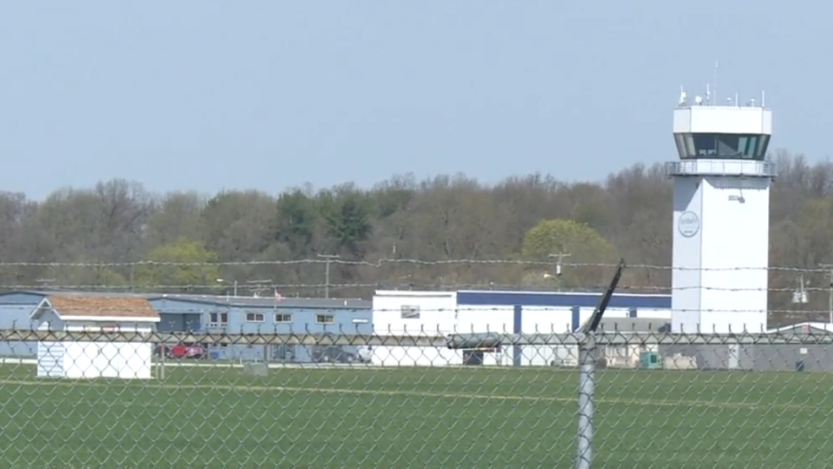

**Board Meeting**

**January 14th 7:00 pm to 8:22 pm**

Doug, Dick, Tim F, Jeremy, Bill, Jim, Steve

For the record, the current Board:

Dr. Doug Busch – President

Tim Green – VP

Jim Butler – Secretary

Jerry Hostetler – Treasurer

Steve Lesher, Jeremy Quick, David O’Connor – Directors

Tim Farrell – Communications / Vortex

Bill Waymouth – Historian / Photographer

Brian Taylor – Chaplin

David O’Connor - Young Eagles

Tim Green has expressed regrets for not being able to attend meetings and participate as much as wished. If an official resignation is submitted the floor will be open for nominations at the next meeting followed by a vote from the membership. Anyone who is interested in taking on this roll should let a board member know and if possible, attend the January meeting.

Doug contacted EAA in regard to a possible spring work party. Unfortunately, we will not be able to this year due to the pandemic.

Brainstormed ideas for upcoming year to keep everyone involved and active.

Fly outs, Young Eagles in September, FI/DI/RI, a monthly mini-function, possible project build, possible RC model build, movies, fly-in in conjunction with camping. Without knowing the course of the COVID-19 it is difficult to plan.

For now, we will proceed with some fly-outs, our monthly meetings (within CDC guidelines), Monday evening popcorn sessions and planning for Fall functions. We are open to and encourage any suggestions or ideas from the membership.

Jerry has submitted the financial statement for 2020. It was noted that without the sale of John Horvath’s donated project we would have been in a negative cash flow for the year.

The expenses for the Christmas party were reviewed. Although those who attended deemed it a success, it was noted that had we had more participation and a silent auction; it would have not been so costly.

Doug and Tim will be putting together the next fly-out and will be notifying both Chapter 132 and other local flying organizations as soon as plans are finalized.

The upcoming January membership meeting was discussed, and Dick volunteered to bring his radial engine model and explain the basics of how a radial engine works.

