Jan 25, 2024 EAA Chapter 132 Membership Meeting at IFC Hanger 7:00-8:50 PM

Our membership meeting was at the Indiana Flight Center hanger with about 20 or more of our members there. Weather was kind of crazy.

Phil mentioned that the Michael Smith Fisher-Classic 2 seat biplane was donated to EAA Chapter 132 and is now in our EAA hanger to be built and then sold by Michael. Phil also mentioned that we can start building the plane on Thursday’s from 5-8pm. There may be another day to have the plane built with us EAA and STEM kids as well.

Chris Henry from EAA in Oshkosh gave us a great presentation about the FU4 Corsair that was made just during the end of WWII and was in the Korean War and is now in the EAA Oshkosh Museum. He also talked about the Baa Baa Blacksheep Major pilot Pappy Boyington using FU4 Corsairs during WWII in the south pacific. Chris also talked about pilots who flew Corsairs in the Korean War. Awesome!!!

Feb 10th, 2024 EAA Chapter 132 breakfast 9-11am by Don & Karen

Your Official Countdown to AirVenture 2024
July 22 – July 28, 2024
Countdown is sponsored by:

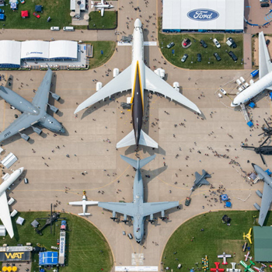

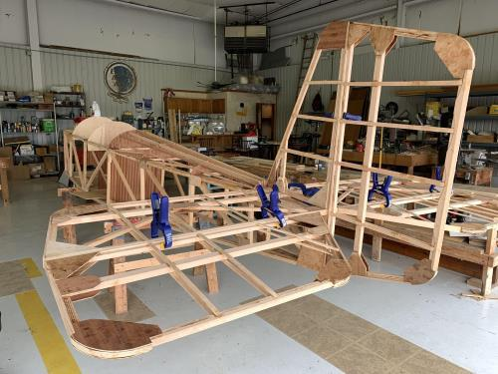

See Jim’s Experimental Aircraft Pietenpol project every Monday evening at 7pm at the EAA 57 hanger at the Elkhart Municipal Airport. He and Steve is adding elevator and rudder to their Pietenpol project. Have popcorn and meet with other
EAA Chapter 132 members too!

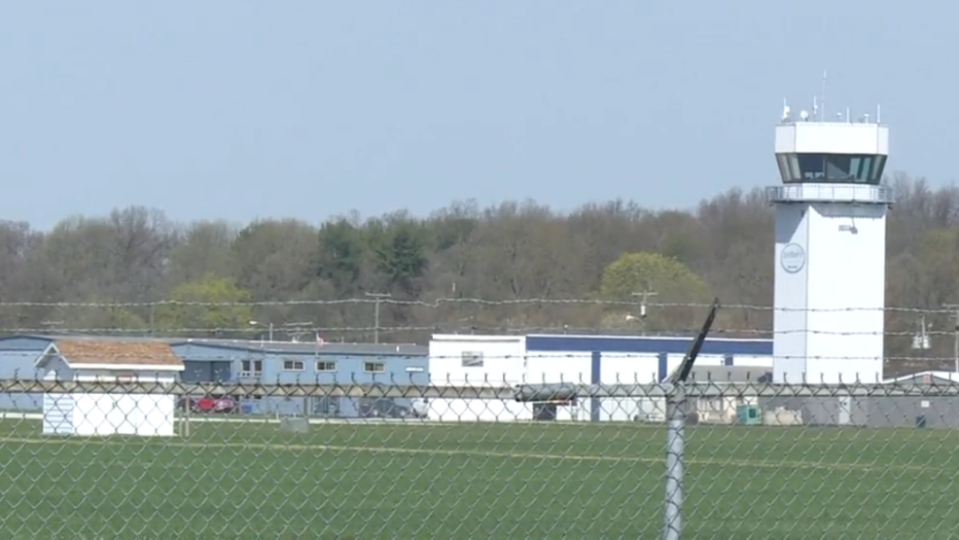

Jan 11, 2024 Board Meeting 7:00-7:45 pm
Phil, Wendi, Tim, Mike, Audry, Dick, Jerry, Steve, Marty, Doug and Yeager

Jan 13, 2024 EAA Chapter 132 breakfast 9-11am by Phil and Wendy cancelled due to bad winter weather.
Jan 25, 2004 EAA Chapter 132 Membership Meeting will be at the IFC at 7pm with Chris Henry doing his presentation about the FU4 Corsair.
Micheal Smith might be donating a Fisher Classic 2 seat biplane to our chapter so we can build it and then we will send money to Micheal in his dad’s name once the plane if built and sold to someone.
Our clubhouse bathroom needs a few things fixed or replaced. A faucet and toilet.
Membership renewal is requested as soon as possible early in each year.
Feb 10th, 2024 EAA Chapter 132 breakfast 9-11am by Don & Karen

